Hello,
Thank you so much for considering a charitable donation to Audience of One Productions. We are so thankful for your interest in our program.
Audience of One Productions is an educational theatre program focused on producing high level Broadway shows while helping performers grow in the arts. Our organization began with the mission to inspire young performers to see themselves through the eyes of love, while also realizing their greatest potential in their craft and beyond. With that mission ever at heart, year after year, Audience of One Productions has dazzled audiences with incredible shows such as: Seven Brides for Seven Brothers, Singin’ in the Rain, Little Women- The Broadway Musical, West Side Story, Mary Poppins, She Loves Me, Newsies, You’re a Good Man Charlie Brown, Guys and Dolls, Sound of Music, Grease and Matilda! The success of our organization over the past seven years has been overwhelming and we are continuing to grow beyond ourselves.
All of our productions are held at the historic Capitol Theatre in Lebanon, TN- a top tier venue in the greater Nashville area, boasting an ideal location for a flourishing arts community-a community that we would love to have your organization be a part of in 2022.
Our upcoming season will introduce advanced productions that invite professionals to work alongside of our students; truly offering learning experiences like no other. The advancement of our productions and educational reach has only been made possible through sponsorships and donations like yours. Your donation dollars go towards production costs for the following: Licensing fees, costumes, building sets, subsidizing our expansive educational programs, and extraordinary artists/instructors to teach our students. It is because of your generosity that we are able to offer these incredible opportunities to Wilson County and beyond.
It is our hope to continue to grow and thrive as Nashville’s leading Regional Theatre in years to come, but we cannot do it alone. It is imperative that we receive continued support, prayer and partnership in this endeavor to continuously offer premier productions while living out our calling: “to do all things unto Him.”

Blessings,

Angie Dee, Founder/Director

Our Programs

Capitol Players Pro / Regional Theatre Program:
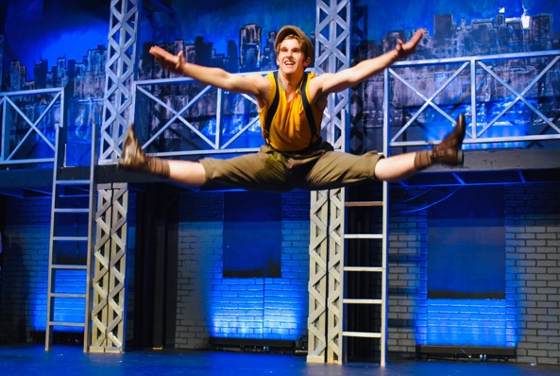
Audience of One Productions is an educational theatre program focused on producing high level Broadway shows while helping performers grow in the arts. Our Capitol Players Pro division caters to advanced and professional level performers of all ages, however, most productions at this level feature actors ages 14 and up. The exponential growth of our program throughout the years has allowed us to offer Wilson County, and the greater Nashville area, a top tier theatrical experience with this program in particular. Typically productions at this level feature a live orchestras, Broadway veteran choreographers, and premier music direction. Recent productions by Capitol Players Pro include Grease, Newsies and The Sound of Music. Capitol Players Pro will also be performing On the Town and Into the Woods in the 2022-2023 season, both featuring live orchestration. It is our hope, and goal, that in the next two years, we will be one of the Southeast’s top regional theatres.

Educational Theatre Program:
One of the fundamental elements of Audience of One is arts education. Musical Theatre boasts a platform like no other to learn and grow in all areas of the arts, as it combines the use of so many artforms. From set building and sound engineering to vocals, choreography and storytelling, musical theatre is a network where every “part” is needed to make the “whole”. From the audition process to the final curtain, our junior students learn to take their individual talents and skills and develop them into a dynamic work of art. Along the way, we hope to instill a sense of self-worth that will travel with them far beyond the stage. Unlike many junior programs that simply hone in on what each student brings to the table artistically, Audience of One also seeks to develop a much deeper sense of self, ultimately leading each student to see themselves and others through the eyes of love. Past junior productions include Beauty and the Beast, Jr. and Seussical, Jr. among others. The 2022-2023 is sure to boast our “wildest” junior show yet with the summer production of Disney’s The Lion King, Jr.

Sponsorship Opportunities
Audience of One Productions would not be possible without the support of community sponsorships and donations. We offer a wide range of sponsorship opportunities and courtesies to best fit your desired donation. We offer two main gateways of sponsorship opportunities: seasonal and individual show. Our seasonal sponsorships are annual giving donations that go to support our season as a whole. Seasonal sponsorships give donors access to unique courtesies and opportunities outlined in the pages that follow. Individual show sponsorships are ad sponsorships only that only go to support one particular production of choice rather than the entire season.

HOW TO DONATE

To become a sponsor, or make a donation for a single show, please fill out the attached form and return to info@audienceofoneproductions.com OR mail to “Audience of One Productions”, 1702 Country Haven Court, Mt. Juliet, TN 37122. Payments are accepted via check or through Venmo (@AudienceOfOneProductions) at the current time.

If you are unsure which donation level to choose or have additional questions, please reach out to info@audienceofoneproductions.com OR contact us via phone at 615-202-0988.

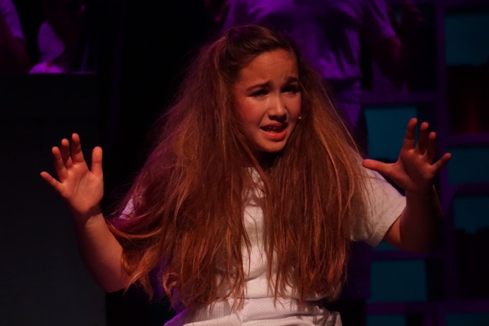

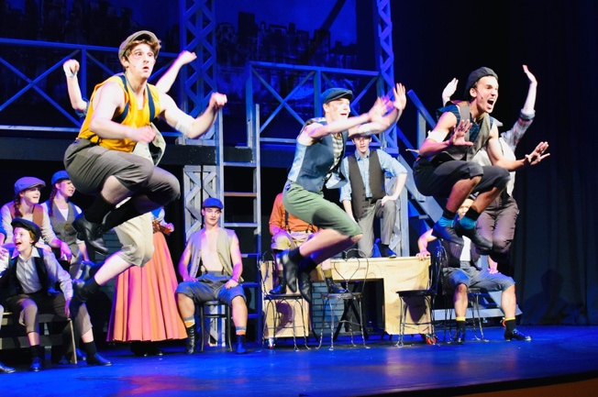

2022-2023 FULL SEASON SPONSORSHIP
Regional Theatre Program Courtesies Beginning in 2023

- Producer’s Circle ($10,000+)
  - Name or Organization listed on marquee of Capitol Theatre for each performance as “Presented By” sponsor
  - Private meet and greet with directors, actors and creative team on opening night of show of choice
  - Exclusive invitation to “Actors Talk Back” event following rehearsal
  - 2 Complementary Tickets to a production
  - Invitation to Pre-Show Cocktail Hour
  - Name or Organization listed in each playbill throughout the 2022-2023 season
  - Subscription to exclusive sponsor newsletter
- Director’s Circle ($5,000-$9,999)
  - Private meet and greet with directors, actors and creative team on opening night of show of choice
  - Exclusive invitation to “Actors Talk Back” event following rehearsal
  - 2 Complementary Tickets to a production
  - Invitation to Pre-Show Cocktail Hour
  - Name or Organization listed in each playbill throughout the 2022-2023 season
  - Subscription to exclusive sponsor newsletter
- Standing Ovation Society ($2,500-$4,999)
  - Exclusive invitation to “Actors Talk Back” event following rehearsal
  - 2 Complementary Tickets to a production
  - Invitation to Pre-Show Cocktail Hour
  - Name or Organization listed in each playbill throughout the 2022-2023 season
  - Subscription to exclusive sponsor newsletter
- Ovation Society ($1,500-$2,499)
  - 2 Complementary Tickets
  - Invitation to Pre-Show Cocktail Hour
  - Name or Organization listed in each playbill throughout the 2022-2023 season
  - Subscription to exclusive sponsor newsletter
- Applause Society ($500-$1,499)
  - Invitation to Pre-Show Cocktail Hour
  - Name or Organization listed in each playbill throughout the 2022-2023 season
  - Subscription to exclusive sponsor newsletter

- Patron Society ($100-$499)
  - Name or Organization listed in each playbill throughout the 2022 season for all theatrical performances and showcases
  - Subscription to exclusive sponsor newsletter
- Contributor Society (up to $100)
  - Subscription to exclusive sponsor newsletter

2022 SINGLE SHOW SPONSORSHIP
Capitol Players Pro-Regional Theatre Program Courtesies

- Grand Curtain Sponsor ($2500)
  - Full page, full color ad displayed in each playbill throughout the 2022 season
  - Recognition on marketing in theatre lobby
- Applause Society ($1000)
  - Half page, full color ad displayed in each playbill throughout the 2022 season
- Patron Society ($775)
  - Black and white, business card size logo or graphic for each playbill during the selected show throughout the 2022 season
- Contributor Society (up to $100)
  - Name or Organization listed in each playbill throughout the 2022 season

Educational “Junior” Theatre Program Courtesies

- Grand Curtain ($1500)
  - Full page, full color ad displayed in each playbill throughout the 2022 season
  - Recognition on marketing in theatre lobby
- Applause Society ($775)
  - Half page, full color ad displayed in each playbill throughout the 2022 season
- Patron Society ($350)
  - Black and white, business card size logo or graphic for each playbill during the selected show throughout the 2022 season
- Contributor Society (Up to $100)
  - Name or Organization listed in each playbill throughout the 2022 season.

ADDITIONAL BENEFITS

MATCHING GIFTS – Many companies match gifts to nonprofit organizations by an employee, director or retiree, which increases benefits of your contribution.

GIFTS OF APPRECIATED STOCK – In general, contributing appreciated stock which you have held longer than one year would avoid capital gains tax and still receive an income tax deduction for the dated fair market value of the gift.

CHARITABLE IRA ROLLOVER – The IRA Charitable Rollover permits taxpayers ages 71+ to make a qualified charitable distribution from any IRA to a 501(c)(3) organizations.

Audience of One Productions, Inc., is a 501(c)(3) nonprofit organization. Audience of One is not rendering legal or tax advice. For details on how your gift impacts your tax situation, consult your professional tax advisor.

2022-2023 DONOR FORM
Regional Theatre Program/ Educational Theatre Program

Donor Name(s)/Organization Name:

__________________________________________________________________________________________
Street Address:

_________________________________________________________________________________________

City: _______________________________________ State: ______________________Zip Code: __________
Contact Phone: ______________________________ Email Address: _________________________________
Please indicate which sponsorship you are interested in and the amount donated:
(Season Sponsor) (Individual Show Sponsor)
Amount Enclosed:________________________
If individual show sponsor, which show are you wishing to sponsor? _______________________________
Payment Information: Checks enclosed should be made payable to Audience of One Productions Inc.
Venmo: @AudienceofOneProductions

Audience of One Productions, Inc., is a 501(c)(3) nonprofit organization. Audience of One Productions is not rendering legal or tax advice. For details on how your gift impacts your tax situation, consult your professional tax advisor.

