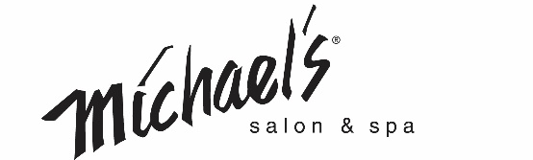

Front Desk Manager

About Us

Michael’s Salon & Spa is a family run and women-owned salon located in beautiful Centerville, OH. Founded in 1974, we are known for an excellent education program and high-quality luxury services. Today we are comprised of a team of nearly 100 employees offering hair, spa, makeup, and nail services.

Summary

The successful candidate will be a motivated, passionate, and positive team player who loves engaging with people to provide the ultimate salon and spa experience. This candidate will also have effective communication skills and keen common sense. The Front Desk Manager's main responsibility is managing 10 or more front desk staff and must create an environment focused on providing the best service to each client. To do this they lead by example, managing staff, assisting with recruiting and training, promoting marketing specials, and identifying areas for improvement. This full-time position is at our salon in Centerville, OH, with full-time working hours Monday through Saturday and reports to the General Manager.

If you enjoy working with others, maintaining a professional appearance with specific attention to your own hair and makeup, this could be the job for you!

Essential Job Functions

- Manage your team to engage with guests to provide the ultimate salon and spa experience
- Support the team by providing solutions to guest concerns in a timely manner
- Perform opening and closing duties within the salon
- Provide excellent guest service
- Serve as a coach and role model—you set the tone for the front desk
- Participate in interviewing and hiring team members
- Set measurable and manageable goals for team members
- Complete documentation for conversations, concerns, and goals
- Manage in-salon schedules and time off requests
- Maintain cleanliness and State board standards within the Salon

Knowledge, Skills, and Abilities

- Two years managerial experience in the service industry.
- One year retail experience or guest service experience in the service industry.
- Excellent written and verbal communication skills.
- Excellent organizational skills.
- Ability to attend and satisfactorily complete all company-required education.
- Ability to work retail hours including weekends, holidays, evenings special events.
- Must be able to work in a fast-paced environment.
- Ability to adapt quickly to change

Perks

We offer great perks for all employees including:
- Free Haircuts
- Discounted Salon and Spa Services
- Discounted Products

Physical Demands

- Talking
- Walking
- Hearing
- Crouching
- Keyboarding
- Visual Acuity
- Reaching overhead
- Must be able to lift 15 pounds.
- Prolonged periods of standing at a desk

