TABANIDS, AKA HORSEFLIES

I have been at war for three years now against the hordes of horseflies that molest my family of four-leggeds—one mustang, three goats, two pigs, and a livestock guardian dog. The flies are abundant where I live, surrounded by woods near the new Bois D’arc Lake. The flies were a serious nuisance in the spring of 2021 (my first spring in the area), and that set me on a quest to find a meaningful solution.
I spent hours on the Internet and experimented with several approaches that came recommended, and some with demonstrable evidence to support their claims. None of them worked well for me, though. These included a water trap, in which the flies bounce off invisible-to-them plexiglass to fall into shallow, soapy water from which they cannot escape. Another was sticky balls—black balls suspended from trees with a covering of Tanglefoot or Olson Sticky Stuff; like a fancy fly paper—the flies land and can’t get away. A third was “H Traps”—canopy traps with a black ball suspended underneath; the flies fly up from the ball into a funnel that leads to a jar-like trap. All of these worked to a limited extent, but not well enough by a long shot. Then I found the answer, after searching under “Greenhead.”
The Greenhead is one of a long list of tabanids (deer flies and horseflies), named for their distinctly green eyes, which help identify them in contrast to other varieties. It seems they breed like crazy in the coastal marshes of New Jersey and create a true nightmare for beachgoers, which led Rutgers University to come up with an answer. Their findings, which they have posted, include instructions for duplicating their “box traps,” and I can vouch for them. They are tops!
Here is a link to the Rutgers article with the plans I followed: https://esc.rutgers.edu/fact_sheet/the-greenhead-and-you/

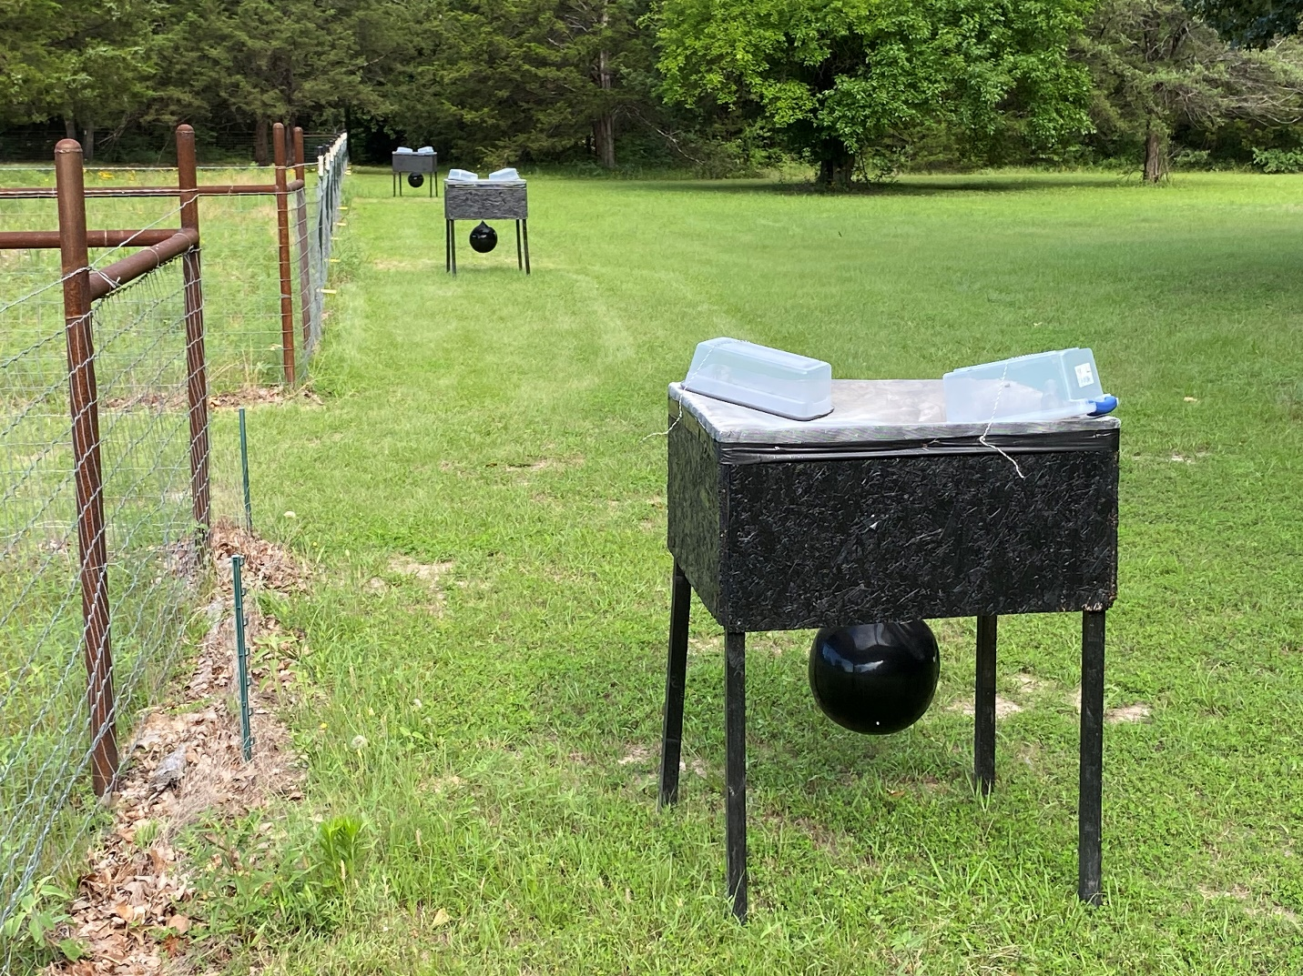
Over time, I built 10 of these box traps and distributed them around all four sides of my 3 ½ acres of pasture. Since starting with them in July 2021, I have been keeping weekly trap counts, calculating daily rates and including the numbers I also kill by swatting. The numbers are staggering, with as many as 95 swatted and an average of 270 trapped in a day! The highest number of dead flies counted in my traps in a week has been 1,684 on the 5th of June 2022! Curiously, the highest weekly number so far this year has been 1,483 on the 11th of June. This points to a consistent finding of seasonal variation: the flies emerge around the end of March, and their numbers peak in early June, after which they gradually decline until around the first of November, when they disappear until the following spring.
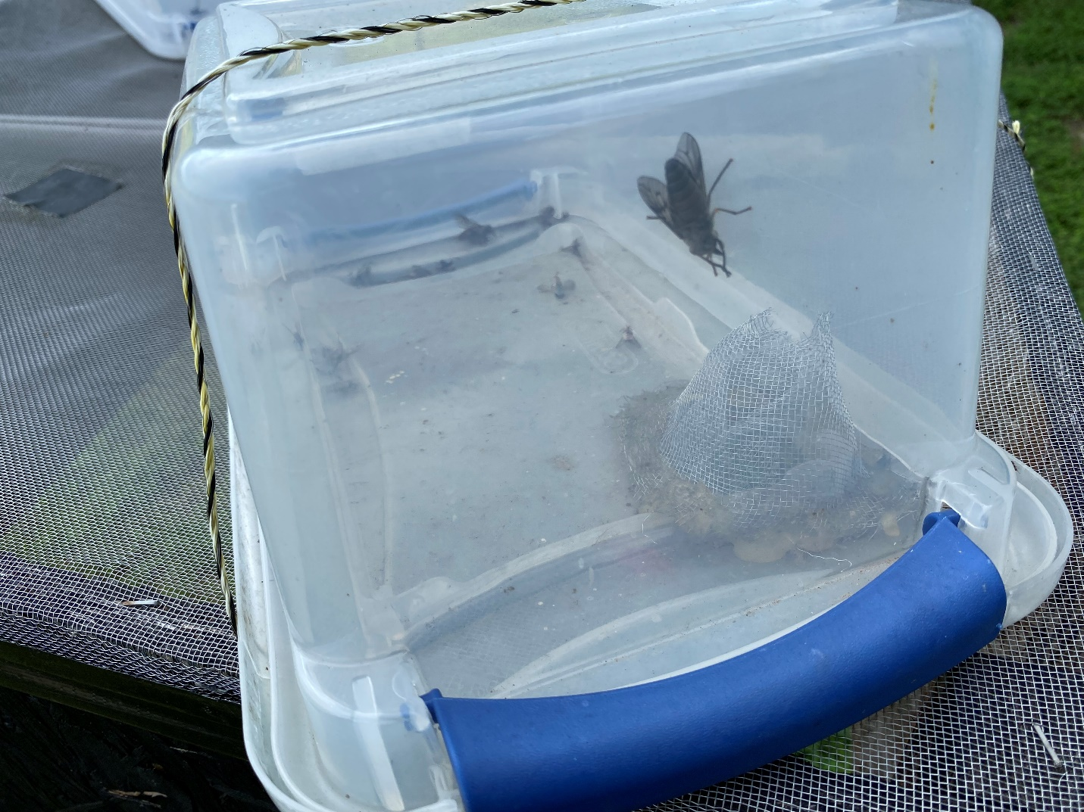

In all, I have removed about 36,000 horseflies from my neighborhood so far. The numbers include a few deer flies, but not many—the vast majority are horseflies. My understanding is that only the females bite, as they seek the protein of a blood meal for their developing eggs.
I have come to identify at least four types of horseflies. They vary in size, appearance, and target—the Greenheads go for the legs, the large Black Horsefly seeks the rump and tail, the common variety go for the main body, and some go specifically for the groin.
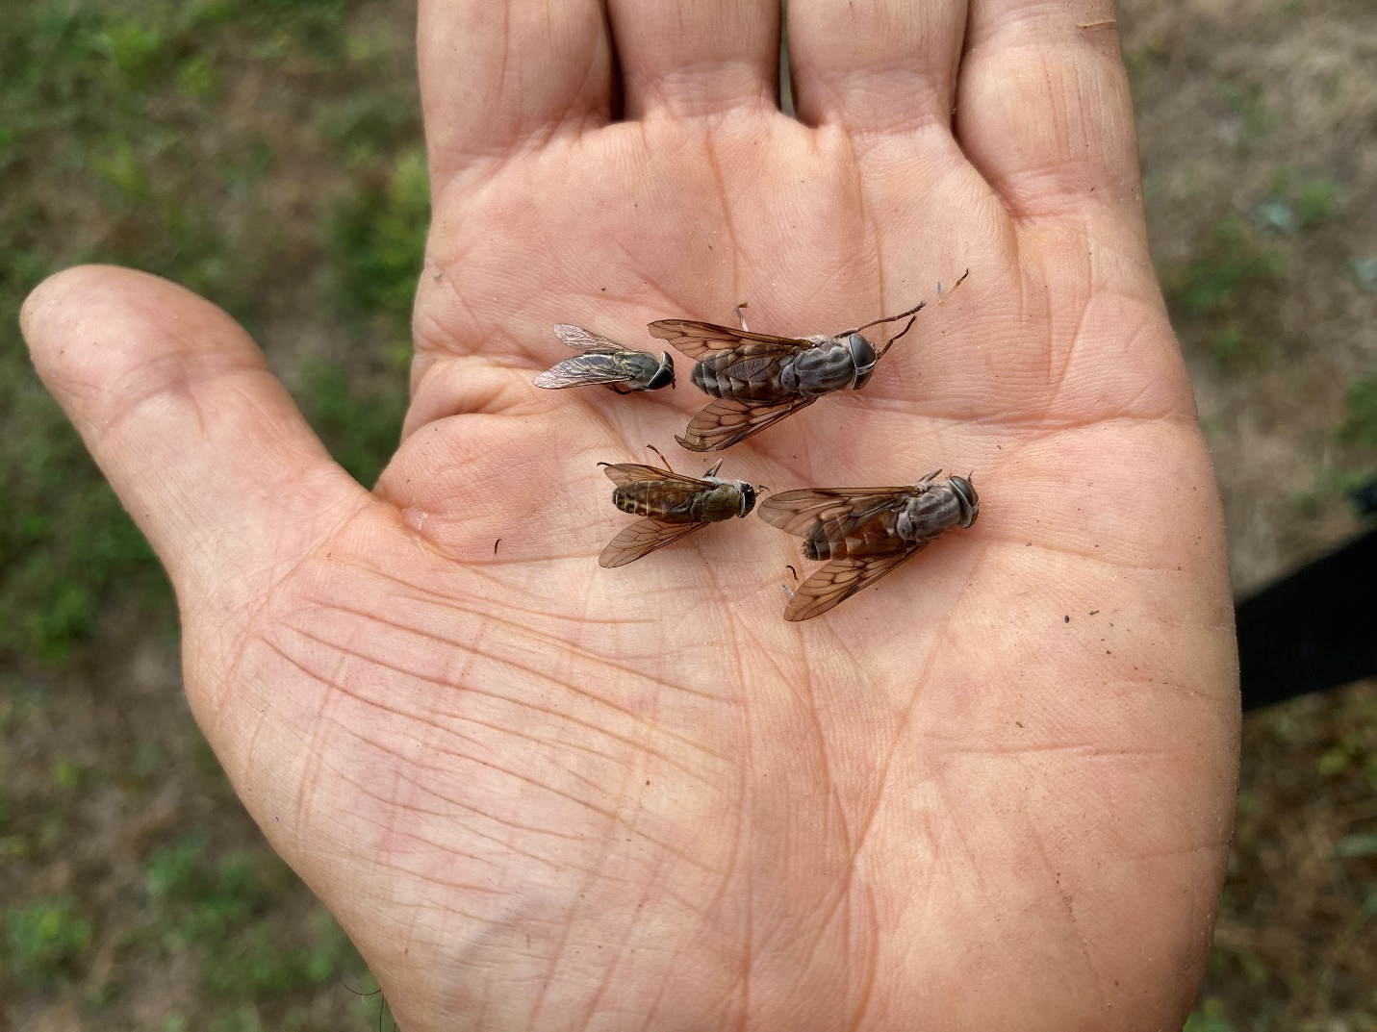

I would like to believe that removing 36,000 egg-laying females from my neighborhood has seriously reduced the presence of these creatures, but I dare not be so optimistic. Only additional years of data will tell me if their numbers are really declining, or if I am only seeing normal annual variations. What I do feel sure of is that the traps provide additional targets and thereby reduce the pressure on my horse. Instead of one big, black, warm, moving object to attract them, they have 11 (horse plus 10 traps), and there is no question that he is far less bothered than he was before the ring of traps went up. Yes, he still gets bites, which is especially likely in the evening. It seems these flies are most active in the last hour or so before dark. So, my horse and I have developed a routine of him munching hay in his shelter, while I sit beside him with a badminton racquet. I also have a heavy-duty fly swatter, but I find that the racquet delivers a lethal blow if the flies get hit in flight, and it makes an effective trap to simply place over them on my horse’s body, allowing me to then squash them, which I am very happy to do. My horse has learned to tolerate swats on his body with a fly swatter (not the racquet!), and he will actually come running to me from the four corners of his pasture if he has a fly he can’t shake loose.
I can’t recommend these box traps highly enough. If you’re among those who live in high-density tabanid country, these could be your winning ticket.

