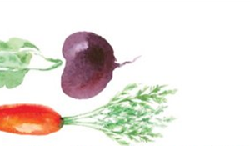
bEETS AND CARROTS
Seafood menu
Wild fish landed locally from NJ to Maine

GRILLED BLACK BASS FILLET WITH SAFFRON RICE 20

SKATE WINGS
STUFFED SUMMER SQUASH WITH FRESH HERBS 18

SCALLOPS SEARED WITH BROCCOLI, CARROTS
AND PISTACHIOS 23

MONKFISH POACHED IN BEET OLIVE OIL
WITH BEET GREENS 26

HALIBUT POACHED IN BASIL OIL
WITH PEAS AND FOAM SOUCE 24

SALMON SLOW- COOKED,
INSPIRED BY GREEN 24

bEETS AND CARROTS
Seafood menu
Wild fish landed locally from NJ to Maine

GRILLED BLACK BASS FILET WITH SHAFRON RICE 20

SKATE WINGS
STUFFED SUMMER SQUASH WITH FRESH HERBS 18

SCALLOPS SEARED WITH BROCCOLI, CARROTS
AND PISTACHIOS 23

MONKFISH POACHED IN BEET OLIVE OIL
WITH BEET GREENS 26

HALIBUT POACHED IN BASIL OIL
WITH PEAS AND FOAM SOUCE 24

SALMON SLOW- COOKED,
INSPIRED BY GREEN 24

