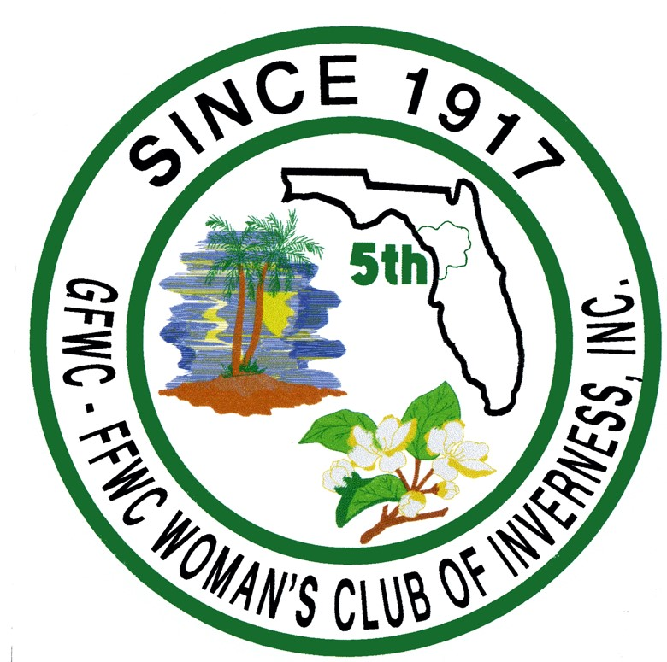
GFWC WOMAN’S CLUB OF INVERNESS
1715 FOREST DRIVE
INVERNESS, FL 34453

RATES FOR CLUBHOUSE USE (PAYABLE IN CASH UPON SIGNING)

4 hours or less ………………………. $150.00
Each additional hour …………….. $ 25.00
Security Deposit ……………………. $ 50.00 (This amount is refundable if rules and regulations are met.)

CONTRACT

The undersigned agrees they have received a copy of and will abide by the rules and regulations of the
Inverness Woman’s Club.

CLUBHOUSE USER’S NAME __________________________________________________

ADDRESS __________________________________________________

__________________________________________________

PHONE __________________________________________________

RESPONSIBLE PERSON(s) __________________________________________________

__________________________________________________

DATE OF USE __________________________________________________

TIME (FROM) ___________________________ (UNTIL) _____________________________

TYPE OF EVENT __________________________________________________

RATE PAID $____ 150.00___________

ADDITIONAL HOURS $_____________________

TOTAL PAID $_____________________ Receipt # ________________

SECURITY DEPOSIT $______50.00___________Receipt # ________________

_____________________________________ ___________________________________
INVERNESS WOMAN’S CLUB REPRESENTATIVE RESPONSIBLE RENTER

_____________________________________ ___________________________________DATE DATE Revised 9-1-2023 Page 1 of 2
GFWC WOMAN’S CLUB OF INVERNESS

CLUBHOUSE RENTAL RULES AND REGULATIONS

- Users of the Clubhouse shall abide by all established rules and regulations.
- Organizations or individuals who use the Clubhouse shall donate $150.00 for four hours minimum. Each additional hour shall be $25.00. There is a refundable $50.00 security deposit if the rules and regulations are met. Donations will be in cash and payable on signing of the contract.
- The $50.00 deposit fee will NOT be refunded if the event is cancelled less than 7 days prior to the event.
- Occupancy of the Clubhouse shall be limited to 138 people (Fire Code #85-10)
- Smoking is prohibited in the Clubhouse, including restrooms.
- No alcoholic beverages shall be permitted in the Clubhouse or on the grounds.
- Pets are prohibited in the Clubhouse. Guide dogs for physically disabled persons are permitted.
- Nothing shall be adhered to the walls, windows, doors, or ceiling inside or outside of the building. No glitter or confetti, please.
- No placement of furniture shall restrict access to any exit. All furniture shall be replaced to its original position. No furniture shall be used outside the Clubhouse.
- Air conditioner shall be set by the Inverness Woman’s Club (IWC) representative and shall not be controlled by anyone else.
- Children under the age of 18 years shall always be controlled by a competent adult.
- No function shall end later the 10:00 p.m.
- All user equipment and effects shall be removed from the Clubhouse at the conclusion of the event.
- All trash shall be removed from the building and grounds at the conclusion of the event. The building must be left clean and arranged as it was when the renter first arrived for the event.
- Clubhouse users shall provide their own electronics/TV/computer, etc. if needed.
- The IWC assumes no responsibility for damages or loss of user property.
- Renter agrees to indemnify the Inverness Woman’s Club, its officers and members, harmless from any liabilities, costs, penalties, or expenses arising out of or resulting from the use of the premises.
- Renter agrees to comply with all applicable City, County, State and Federal laws and regulations, including all health rules and regulations. The IWC assumes no responsibility associated with the transmission of any infectious diseases incurred because of the renter’s use of premises. Renter shall conduct no illegal acts on premises.
- The IWC shall deliver the premises “broom swept clean” prior to the event. All additional cleaning and sanitation are the responsibility of the renter.

_________________________________ ________________________________ ____________
Inverness Woman’s Club (IWC) Responsible Renter Date
Representative

Revised 9-1 2023 Page 2 of 2

