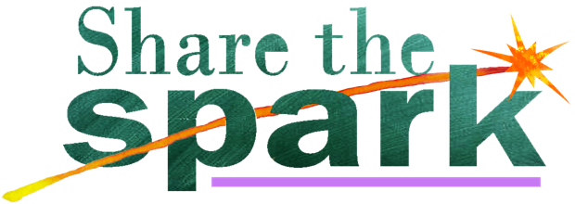
Spark Tank Submission Form
1. Who is on your team?
Minimum of 2 and maximum of six people between the ages of 8 - 23.

KEY CONTACT PERSON:
Name –
Age –
Email –
Phone –
Additional team members names and ages:
2.

3.

4.

5.

6.

2. What is your idea about?
Maximum 250 words. Tell us what you want to do and why you want to do it.

2. How will you make your idea work?
Maximum 250 words. Tell us how you want to do it, what are the steps?

3. How long will it take and what will it cost?
Maximum 250 words. We just want your best guess here. Give us a rough timeline for the steps you wrote above and suggest what you think each step may cost.

Congratulations, you’re done! Now be sure to email this form to us by 15 August 2019.
Email this form, and any questions you may have when filling it out, to succeed@sharethespark.org.au

