Socrates’ Critique of 21st-Century Neuroscience
The ancient thinker saw limits to what natural science can tell us about ourselves
- By Daniel Silvermintz on July 10, 2019
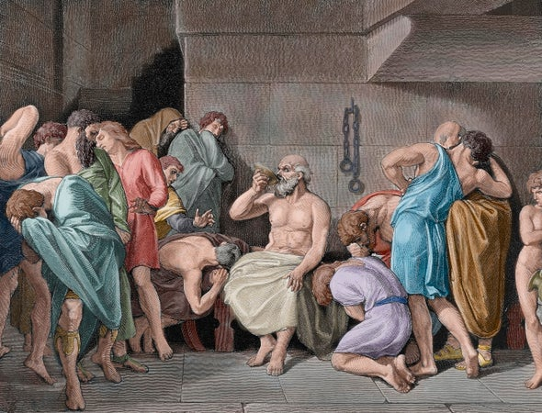
Credit: Getty Images
If chocolate releases the same chemicals in the brain as sexual excitement, why not forgo the trials and tribulations of a romantic relationship for a bowl of Hershey’s kisses. Twenty-first century neuroscience provides such a sophisticated understanding of brain functions that it is tempting to mistake the psychic mechanism with the ultimate goal.
This is precisely what goes on in the field of psychobiology, which eschews discussion of meaning beyond the biological process. Ironically, the scientific study of psychology was initiated by Socrates’ disillusionment with the natural sciences in light of their complete inability to account for human behavior. Alongside advances in brain science, we need to rediscover the ancient approach to behavioral science as a means of restoring meaning to function, if for no other reason than that our lives depend on it.
Socrates (469-399 B.C.) recounts, in his final recorded conversation before his fateful execution, his interest and subsequent disenchantment with the works of the natural scientists. “When I was young, Cebes, I was tremendously eager for the kind of wisdom which they call investigation of nature,” Socrates tells those gathered in his prison cell, “I thought it was a glorious thing to know the causes of everything, why each thing comes into being and why it perishes and why it exists.”
Rather than appealing to a supernatural world of gods, the Ionian physicists had, for the first time in history, attempted to apply reason to understand the natural world. Thales of Miletus (circa 624-548 B.C.) initiated this approach with the provocative claim that everything is water—not a bad first attempt given water’s plasticity and primacy.
Later thinkers presented rival claims culminating in the work of the atomists, who posited that all reality, including human behavior, could be understood by an indivisible substance along with empty space to give the atoms room to move. As one atomist puts it, mental states are nothing other than sensations that result from the imposition of atoms on the organism: “We know nothing about anything really,” declares Democritus (circa 460-370 B.C.), “but opinion is for all individuals an inflowing of the atoms.”
Socrates was initially excited by the explanatory power afforded by the physicists, who were able to explain the multiplicity of existing things by appealing to a few simple principles. His youthful exuberance soon turned to dismay as he realized that the natural sciences could explain everything except the most important thing he could hope to understand. “Since I had given up investigating realities,” Socrates goes on to detail the mental turmoil he experienced: “I decided that I must be careful not to suffer the misfortune which happens to people who look at the sun and watch it during an eclipse.”
For Socrates, the misapplication of the natural sciences to human affairs renders the investigator incapable of seeing such fundamental notions as justice, beauty and goodness since they lack a material explanation. He poignantly illustrates the fallacy of scientific reasoning by considering how a biologist would explain why Socrates is sitting in his prison cell: “The bones are hung loose in their ligaments, the sinews, by relaxing and contracting, make me able to bend my limbs now,” declares Socrates just before drinking the poison, “and that is the cause of my sitting here with my legs bent.” Of course, one cannot argue with the truth of the biologist’s explanation; nonetheless, bones and sinews have nothing to do with why Socrates is sitting on death row.
Socrates’ disenchantment with the natural sciences led him to initiate a second scientific revolution in which he establishes the rational basis of ethics and politics. Despite disavowing the natural sciences, he remained committed to the scientific approach, which attempts to explain a multiplicity of phenomena by appealing to a single cause. The Socratic scientific revolution was thus not so much in the method he pursued but in his application of it. Rather than positing primal matter as his first principle, Socrates initiates a whole new line of investigation premised on the absolute existence of immaterial ethical principles such as justice and goodness. Socrates unique research method began with a ruthless examination of people’s belief systems.
He further clarifies how he used these discussions as a therapeutic means of helping to purge his discussion partners of their misguided opinions. “But the greatest thing about my art is this,” says Socrates about his unique gift for helping others, “that it can test in every way whether the mind of the young man is bringing forth a mere image, an imposture, or a real and genuine offspring.” In contrast to Freudian psychotherapy, Socrates employs the talking cure to get people to join in the inquiry as co-investigators and in so doing to get them to think more rationally about their lives.
Although Socrates wrote nothing, we have preserved (with more or less fidelity) several thousand pages of these unique therapy sessions. In one of these discussions, a young man approaches Socrates for help in treating a reoccurring problem with headaches upon waking in the morning—no doubt caused by the teenager’s overindulgent behavior the prior night. Socrates informs the young man that most physicians fail to treat the real cause of many physical maladies because they neglect the patient’s mental health.
In contrast, Socrates claims to have learned a technique that will effectively treat the boys’ condition: “A certain leaf, but there was a charm to go with the remedy,” Socrates explains, “and if one uttered the charm at the moment of its application, the remedy made one perfectly well; but without the charm there was no efficacy in the leaf.” Socrates then went on to engage the young boy in a long discussion about the meaning of moderation. Sobriety will obviously afford the boy a more permanent solution than the immediate relief provided by any drug.
By the end of the discussion, one realizes that Socrates was not completely forthright when describing the treatment plan since he never actually administered the leaf. Evidently, the medicinal leaf needs the charm, but the charm of philosophic inquiry does not need the addition of a drug to produce the desired effect.
Socrates demanded that human behavior be treated as a legitimate field of scientific inquiry. Just like other sciences, he insisted that ethical claims must be validated in order to be regarded as knowledge. It was this rigorous commitment to knowledge that compelled him to admit his ignorance in spite of his sustained efforts investigating human behavior: “The one thing I know is that I know nothing.” Just as cancer research continues despite the inability to find a cure, Socrates demands that inquiry must continue in the human sciences even if many fundamental questions remain unanswered. “The duty of inquiring after what we do not know,” charges Socrates to one of his skeptical conversation partners, “will make us better and braver and less helpless than the notion that there is not even a possibility of discovering what we do not know.”
Advertisement
The views expressed are those of the author(s) and are not necessarily those of Scientific American.
Rights & Permissions

ABOUT THE AUTHOR(S)

Daniel Silvermintz
Daniel Silvermintz is associate professor of philosophy at the University of Houston–Clear Lake. His book on the founder of the sophistic movement, Protagoras: Ancients in Action, was published by Bloomsbury Academic in 2016.

