Worshipful Master: Joseph Felix Editor: Henry Spomer, PM

Edition: July 2022
Garfield, James A. (James Abram), 1831-1881. The 20th President, March 4, –September 19, 1881, after nine terms in the U.S. House of Representatives. His Presidency was impactful, but cut short after 200 days when he was assassinated. Initiated on November 19, 1861, in Magnolia Lodge No. 20, Columbus, Ohio and raised on November 22, 1864 in Columbus Lodge No. 30. Joined Garrettsville Lodge No. 246, Garrettsville, Ohio in 1866 and was its chaplain for the years 1868-69. Charter Member of Pentalpha Lodge No. 23, Washington, D.C. As the last of the log cabin Presidents, James A. Garfield attacked political corruption and won back for the Presidency a measure of prestige it had lost during the Reconstruction period.
He was born in Cuyahoga County, Ohio, in 1831. Fatherless at two, he later drove canal boat teams, somehow earning enough money for an education. He was graduated from Williams College in Massachusetts in 1856, and he returned to the Western Reserve Eclectic Institute (later Hiram College) in Ohio as a classics professor. Within a year he was made its president.
In 1862, when Union military victories had been few, he successfully led a brigade at Middle Creek, Kentucky, against Confederate troops. At 31, Garfield became a brigadier general, two years later a major general of volunteers. Meanwhile, in 1862, Ohioans elected him to Congress. President Lincoln persuaded him to resign his commission: It was easier to find major generals than to obtain effective Republicans for Congress. At the 1880 Republican Convention, Garfield failed to win the Presidential nomination for his friend John Sherman. Finally, on the 36th ballot, Garfield himself became the “dark horse” nominee and defeated Winfield Scott Hancock for the Presidency.
On July 2, 1881, after only four months in office, Garfield was shot twice. The first shot only grazed Garfield’s arm, but the second bullet pierced his back and lodged behind his pancreas. In an era when the practice of medicine was largely oblivious of the role played by germs in illness and disease, a parade of doctors, both at the shooting and in the hospital, poked and prodded Garfield’s wound in search of the bullet. For 80 days the president lay ill before his death on September 19, which was attributed to a fatal heart attack, massive hemorrhaging, and slow blood poisoning. Garfield was buried beneath a quarter-million-dollar 165-foot (50-metre) monument in Lake View Cemetery in Cleveland.

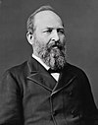
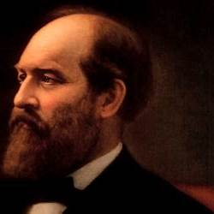
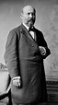
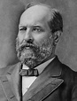

Greetings to all brothers! We hope this edition finds you all doing well, and we wish you and yours good health and happiness.
Check out our Web Page at mm56.org. It has posts and new Masonic Education articles on it.

From Our Worshipful Master:
Nobler Deeds, Higher Thoughts, Greater Achievements
Freemasons believe that we should always try to do better. While celebrating our success today we also want to do even greater things tomorrow. We are never complacent with our work, nor do we ever think that our current standard is as good as it can get. We are always seeking to improve. We respectfully look at the splendid accomplishments of those who have gone before us with gratitude for their labor and respect for their impact. While we do that, we are also doing our level best to continue the upward trajectory of their work through our own efforts now. All the while we are dreaming of how the next generation will reach even higher heights than we can obtain today. In this great work of advancement, growth, and progress, the whole human race is linked; generation to generation, in an upward trajectory planned by the Great Architect of the Universe himself. We must strive to be better all the time.
A phrase that is often used to describe Freemasonry is “Making Good Men Better.” The truth is that the structure of Freemasonry does very little to accomplish that goal itself. Instead, the ritualized teachings of Freemasonry are made available to every Freemason as he is initiated as an Entered Apprentice, passed to the degree of Fellowcraft, and raised to the sublime degree of Master Mason. Once he learns the teachings of our ritual, it is up to each individual Freemason to apply those teachings to his life. It is in the application of those teachings that he becomes better. In this way each Freemason strives towards Nobler Deeds, Higher Thoughts, and Greater Achievements in his personal life through daily growth, even as the human race does from generation to generation.
Davis, Carl. “Making Good Men Better Men.” p. 148-154
Secondly, as one of my charges I agreed that I would diligently to search the Book of Constitutions and to cause its contents to be read in Lodge, that none may remain ignorant of the precepts it enjoins or of the ordinances which it promulgates. To ensure that this is fulfilled I will begin to include sections of the Constitution and Statues here to be published as well as include a section to be reviewed at our Stated meetings beginning when we return from being dark. We will continue with Article 1.
Article I - Establishment, Composition, Esoteric Work and Recognition

§1-1 Establishment. This Grand Lodge shall be entitled "The Most Worshipful Grand Lodge of Free and Accepted Masons of Arizona." It is the Supreme Masonic Power and Authority in Arizona, possessing all the attributes of sovereignty and government -- legislative, executive, and judicial -- limited only by a strict adherence to the Ancient Landmarks of the order, and by the provisions of its own Constitution and Statutes. It shall have a Seal -- bearing such devices and inscriptions as by it shall be determined -- which shall be affixed to all instruments issued by or under its authority.

§1-2 Composition. The Grand Lodge shall be composed of a Grand Master (whose address shall be Most Worshipful), a Deputy Grand Master, a Senior Grand Warden and a Junior Grand Warden (whose address shall severally be Right Worshipful), a Grand Treasurer and a Grand Secretary (whose addresses shall be Very Worshipful), a Grand Lecturer (whose address shall be Worshipful), a Grand Chaplain (whose address shall be Very Reverend), a Grand Orator, a Grand Marshal, a Grand Standard Bearer, a Grand Sword Bearer, a Grand Bible Bearer, a Senior Grand Deacon, a Junior Grand Deacon, two Grand Stewards, a Grand Pursuivant, a Grand Organist, a Grand Tyler and a Grand Editor (whose address shall severally be Worshipful), together with all Past Grand Officers and Past Masters of this jurisdiction, and the Masters and Wardens of the several chartered and duly constituted Lodges or the representatives thereof duly elected as provided by statute.

§1-3 Ritual and Esoteric Work. The esoteric work and the ritual heretofore and now recognized and adopted by this Grand Lodge shall be communicated, taught and practiced within this Grand Jurisdiction. The power to modify or to make any change in said work or ritual rests solely in the Grand Lodge. No other esoteric work or ritual shall be recognized, communicated, practiced or taught within this jurisdiction, except as provided in Statute 10-103(a). The Grand Master, Grand Secretary and Grand Lecturer are the sole custodians of the esoteric work, and they shall never make or permit to be made any change or modification in said work or in the ritual except such as shall have been first approved and adopted by this Grand Lodge.

§1-4 Recognition of Foreign Jurisdictions. A Grand Lodge may be recognized by this Grand Lodge as Regular if it is determined:
(a) That such Grand Lodge shall have been established lawfully by a duly recognized Grand Lodge or by three or more regularly constituted Lodges;
(b) That a belief in the GAOTU, and His Revealed Will, shall be an essential qualification for membership;
(c) That all Initiates shall take their obligation on or in full view of the open Volume of the Sacred Law, by which is meant the revelation from above which is binding on the conscience of the particular individual who is being initiated;
(d) That the membership of the Grand Lodge and individual Lodges shall be composed exclusively of men;
(e) That each Grand Lodge shall have no Masonic intercourse of any kind with mixed Lodges or bodies which admit women to membership;
(f) That the Grand Lodge shall have sovereign jurisdiction over the Lodges under its control, i.e., that it shall be a responsible, independent, self-governing organization, with sole and undisputed authority over the Craft of Symbolic Degrees (Entered Apprentice, Fellowcraft and Master Mason) within its jurisdiction; and shall not in any way be subject to or divide such authority with any other power claiming any control or supervision over those degrees
(g) That the three Great Lights of Freemasonry (namely the Volume of the Sacred Law, the Square, and the Compasses) shall always be exhibited when the Grand Lodge or its subordinate Lodges are at work, the chief of these being the Volume of the Sacred Law;
(h) That the discussion of religion and politics within the Lodge shall be strictly prohibited;
(i) That the principles of Ancient Landmarks, customs, and usages of the Craft shall be strictly observed.

Fraternally,

Joe Felix, WM

Our Lodge Trustee and Tyler: Worshipful Brother Jim Wild
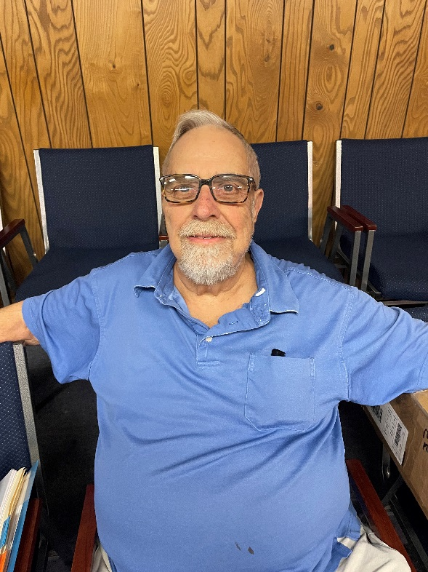
I grew up in a small town in North Central Indiana, one of thirteen children. My dad was the county Judge and juvenile Judge. The 1950 census showed us to have the largest family in Indiana, so we couldn't get away with anything. At the age of 14 I joined Logansport Chapter DeMolay. I was Master Counselor in 1959. After I graduated from high school in 1960 I moved to Tucson where my parents and 7 younger brothers and sisters had moved the year before.

I attended the U of A for a year and a half until for health reasons I dropped out. I got an associate degree in accounting from Lamson business college. I held several jobs until in 1969 I went to work for Hughes Aircraft Co. I spent 26 and a half years with Hughes and retired in June 1997.

I got married in 1969. but only for about a year and a half. I have been happily single ever since.

After retirement I traveled around the country for several years. I have visited all the 48 contiguous states. Don't travel much any more. Just around Arizona visiting Lodges.

I received my Masonic degrees in 1963 in Marion McDaniel Lodge. I started learning the ritual from the very beginning, and conferred a first degree before I held any office. I knew most of the ritual before holding any office. I sat in most all of the chairs before being elected Junior Warden. I'm one of only 2 or 3 still alive who were there when Duke (John Wayne) got his degrees in 1970. Jim was the Senior Deacon for the Dukes Degrees.

I became an Advisor for Palo Verde Chapter DeMolay shortly after I received my degrees. I have been an Advisor for Arizona Chapter for a number of years.

I joined the Chapter of York Rite in 1969, and the Council and Commandery in 1970. I joined Scottish Rite in 1974. I'm currently Master of Kadosh, which is the head of the Consistory. I received the KCCH (Knight Commander Court of Honor) or red hat in 2017.

I was Worshipful Master in 1972 and then again in 2012. I guess they wanted to see if I had learned anything in those 40 years.

I was DDGM for three and a half years before being appointed Grand Bible Bearer of the Grand Lodge of Arizona in the Masonic year of 2018-2019. That was the Masonic year MW Craig Gross gave the honorary title of Grand Teddy Bear. In 2018 I received the Grand Lodge Meritorious service award.

I became a member of Aaron Lodge in 2017, and was named Mason of the Year of that Lodge that year. I am now Chaplain of Aaron Lodge. My Masonic activities are somewhat limited these days, because at the age of 80 I don't get around as easily as I used to. I still try to stay as active as I can. Masonry has been a very large part of my life, and I have enjoyed every minute of it.

On June 9, 2022 Jim was awarded the Arizona Grand Lodge Life Time Achievement award for all the work he has provided and things he has accomplished during him many years of endless service in Masonry and for his Masonic Brothers. The Brothers of Marion McDaniel Masonic Lodge are fortunate to have him as a Brother.

Past History from the Lodge:
Haskel "Hack" G. Baldwin was a successful businessman and the owner of many service stations in Tucson during the 40's-60's. He was active in City Council, having served Tucson in that capacity for many years. He was also a past president of the Tucson and the Arizona Gasoline Retailers Assn. He became a Mason in 1940 and served as Monarch of the Alton Kol Grotto, First Worthy Patron of the Eastern Star, Associate Guardian of Job's Daughters, member of the Scottish Rite, Valley of Tucson, but his biggest pride was that he was the fifth Illustrious Potentate of Sabbar Shrine Center in 1970. The Shrine and it's charity, Shriners Hospitals for Children was his first love and volunteered to support it for his entire life. It not only brought him great joy, it introduced him to a number of great people. At his funeral, honorary pallbearers included JOHN WAYNE and Rex Allen. Masonic services were performed by Marion McDaniel Masonic Lodge

Marion McDaniel Lodge members attending Amaranth Installation June 5, 2022:
Worshipful Master Joe Felix, Senior Warden Josh Stich, Junior Stewart Joe Santistaban, Past Masters Henry Spomer and Joe Leininger.
Front Row L-R Linda Gillis, Grand Royal Matron of Arizona; Carolyn Simson, Royal Matron, Tash Tonlik Court 10; Joe Santistaban, Royal Patron, Tash Tonlik Court 10; David Gillis, Grand Royal Patron of Arizona; Back Row: Henry Spomer, Deputy Supreme Royal Patron; Michele Felix: Joe Felix, WM; Josh Stich, SW; Joe Leininger, Deputy Supreme Royal Patron.
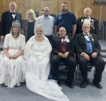

Brother John Wayne:
When Soviet Assassins Came After John Wayne, He Apparently Knew Exactly What To Do:
A team of hitmen tracking down a Hollywood star may seem like the premise for an outlandish thriller, but then truth is often stranger than fiction. Yes, apparently that’s exactly what happened to movie legend John Wayne, who somehow found himself becoming a target of Joseph Stalin. However, when the notorious Soviet dictator decided to take out Wayne, he didn’t reckon on Duke’s resourcefulness.
Wayne, of course, was a Western icon and war film hero famous for his swaggering presence in pictures such as True Grit and Sands of Iwo Jima. He became so well-known, in fact, that in 1975 even Emperor Hirohito from Japan wanted to meet him. Soviet leader Nikita Khrushchev had that pleasure, too.
And the star’s legend grew over more than 170 films – many of which were successful. At one point, Wayne shifted more tickets at the box office than anyone bar Clark Gable. Interestingly, both men began their respective rises to fame at about the same time, although Wayne’s career endured for years longer than his contemporary’s.
Famously, the ever macho Wayne also preferred to be known by his nickname of Duke – a moniker that had come courtesy of a childhood neighbor. The man dubbed the young Marion Morrison “Little Duke,” as he had gone everywhere with a family pet called – you guessed it – Duke.
Wayne even began his career as Duke Morrison, although that soon changed. After the actor was cast in 1930’s The Big Trail, you see, it was decided that he needed a new name. And while director Raoul Walsh suggested Anthony Wayne – after the Revolutionary War general – the studio curiously thought that this suggestion was “too Italian.”
After the fledgling star received his brand-new screen name, though, he became instantly recognizable across the world. Wayne came to symbolize America in many respects – something that the man himself would go on to recognize. And as his career went from strength to strength, he started to pick roles that matched that image and rejected those that didn’t.
Most famously, Wayne portrayed rugged characters – often cowboys or outlaws. After appearing in The Big Trail, he had honed his craft in a string of small Western movies, building up to the film that would bring him his big break. This came in 1939 with the release of John Ford hit Stagecoach – an acclaimed epic that won Wayne considerable plaudits from critics.
And thanks to his performances in movies such as Red River and The Searchers, Wayne arguably came to embody America’s frontier past. Perhaps his defining role, though, was as True Grit’s grizzled lawman Rooster Cogburn – a part that saw Wayne finally scoop the Best Actor Oscar.
The Academy Award was far from the only honor that Wayne would receive, either, as in 1979 he was presented with the Congressional Gold Medal. This is one of the two most prestigious decorations given out to American civilians, with the actor achieving the other accolade the following year when President Jimmy Carter posthumously granted him the Presidential Medal of Freedom.
Two decades on, the American Film Institute even saw fit to place Wayne on its list of the “Greatest American Screen Legends.” And his legacy endures through the several places that have been named in his honor – the most notable of these being, perhaps, John Wayne Airport in California’s Orange County.
Wayne’s trenchant conservative views are arguably part of that legacy, too. And this was despite the fact that the star paid little mind to political matters during his early years – something that would lead Henry Fonda to claim, “When we first made movies together, the Duke couldn’t even spell politics.” In the 1940s, though, Wayne earned a place on the board of the Screen Actors Guild, after which he became aware of the more left-leaning aspects of Hollywood.
It seems, moreover, that Wayne became interested in politics after being denied entry into the military during World War II. He was said to have been downcast at his rejection and reportedly never felt wholly comfortable about playing military heroes when he hadn’t actually served. Consequently, then, he looked for other ways in which he could display his fierce patriotism.
So, towards the end of the war, Wayne became a founder of the Motion Picture Alliance for the Preservation of American Ideals (MPA), which aimed to take on Hollywood’s leftist fraternity. And while there’s talk that the actor only joined the organization to keep some of his rightwing buddies happy, he nevertheless served as MPA’s president from 1949 through 1952 – when Red Scare hysteria had America firmly in its grip.
Studio bosses pleaded with Wayne to step back from politics, telling him that it would end his career to court controversy. When the opposite happened, though, the star seemed to have the last laugh. Reportedly, he once said, “When I became president of the Alliance, I was 32nd on the box office polls, but last year [1950] I’d skidded up near the top.
During his time with the MPA, Wayne also worked on a “blacklist” intended to destroy the careers of purported communists. And legend has it that this endeavor ultimately came to the attention of the Soviets – in particular, noted Russian movie director Sergei Gerasimov.
Wayne had tasted the anger of communists before, having previously been sent anonymous threats. But when a friend suggested that the actor could back off a bit on his red-baiting, he was adamant, allegedly responding, “No goddamn commie’s gonna frighten me.” Yet Gerasimov had the ear of someone who was not just any “goddamn commie.”
And debate still rages about how anti-red Wayne was in reality. Unlike a number of his contemporaries, he showed a willingness to forgive former communists if they were repentant – most notably welcoming Edward Dmytryk back into Hollywood after the director had recanted his leftwing political stance.
Nonetheless, Wayne’s work for the MPA showed which side of the fence he was on. And this was what Gerasimov is said to have reported to Stalin when he returned to Moscow. Supposedly, the Soviet leader was all ears when Gerasimov gave him the lowdown on both the blacklist and Wayne’s fierce attacks on communists.
Yet the Soviet dictator was perhaps not in the best frame of mind to receive this news. Stalin was in his 70s at the time, and the stresses of World War II had left him ailing. Some thought that he’d even had either a stroke or a heart attack shortly after the conflict had ended; in any case, he apparently barely bothered with actually governing the Soviet Union.
Instead, Stalin was said to gather his cronies to watch movies – and not just Soviet-made productions, either. By some accounts, the leader had a penchant for European and U.S. films, including detective and boxing flicks. Stalin was also said to have been keen on the work of Charlie Chaplin – although apparently not The Great Dictator – as well as some of Jimmy Cagney’s big-screen outings.
But Stalin supposedly appreciated cowboy films above all others. Indeed, his successor, Nikita Khrushchev, is said to have once claimed, “[Stalin] used to curse [cowboy movies], give them a proper ideological evaluation and then immediately order new ones.” And as John Ford westerns apparently had a special place in the dictator’s heart, it’s likely he knew Wayne’s screen work pretty well.
In fact, Stalin may well have seen himself in some of Duke’s characters. In his 2003 work Stalin: The Court of the Red Tsar, Simon Sebag Montefiore hinted as much, writing, “Stalin regarded himself as history’s lone knight, riding out with weary resignation on another noble mission. [He was] the Bolshevik version of the mysterious cowboy arriving in a corrupt frontier town.”
And the aging strongman reportedly didn’t draw the line between fantasy and reality. In a subsequent piece for Sight and Sound magazine, filmmaker Grigori Kozintsev wrote of the dictator, “Stalin didn’t watch movies as works of art. He watched them as though they were real events taking place before his eyes – the real actions of people.”
So, somewhat curiously, Stalin sent Gerasimov to attend a peace conference in New York. And when the director returned, he had plenty to say about Wayne’s behavior. What’s more, these details apparently left Stalin so furious about what he heard that he decided to take action. The plan was simple, too: a KGB hit team was to go to Hollywood and take John Wayne out.
Then, when news of the plot reached America, the authorities took heed and offered Wayne some protection. Yet the actor was having none of it. In his 2001 work John Wayne: The Man Behind the Myth, Michael Munn claims that Wayne had responded, “I’m not gonna hide away for the rest of my life. This is the land of the free, and that’s the way I’m gonna stay.”
Apparently, the KGB hit squad really did turn up in Hollywood. And after having found out that Wayne kept an office on the Warner Brothers lot, the Soviets are said to have gotten through security by pretending to be FBI agents. Obligingly, they even received directions to find Duke.
But as we mentioned, the FBI was fully aware that the foreigners had come for Wayne. So members of the bureau lurked nearby – out of sight – as the star and a writer called James Grant took their places in the front of the office, trying to maintain a pretense of normality.
Then the would-be murderers apparently came into Wayne’s office. But before they could complete the mission that Stalin had set for them, the feds went into action, jumping out and grabbing the bad guys. Yes, before the two hitmen could even touch a hair on Wayne’s head, they allegedly found themselves weaponless and cuffed.
After that, the FBI agents supposedly bundled the Soviets into cars and traveled to a beach out of town. There, the captives were taken to the surf and forced to their knees, awaiting what they may have feared would be their executions. But when weapons were fired, there was a twist: they were loaded with nothing more dangerous than blanks.
However, this terrifying experience was a mere taste of what awaited the KGB men back in Russia – where failure would surely not be tolerated. So, the duo chose to defect on the spot. And the watching Wayne was characteristically cool, telling the Soviets, “Welcome to the land of the free” before driving off and leaving them to the American authorities.
You may think that after that attempt, Wayne would have changed his mind about receiving protection from the FBI. Yet that wasn’t the case; instead, he knocked back an offer of guards, as he believed that it would set his family on high alert. As a compromise, Wayne changed residences, relocating to a place that was surrounded by a high wall.
Still, even if Wayne was secure at home, there were other ways and means by which Stalin could track him down. Bearing that in mind, the actor’s stuntman buddy Yakima Canutt decided to take action. Specifically, Canutt and his friends infiltrated communist groups in southern California in order to find out what was going on and whether Wayne was still in danger.
In the process, the group discovered that the thwarting of the previous murder attempt seemingly hadn’t put off the KGB altogether. Allegedly, there was also a scheme to attack Wayne on the set of the film Hondo in Mexico in 1953 – although this plot was ultimately foiled, too.
Then, in 1955, the stuntmen apparently found out that KGB agents were hiding at a printing company in Burbank, California. In response, then, Canutt and his crew gave the Soviets a beatdown and sent them packing. After that, the agents were put on a plane to Moscow – and, reportedly, that was the last anyone ever heard of them.
How did the story of Wayne’s brush with the KGB come to light? Well, Munn claimed that the tale had been recounted to him by none other than Orson Welles in 1983. In 2003 the biographer added to The Guardian, “Mr. Welles was a great storyteller, but he had no particular admiration for John Wayne.”
And Welles may have had impeccable sources, too. Supposedly, the director had heard about the Wayne plot from filmmaker Sergei Bondarchuk, who in turn had been told by another Russian movie man named Alexei Kapler. Bondarchuk hadn’t believed the news, though, until he’d spoken to Gerasimov, who gave assurances that the tale was legitimate.
Wayne himself would receive first-hand confirmation of the attempt on his life from an even better authority: Khrushchev. The Russian leader met with the star during a visit to the U.S. in 1959, and on that occasion he supposedly told Wayne that the plot had indeed been real.
While at a 20th Century Fox event, Wayne had apparently taken Khrushchev to one side and questioned him as to why the Soviets had wanted him dead. To this, Khrushchev reportedly told him, “That was the decision of Stalin during his last five mad years.” And the politician confirmed that he was certain the danger was past, continuing, “When Stalin died, I rescinded the order.”
Still, Wayne was supposedly not completely safe from communist foes. Khrushchev is said to have explained that Chinese leader Mao Zedong had also known all about the plot – and that it may have given him the idea to eventually succeed where Stalin had completely failed.
And one rumored incident suggests that Mao did indeed have it out for Wayne. While Duke was visiting a Vietnamese village in 1966, he allegedly came under fire from a sniper who was subsequently caught by the U.S. military. Peculiarly, though, the would-be killer was not Vietnamese but Chinese – and he had apparently carried out the attempted hit on Mao’s behest.
More recently, though, Wayne has come under fire for his opinions – even though he passed away back in 1979. After an old interview resurfaced on social media, users were shocked at the ways in which the late actor expressed himself. And it’s safe to say that his words haven’t aged well.
John Wayne remains one of the most iconic actors to ever grace the silver screen. And even to this day, the star defines the Western genre like no one else. But it seems that there was also a lesser-known dark side to Wayne that not many of his fans know about. In fact, when you hear what the movie legend had to say for himself during his lifetime, you may be completely shocked.
Yet the image that most associate with Wayne is that of the all-American hero. Resplendent in cowboy hat and spurs, the actor wooed leading ladies and audiences alike as the charismatic lead of films such as Stagecoach, The Searchers and True Grit. That said, Wayne sometimes jumped genres, as Sands of Iwo Jima, The Quiet Man, and The Longest Day all prove.
Still, Wayne is indubitably best known for his Western movies, with one biographer, Ronald L. Davis, perhaps best summing up that fact. “John Wayne personified for millions the nation’s frontier heritage. Eighty-three of his movies were Westerns, and in them he played cowboys, cavalrymen and unconquerable loners extracted from the Republic’s central creation myth,” Davis wrote in his 1998 work Duke: The Life and Image of John Wayne.
Throughout his prolific career, Wayne made more than 170 movies, in fact, and ultimately walked away with the Best Actor Academy Award for his portrayal of Reuben J. “Rooster” Cogburn in True Grit. But there were so many other iconic performances that helped define Wayne’s legacy. And the star himself was aware of his significance. “I was America to them,” he once said in reference to his legions of fans around the world.
But just as a country – any country – can be flawed, so was Wayne. Despite his status as a screen legend, he was outspoken on several sensitive topics. And one particular interview with Playboy magazine in 1971 reveals some particularly unsavory views – ones that threaten to distort the lens through which Wayne is now regarded.
What’s more, those comments have since spread far and wide – well beyond those who are familiar with Wayne’s films and his persona. And as a result, the actor’s status as an American icon could be in real jeopardy – especially in an era where legacies can be undone in what may seem to be just a matter of days.
Perhaps, though, it helps to understand the era in which Wayne grew up. He was born Marion Morrison in 1907 – originally with the given middle name of Robert. However, Wayne’s parents ultimately switched that moniker to Mitchell when they had a second son. And the name change ultimately proved to be a fitting one, as the young boy’s paternal grandfather, also known as Marion Mitchell Morrison, had been an American Civil War veteran.
Then the Morrison family moved from Iowa, the state of Wayne’s birth, to California. It was in the Golden State, in fact, that the future actor became known as “Little Duke.” A local firefighter, you see, had noted that the youngster never went anywhere without his faithful dog Duke. And, famously, that particular nickname stayed with Wayne his entire life.
Finally, upon completing high school, Wayne applied to the U.S. Naval Academy – although he wasn’t accepted. Ultimately, then, he won a football scholarship to the University of Southern California, where he took studies preparing him for law school. But after an injury put an end to Wayne’s football career, he went on to lose that scholarship, and this left him with no other option but to drop out of college.
Specifically, Wayne had sustained a shoulder injury while bodysurfing. Yet the young man’s luck changed when his football coach Howard Jones secured him a position as a prop boy and movie extra at the local film studios. Jones had struck up a friendship with the silent Western movie actor Tom Mix and had called in a favor in order to secure Wayne the position.
Mix collaborated frequently with the director John Ford, too, and so Wayne started working with the pair of them. It was also through Mix that Wayne got to know legendary lawman and icon of the American West Wyatt Earp, who was hired as a consultant for the early Western movies. And, interestingly, Wayne later claimed that he had modeled the way in which he talked, walked and behaved on screen on Earp.
Then, after Wayne had his foot in the door in Hollywood, he started to develop an influential friendship with Ford, who later directed the star in some of his most memorable movies. And to begin with, Wayne secured a few uncredited roles in pictures such as Bardelys the Magnificent, Brown of Harvard, and Salute. Soon, though, things were to change.
Interestingly, Wayne was only once credited under his real name – or at least as close to it as it would ever be. This came by way of Fox’s 1929 production Words and Music, which saw him referred to as “Duke Morrison.” And when the actor secured his first starring role a year later, he had adopted the screen name by which he would go on to become famous.
That part was in The Big Trail – a Western, of course. The movie’s director, Raoul Walsh, had spotted Wayne – then still known as Marion Morrison – moving studio equipment while carrying out his role as a prop boy. And Walsh was seemingly taken with the aspiring star, too, as he quickly cast him in the big-budget picture. Nevertheless, a change of name was apparently in order, and the filmmaker had some suggestions.
Walsh first put forward “Anthony Wayne” in tribute to a famed Revolutionary War general. However, the head of Fox Studios, Winfield Sheehan, is said to have rejected the new name under the grounds that it sounded “too Italian.” Instead, Sheehan recommended John as an Anglo-Saxon alternative. In that way, John Wayne was born, and the man who began to go under that moniker hadn’t even been part of the decision-making process.
Yet The Big Trail flopped. While it is now remembered by critics as a significant movie, it wasn’t well-received at the time. And as the star, Wayne’s career duly suffered. In fact, for the next decade, the actor was relegated to mere bit parts in bigger pictures and leading roles in the types of films that played second fiddle in Hollywood.
Indeed, many of Wayne’s movies throughout the 1930s were deemed “Poverty Row” productions. This was the name given to films made by the number of smaller budget studios that popped up in Hollywood on the back of the industry’s success. Nevertheless, the actor continued to make a name for himself within the ever-popular Western genre, appearing in what he later estimated to be 80 such movies – albeit with little success at first.
But all of that changed with 1939’s Stagecoach. Directed once more by Wayne’s friend John Ford, the film catapulted the actor to stardom. The war years didn’t dampen his celebrity, either. Yet Wayne’s failure to serve his country during World War Two, was, according to his third wife, Pilar Pallete, one of the most painful episodes of his life. “He would become a ‘superpatriot’ for the rest of his life trying to atone for staying home,” Pallete later said.
As Wayne’s career continued to go from strength to strength, moreover, his political sympathies became ever more overt. Wayne had long been a Republican, but he became more active for the cause in 1944 by becoming part of a Hollywood group that set up the conservative Motion Picture Alliance for the Preservation of American Ideals. He also became the alliance’s president in 1949.
Wayne was also an ardent anti-communist and often expressed support for the House Un-American Activities Committee (HUAC). This House of Representatives organization targeted those individuals who had at any time expressed socialist sentiment or views that could be loosely identified as such. Wayne even went on to portray a HUAC investigator in 1952 movie Big Jim McLain.
Wayne’s stance against communism was famed, too. Although he was never actively associated with the governmental efforts to weed out supposed sympathizers, he was known to ostracize actors and movie industry workers who he deemed to have communist leanings. This activity was known as blacklisting, and it’s looked upon poorly through the lens of history. In fact, even at the time, some noted the sinister nature of the practice.
Then, later on, Wayne was also a supporter of the hugely unpopular Vietnam War, which the U.S. fought in varying degrees of intensity between 1955 and 1975. Indeed, the star was single-handedly responsible for the 1968 movie The Green Berets, which was the only Hollywood-produced movie to support the war effort. Ultimately, then, Wayne’s opinions set him apart from most of those with whom he usually worked.
Yet these strong beliefs never really alienated Wayne from his audience or from the rest of Hollywood. His career and persona arguably transcended the movie business, in fact, with the result being that the actor arguably came to signify something uniquely American.
Naturally, then, Wayne was mourned when he died from stomach cancer in 1979. The actor left behind seven children from three marriages, along with many more grandchildren. And just two weeks before his death, he was awarded one of the two highest honors that could be bestowed upon a civilian by the U.S. government: the Congressional Gold Medal.
Just a year after his death, Wayne was also awarded the Presidential Medal of Freedom by President Jimmy Carter. That completed the set for the actor in terms of the most prestigious civilian awards available. Posthumously, a school, an airport, a trail and a highway were all renamed after the actor, too, while a statue was ultimately erected of Wayne in Beverly Hills.
So, despite some of the questionable political beliefs that Wayne had harbored and actively spoken of during his lifetime, his legacy was secured. His movies are still ubiquitous on TV networks around the globe, in fact, and he is still seen by many as the quintessential American patriot.

Updates/Reminders:
The Lodge has Raffle Tickets for three great prizes in the Jim Click Tucson Millions drawing. The offered prizes are A new 2022 Ford Maverick Lariat Hybrid, two round-trip first-class airline tickets to anywhere in the world or $5,000 cash. Tickets are $25 each or 5 for $100. The lodge gets 50% of the sale for own school charity while the other 50% goes to our Arizona Masonic Foundation for Children charity. Yes 100% goes to our Masonic Charities. Anyone can purchase tickets and the funds raised stays within the Masonic Fraternity. Please contact Henry Spomer to purchase tickets. 1papapie@comcast/net or text @ (520) 661-2021
The Business Meetings are only about an hour in length. Come join us as we move into the future. Let us all come together and take a small job to make our lodge stronger. See you in Lodge.
Dinner: No meals for July and August as he Lodge is dark for meeting. Degree work will continue thru the summer. Check upcoming events.
Helping Hands: Brothers, some of us are healthier and in better shape than others and some may need some help. If you are in need of some minor help, please reach out to your brothers, maybe we can give you a hand.
If you or you know of one of our Lodge Brothers who has fallen on hard times and needs help with his dues or help in general, please let WM Joe Felix or Secretary Dave Brown know. The lodge and Brothers are there to help you. Please let someone know so we can help.
If you would like to participate in a degree, please contact, Josh Sticht at joshsticht@gmail.com. He will work to schedule practices.
Please contact the Worshipful Master to obtain a blank form for Ritual Proficiency that you can fill out. This form will give the Senior Warden information as to who can current and able to provide certain Ritual Work. This will greatly help him when planning degrees and also when other lodges request help.
Upcoming Events July 2022
July 18 – Dinner 6pm and 1st degree 7pm “Junior Warden’s night”
July 30 – Lodge BBQ and Fundraiser for Children on Their Own. 11am to 4pm
Officers for 2022
Worshipful Master--Joseph Felix Senior Warden--Josh Sticht Junior Warden--Matt Hedrick PM
Secretary--David Brown PM Treasurer--Pat Zech PM Chaplain—Henry Spomer PM
Sr. Deacon—Carl Warren Jr. Deacon—Tyler Rivas Tyler—Sam Talvy
Sr. Steward—Thomas Christopherson Jr. Steward—Joe Santisteban PM Marshall--- Stephen Lamb
1 yr. Trustee--Jeff Horton PM 2 yr. Trustee--Jim Wild PM 3 yr. Trustee--Gordon Beatty

Educationally:

#1 Why is it called Free Masonry
Why is it called "Free"? Because men were "Free" to choose what they wanted to believe. In fact "heretic" means free or "choice". From Late Latin haereticus, from Greek hairetikos, 'able to choose'.
1’ "A professed believer who maintains religious opinions contrary to those accepted by his or her church or rejects doctrines prescribed by that church."
2. Roman Catholic Church; "a baptized Roman Catholic who willfully and persistently rejects any article of faith."
3. "Anyone who does not conform to an established attitude, doctrine, or principle."
4. "A person who holds controversial opinions, especially one who publicly dissents from the officially accepted dogma of the Roman Catholic Church."
The Templars were 'outlawed' because they believed something different than the Pope or the Church of England wanted them to believe. But they had a very good reason. They were descendants of the high priests of the Jerusalem Temple before Rome took control over their religion. These priests were from a holy family that had Jesus as a 'Son'. From that time until now, what they wanted was 'freedom'. Freedom to believe based on their own understanding of what the scriptures taught and the life of Jesus which they say the church tainted.
The 'Lack of Knowledge', or should we say the suppression of it, is the reason for the fall into the dark ages. The Christians under St. Augustine (5th century) were told that learning and education was against God's laws. Pythagoras, Hipparchus and Galileo were condemned by church decree for teaching beliefs 'outside church doctrine'. The church burned every record that they thought was connected to what they called 'sin' and called it 'witchcraft'.

#2 Augustine of Hippo (Saint Augustine 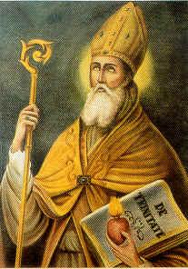
Augustine of Hippo (Latin: Aurelius Augustinus Hipponensis; 13 November 354 – 28 August 430), also known as Saint Augustine or Saint Austin, was an early Christian theologian whose writings were very influential in the development of Western Christianity and Western philosophy. He was bishop of Hippo Regius (present-day Annaba, Algeria) located in the Roman province of Africa. Writing during the Patristic Era, he is viewed as one of the most important Church Fathers. Among his most important works are City of God and Confessions, which continue to be read widely today.
Augustine was one of the first Christian ancient Latin authors with very clear anthropological vision. He saw the human being as a perfect unity of two substances: soul and body. In his late treatise On Care to Be Had for the Dead, section 5 (420 AD) he exhorted to respect the body on the grounds that it belonged to the very nature of the human person. Augustine's favorite figure to describe body-soul unity is marriage: caro tua, coniunx tua — your body is your wife. Initially, the two elements were in perfect harmony. After the fall of humanity they are now experiencing dramatic combat between one another. They are two categorically different things. The body is a three-dimensional object composed of the four elements, whereas the soul has no spatial dimensions. Soul is a kind of substance, participating in reason, fit for ruling the body. Augustine was not preoccupied, as Plato and Descartes were, with going too much into details in efforts to explain the metaphysics of the soul-body union. It sufficed for him to admit that they are metaphysically distinct: to be a human is to be a composite of soul and body, and the soul is superior to the body. The latter statement is grounded in his hierarchical classification of things into those that merely exist, those that exist and live, and those that exist, live, and have intelligence or reason.
- "Patience is the companion of wisdom."
- "Charity is the root of all good works."
- "Love all men, even your enemies."
- "It was pride that changed angels into devils; it is humility that makes men as angels."
- "Virtue and vice are not the same, even if they undergo the same torment."
- "The violence which assails good men to test them, to cleanse and purify them, effects in the wicked their condemnation, ruin, and annihilation."
- "The good man, though a slave, is free; the wicked, though he reigns, is a slave, and not the slave of a single man, but — what is worse — the slave of as many masters as he has vices."
- "It is no advantage to be near the light if the eyes are closed."
- "If there is something more excellent than the truth, then that is God; if not, then truth itself is God."
- "All those of you who rejoice in peace, now it is time to judge the truth...."

Wisdom:

The Hebrew Origins of the Vulcan Hand Sign of Spock

By Moe | History of the Brotherhood, Meaning of Symbols |
In my last article on hand signs called, “The Illuminati Hand Sign of the Pyramid,” I explained that the hand sign we often see many modern entertainers such as Jay Z and his wife Beyonce make with both hands in the shape of a triangle is actually derived from the Hebrew Kohanim Tribe of Levi who are also known as the Levites.
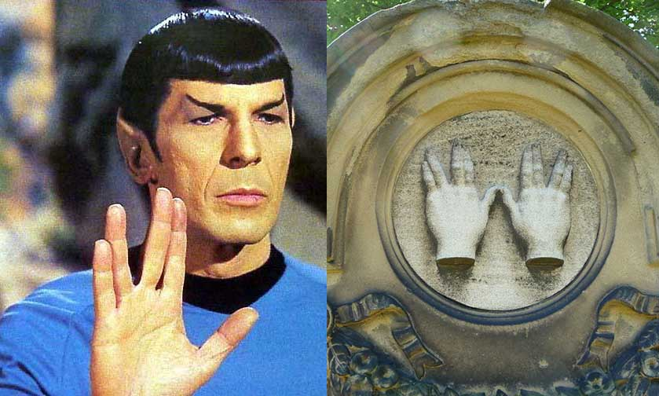
The priests perform what is called the nesiat kapayim or the “Priestly Blessing”, that accompanies the prayer service. The Levites use two hands with the thumbs touching and fingers paired and split, and extended outward for the Shin gesture forming the letter Shin (שׁ), an emblem for Shaddai, “Almighty [God]” which can be seen in the images above and below.

This ancient hand sign of the Levites was made famous in modern times during the 1960’s-70’s when the TV cult classic called StarTrek with one of the lead Jewish actors, Leonard Nimoy who played the pointed ear half human and half Vulcan named Spock.
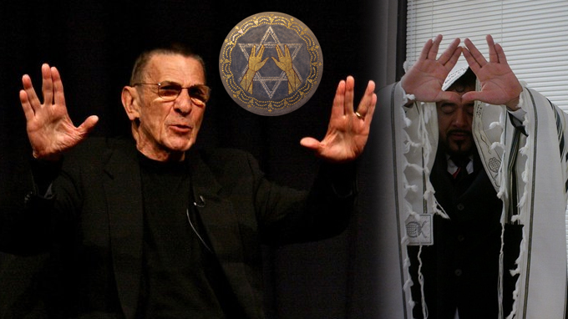
This mixed breed Vulcan character is interesting given the fact that in the Hebrew Torah and Book of Enoch we learn about a mysterious group of half-breed humans who are sometimes called the Sons of God, and the Nephilim who had mated with the daughters of men. Spock was also from an alien type father who was a Vulcan and his mother was human.

It was the character of Spock introduced the Hebrew sign for the letter Shin (שׁ), an emblem for Shaddai, “Almighty [God]” as the salutary Vulcan hand signal used for greeting others. In addition, Spock was a scientist who worked with healers and the Kohanim Levites were known in ancient times not only as priests, but as the world’s first scientists and doctors who were healers that travelled the world working and healing at various King’s courts around the world. One of the most famous Kohanim Levites is actually the Father of Medicine, Hippocrates.

Also, let us not forget that the Star Trek theme with Spock was based on the people known as the Vulcans losing their homeland in the 2009 movie and forced to wander in space on USS Enterprise much like the Jews were expelled from their ancient homeland and forced to wander to this very day.

I thought that it was pretty cool that later in his life, Nimoy had given several interviews where he explained his Jewish heritage and how the Hebrew origins of the Vulcan hand signal. He first saw what became the famous Vulcan salute, “live long and prosper,” as a child at an Orthodox Jewish synagogue service in Boston. In a 2013 interview, he had said, “This is the shape of the letter shin,” making the famous V gesture.

The Hebrew letter shin, he noted, is the first letter in several Hebrew words, including Shaddai (a name for God), Shalom (the word for hello, goodbye and peace) and Shekhinah, which he defined as the feminine aspect of God who supposedly was created to live among humans.
The Shekhinah, Nimoy has said, was also the name of the prayer he participated in as a boy that inspired the salute. The prayer, meant to bless the congregation, is named after the feminine aspect of God, Nimoy explained in a 2012 post on the Star Trek site.

He was born in Boston, but his parents came from a village in what is now Ukraine, where his father worked as a barber. “My first language was English,” Nimoy told the interviewer in Yiddish, “but I needed to speak Yiddish with my grandparents.”

Word Scrambler:
July Scrambled word is: OECUARNLGATT
June’s Word was: EALEIMTACLMBYL – Emblematically. Where is this word used in the ritual? 1st degree charge, last paragraph-- solved by Pat

July Masonic History:
July 1 | On this date in 1964, Roscoe Pound, a Masonic scholar and the Dean of Harvard Law School, died.  On this date in 1989, the Grand Lodge of Hawaii was organized
July 2 | President James A. Garfield was shot at the train station in Washington, DC
July 4 | On this date in 1781, Robert Burns received his 1st degree.
July 6 | On this date (or July 5) in 1830, the Grand Lodge of Florida was formed
July 8 | On this date in 1789, the Grand Lodge of Connecticut was formed
July 19 | On this date in 1901, Sir Winston Churchill received his 2nd degree in Studholme Lodge #1591, London.
July 21 | On this date in 1758, the Grand Lodge of Scotland granted a charter to Fredericksburg Lodge in Virginia, the lodge that had conferred the Masonic degrees on George Washington in 1752 and 1753.  On this date in 1875, the Grand Lodge of South Dakota was formed.

Birthdays DOB Masonic
 | Joseph | Henry | Santisteban |  |  |  | 7/15/1946 |  | 8/4/2001
 | Loys | Marvin | Tipping |  | Jr |  | 7/18/1940 |  | 3/16/1970
 | Sidney | John | Leluan |  | III |  | 7/5/1959 |  | 9/21/1981
 | James | Bowling | Miller |  |  |  | 7/1/1940 |  | 2/24/1992
 | Don | Macray | Bunch |  |  |  | 7/25/1971 |  | 8/6/2007
 | Frank | Albert | Barnes |  | Sr |  | 7/3/1928 |  | 2/3/1950
 | George | John | Chardukian |  |  |  | 7/2/1953 |  | 4/28/2014
 | Wayne | Alvin | Bast |  |  |  | 7/12/1953 |  | 11/24/1997
Mark your Calendars!

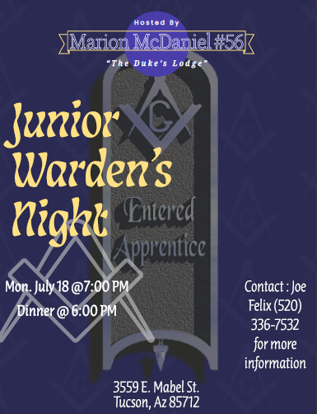 | 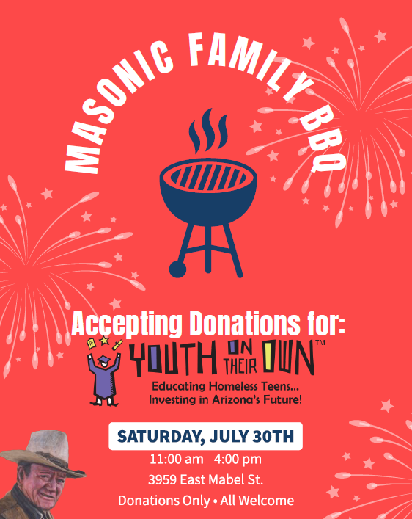
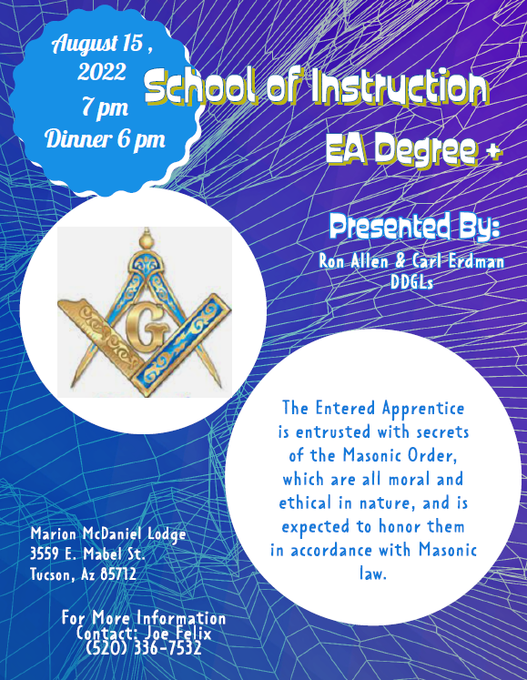

Fraternally,
Joseph Felix, WM Matt Hedrick, PM JW
(520) 336-7532 (808) 266-0408
joseph.felix.m.m@gmail.com copen73@gmail.com

Josh Sticht, SW Henry Spomer, PM Editor
(520) 977-8607 (520) 661-2021
joshsticht@gmail.com 1papapie@comcast.net

