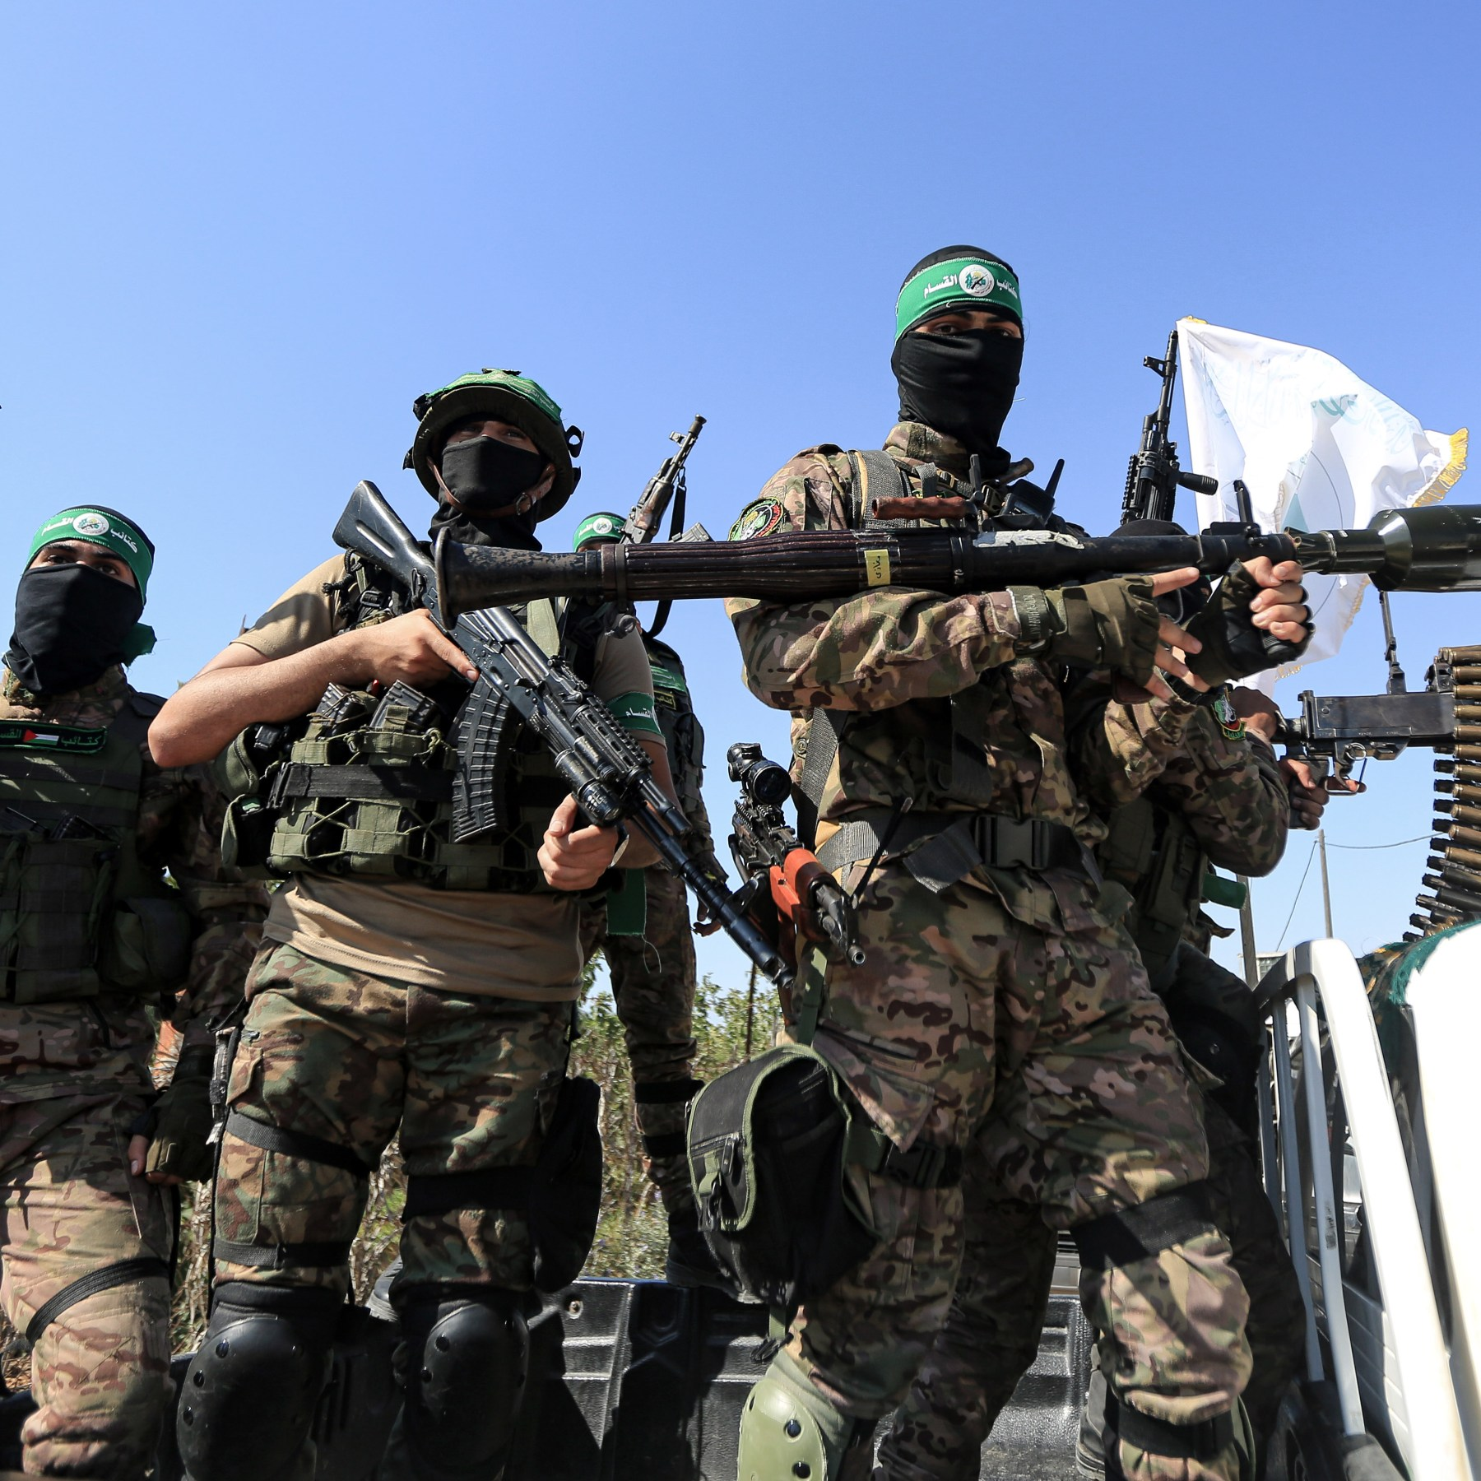
DISEC
The Question of Terrorist training facilities in the middle east
Committee: DISEC
Topic: The Question of Terrorist Training Facilities in the Middle East
Chair: Hamish Donaldson-Sinclair & Amber Bravo-Faraday

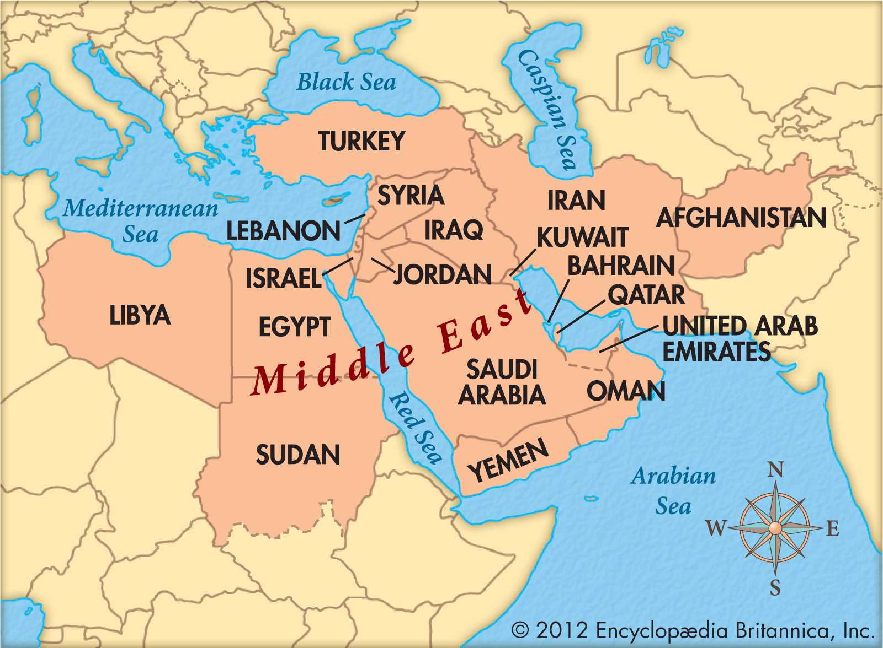
Currently, there are 58 UN recognized terror organisations. In 2019, 20,000 people were killed by terrorist attacks globally.

Between Iraq and Syria, current UN information suggests ISIS alone has 10,000 fighters. The number of terror attacks globally is unfortunately on the rise, with 1,570 attacks in 2000, compared with 16,745 in 2014. There is a rapid growth in the size of terror organizations and their capabilities, all of which comes down to the fact that they have more troops. This therefore requires these organisations to set up training facilities. It is these targets many believe will cut the head off the snake, as while terror leaders may be well hidden, taking out the ability to train troops will leave the terror organisations unable to fight, allowing governments struggling to fight back, or who have lost huge swathes of territory to terrorists, such as Iraq, to remove the last of these forces from their regions, and once that is done, these governments can stabilise their nations, improving quality of life and infrastructure, as well as leaving them better prepared should they have to face further conflict.

In the past decade, several air strikes against terrorist training facilities in the middle east have been carried out, namely by British and American forces, however it has not been enough to destroy the threat in its entirety.

Definition of Key Terms

Terrorism – Criminal acts, including against civilians, committed with intent to cause death or serious bodily injury, or taking of hostages, with the purpose to provoke a state of terror within the general public or in a group of persons or particular persons, intimidate a population or compel a government or an international organization do or to abstain from doing any act.
ISIS – Islamic State of Iraq and Syria

Major Countries and Organizations Involved
Iraq
Syria
ISIS
Al Qaeda
The Taliban
The United States of America
The United Kingdom

