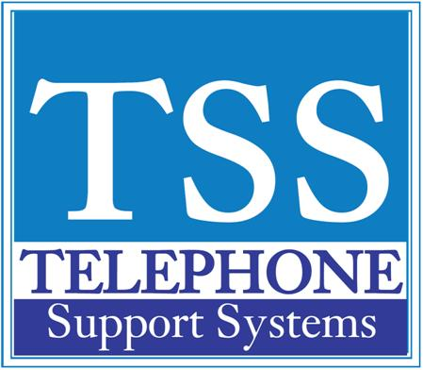

|  |  |  |
| --- | --- | --- |
|  |  |  |

|  |  |  |  |  |
| --- | --- | --- | --- | --- |
| |  |  |  | | --- | --- | --- | | **Changing System Greeting on a Stratagy Voicemail System (CTX/CIX Systems Only)** |  |  |  |  | | --- | | **1. From your desk dial voice mail pilot extension - usually 500 2. When prompted for a security code do not press anything 3. When the auto attendant begins to play press the * key 4. When prompted for a User ID press 990 5. When prompted for a Security Code enter the Security Code for the greeting box - if you do not know this code contact your system administrator or a Telephone Support Systems representative 6. Select option 3 - Manage your Mailbox 7. Select option 1 - Record Greeting - this is the lead in greeting where you would say something like "Thank you for calling ABC Company" 8. Select option 1 - Greeting Number 1 (you have up to 8 greetings you can record) 9. Select option 2 - Re-Record Greeting 10. Record your greeting 11. Press # after speaking 12. Follow options (listen - 1, re-record - 2, save - 9) -  13. Make sure you set the greeting you recorded to be the current active greeting 14. When completed with recording press 9 three times and Hang Up 15. Repeat above steps for box 991 - this is the routing greeting where you would say something like "If you know your parties extension you may enter it at any time....."** |   For additional help please call our office at 249-248-0000 (Michigan) or 239-561-0090 (Florida) |