Join a Video Session: Step-By-Step Guide
Technical Support: 888-540-2829, 912-489-1629
Step 1: You will receive an e-mail invitation from SecureVideo Support that includes:
- Time and date of your session
- Two RSVP options: Yes or No
- Join Session link
How the email will look:
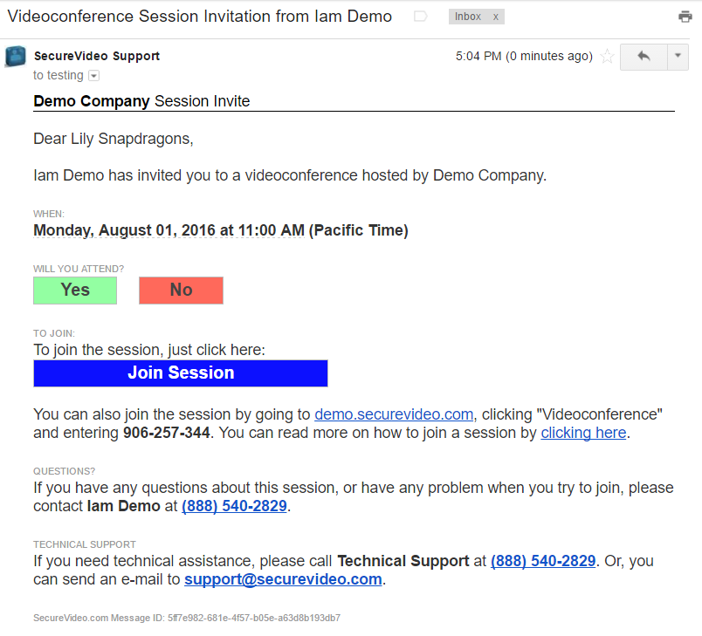

Step 2:
- Click Yes or No to RSVP and let your host know you are coming!

Step 3:
- A few Minutes before your session, click Join Session button in the e-mail as below:

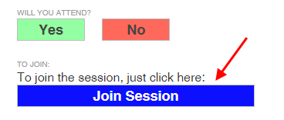

Step 4 and 5:
- If this is the first time you are joining a session: “Install Zoom” at the bottom left corner of your screen.Once Zoom is installed, click "Enter Waiting Room.”

Steps 4 & 5 Will Look Like This: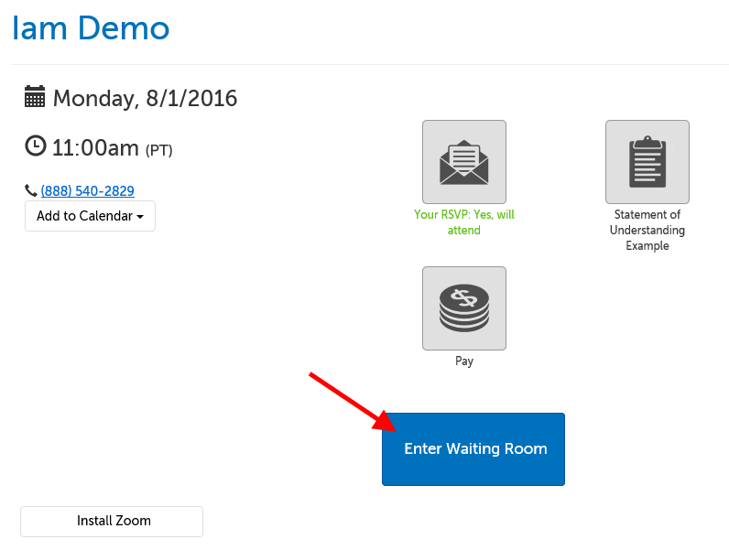

Step 6:
When Zoom has successfully launched, you'll see either your own video image, or the message below, depending on your host's settings. In either case, please wait for your host to arrive.

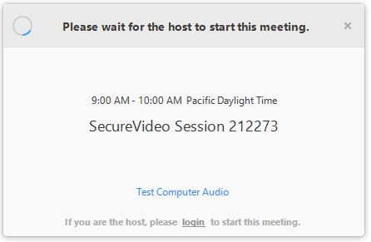

Step 7:

Once connected, you'll be prompted to choose how to enable your audio. Click "Join Audio by Computer" to use your computer's microphone and speakers.
- TIP: Check the box next to "Automatically join audio by computer when joining a meeting" before clicking "Join Audio by Computer" to avoid having to confirm this every time.
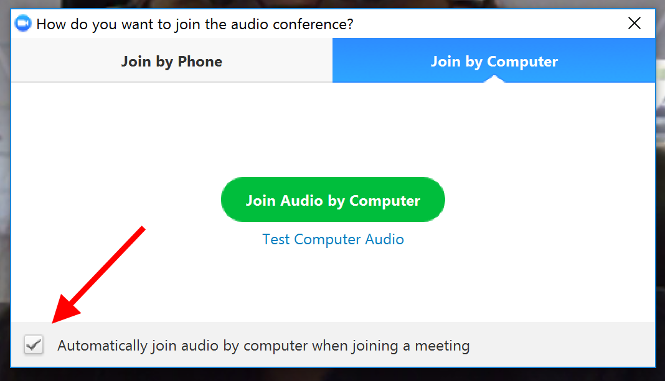

Step 8:
Your camera is off by default, but you can turn it on by clicking anywhere on the video app window and then clicking the "Start Video" button in the lower left hand corner.
