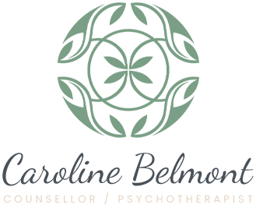

CAROLINE BELMONT: COUNSELLOR / PSYCHOTHERAPIST

UNIT 1D, 9-11 BLAXLAND RD RHODES NSW 2138. MOB: 0403 152 514

CLIENT INTAKE FORM
*Please fill in the form below and sign the client agreement. Then save a copy for yourself and email a copy to me at belmontcaroline@gmail.com
Instructions for filling the form: Just start typing in the grey boxes. Press Tab to move onto the next box.
- CLIENT DETAILS
Client’s Full Name:
Date of Birth:
Address: Street no. and name:
Suburb:
Postcode:
Email:
Mobile no.

- PRESENTING PROBLEM
Briefly describe the main issue that is your concern.

- GENERAL HEALTH
Briefly describe your general health.

- MENTAL HEALTH HISTORY / MEDICATIONS
- Are you currently taking prescribed medications for your mental health?
- List medications.
c) Have you been hospitalised for a mental health condition in the past?
d) If so, when?
e) What was the condition?

Important information for clients.

Counselling can proceed under the following conditions;

- Confidentiality is extremely important and I abide by the regulations of Psychotherapist and Counselling Federation of Australia (PACFA) of which I am a registered clinical member. Federal privacy laws are relevant to counselling. Information that you provide to me, or my notes, cannot be passed on to anyone without your permission except under the following circumstances a) If you are in danger of seriously harming yourself or another person, b) if you tell me about a child who is in danger of being seriously harmed or c) if the Court subpoenas my notes in a legal case. I will not be recording any counselling sessions and for the sessions to proceed, I ask that you agree that you will not record any session or part thereof, and that anyone else will not be present in the room or will not record any session remotely.

- I will be taking notes during the session which will be stored confidentially in a locked filing cabinet in accordance with PACFA regulations.

- The fee for individual counselling is $120 for face to face and $150 for couples, payable at the end of the session.
Concessions can apply for low incomes clients. Cancellations for sessions should be given 24hrs ahead of the scheduled time. A cancellation fee of 50% of the fee will apply except in unavoidable circumstances.

4. A counselling/psychotherapy session is 50mins.

5. Payment is to be made by eftpos at the end of the session.

Bank details.
Westpac account: Caroline Belmont BSB: 732 249 Acc:510931

I, ______________________________________________ agree to the conditions listed above.
(type in your full name)

Date: ____________________________________________

Please save a copy of this completed form and then also email it to belmontcaroline@gmail.com before your first counselling appointment.

Looking forward to meeting you,
Caroline Belmont.
Masters of Counselling and Psychotherapy,
Clinical Member of PACFA

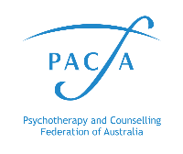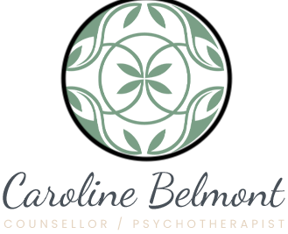
Reg. No. 22902

