Spay Today Feral Policy

A feral cat/community cat is unsocialized and tends to be fearful of people and keep their distance. They tend to live in groups called colonies. Sometimes stray or lost cats will join these colonies for a source of food. They tend to be the more friendly ones.

A feral cat brought to Spay Today needs to be brought in a trap. We are unable to accept a feral cat in a carrier (soft or hard) or a dog crate. This is for both the safety of the cat and the staff. If a cat is brought in a carrier, it will be the same price as an owned cat, 100.00. All cats in traps will get an ear-tip.
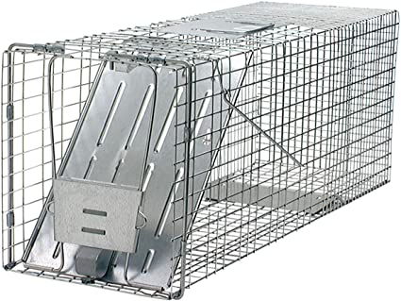
* At this time we do not have traps to lend out.

To schedule an appointment please email spaytoday6@gmail.com OR text 252-651-1946

Basic Information:

1) Our feral package costs 50.00 and this includes the surgery, rabies, and ear tip.

- The ear-tip is mandatory by state law. This is to help identify that the cat has already been altered and helps prevent retrapping. This process involves surgically removing a small part of the ear.

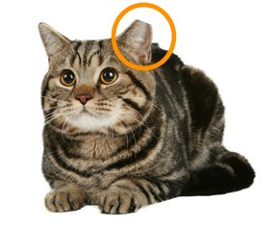
2) Our clinic requires appointments for all surgeries, including ferals. We understand that capturing a cat isn’t always a guarantee. For that reason, there is no penalty if you’re unable to capture the cat for your appointment.

- It is important to not set a trap unless you have an appointment because we book a month or more out at a time.
- We take ferals by appointment only on Tuesday and Thursday.

Tips for Trapping:
- Leading up to your appointment, use dry food to feed the cats in their usual feeding area. Then once you set the trap, use wet food to tempt them.
- Trap at night.
- Try a method called Trap Training, this works best if your location is secure and the trap can safely be left in place. Tie open the trapdoor with a twist tie, put the trap in the feeding area and every day slowly move the food dish toward the trap, and then in it, and move the dish further back in the trap until the cat becomes comfortable eating in the back of the trap. Do not leave food anywhere else during this process. Ideally do this for a week or more prior to actual trapping.

