How to order Ghost tall Boots
- Wear the socks and pants/breeches that you would typically wear riding. If you wear thicker clothes riding in Winter, wear those. Do not wear any shoes.
- Sit in a chair so that your knee is at a 90° angle and your feet are flat on the floor
- Measure ALL noted places. Take several measurements up and down your calf to be positive you have found the widest spot when measuring the mid-calf.
- Have a friend help you measure from the floor and up to the inside of your knee – as high as you are comfortable having your upper boot edge when you have a bent leg. Note that many people want to measure about 1 cm below where it’s uncomfortable, but also keep in mind that the shaft will “collapse” a little and bunch up just a tad at your ankles, so you may want to measure all the way to where it’s a little uncomfortable. Measure several times.
- Stand up straight with your heel barely touching a wall, and have a friend measure the length and width of your foot. Measure both feet.
  - What is your typical US boot size? Do you know your typical EU boot size or shoe size?
  - Do you like your boots a little roomy or snug?
- Our boots are built on a Vibram sole in EU sizes (whole sizes only), which is true to size and typically gives generous room in the toe-box.
  - Do you need wide or normal width?
  - Do you need a normal or high instep? This is how tight the top of the foot-part of the boot sits over the top of your foot. Note that for leathers, an instep that starts out feeling too snug will eventually stretch to fit your foot better. Synthetics will need to fit right from the start.
- Which sole?
  - Black Vibram Viking with glued-on with moderate tread
  - Vibram sneaker with less tread
  - Vibram Revflex for cushy support for sore feet
  - Cream rubber sole – stitched on, with finer tread
  - Stitched leather – smooth tread
- Liner in lightly cushioned airshell or wool or sheepskin or synthetic sheepskin?
- Model?
  - Stelvio
  - Terra
  - Stelvio with elastic panel

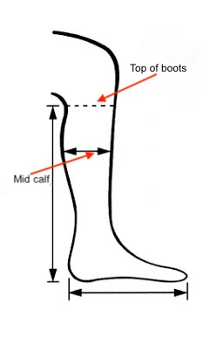
You choose materials and colors on the 3 zones below, and the 4th zone is the little tab at the top of the zipper. Choose any material and color that is available for our saddles https://equinekarma.com/saddle-options

Sizes in centimeters
Size Mid calf: .. cm
Size top of boots: .. cm
Hight of boot: .. cm
Length of foot

High instep?
Wide foot (..cm)
Exceptions?

For lower boots (Sentiere/Ranch) measure the circumference on that height

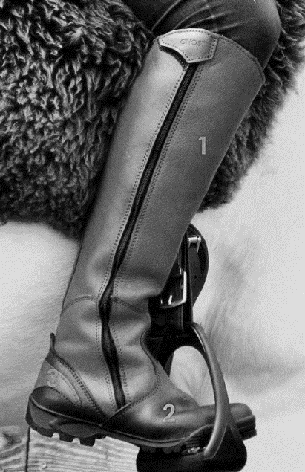
COLOUR & MATERIAL
Zone 1:
Zone 2:
Zone 3:

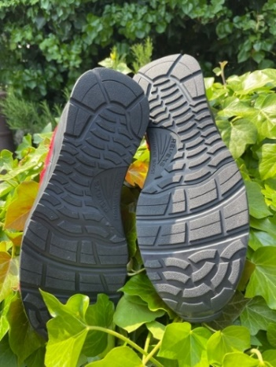
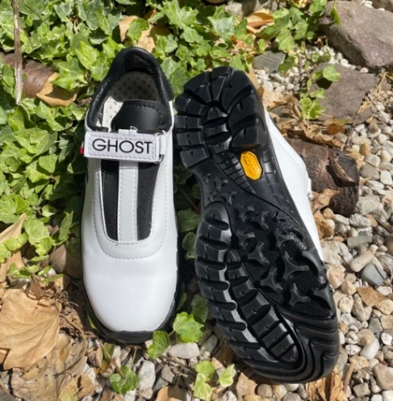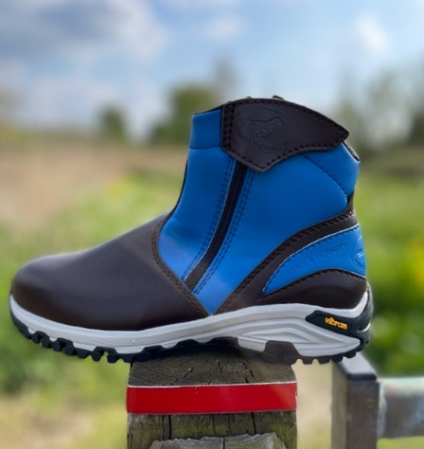 IBRAM VIKING VIBRAM SNEAKER REVEXS (currently only in white!)

