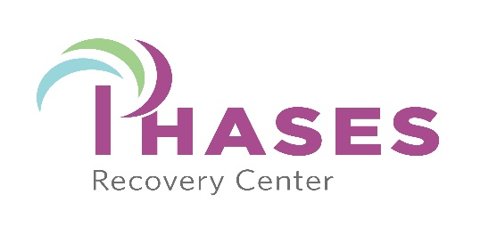
In an effort to have your stay at Phases Recovery a productive one, we would like new admissions to fill out the following questionnaire. Thank you.

- Describe your substance use history including what and how long you have use.
- Have you ever been in the hospital for mental health reasons?
- Have you ever tried to commit suicide?
- Discuss any mental health issues including diagnosis and history.
- List what meds you are taking if any and why.
- Describe your present situation- be as specific as possible.
- Why do you feel you will gain from being a part of Phases Recovery program?
- During past experiences, what has not worked for you and your recovery process?
- Discuss specific changes you want to make in your life.
- What goals do you want to achieve while you are at Phases?
- What are your goals for Recovery?
- What are you willing to do to stay clean?
- How will you contribute to the program and your fellow residents?
- Describe your personal strengths?
- Describe your personal weaknesses?

This information is CONFIDENTIAL. At your request, it will be returned to you at time of discharge. This information helps us determine if you are appropriate for our program and how we may best serve you.

Attn: Devin Lyall
Fax: 336.217.8897
Mailing Address: PO Box 893
North Wilkesboro
NC 28659

