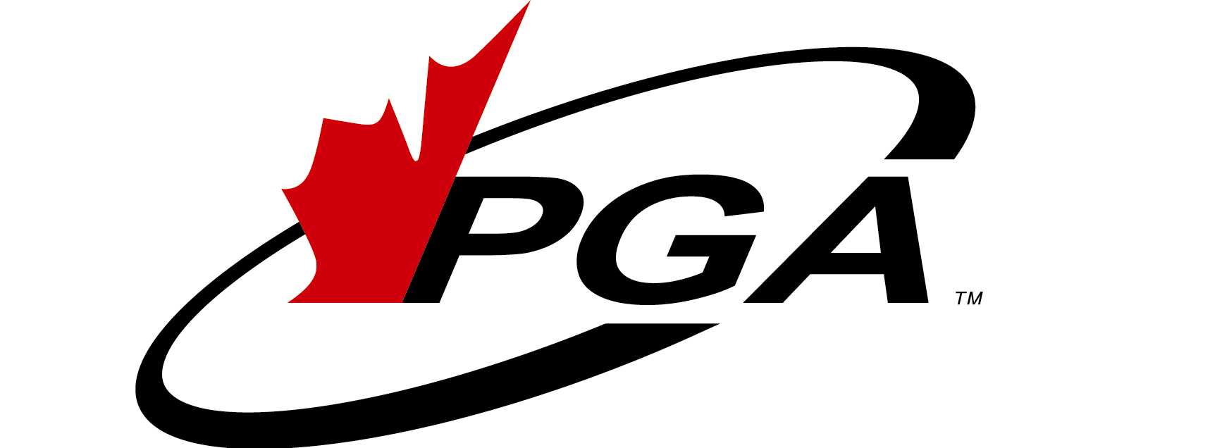

ALL – INCLUSIVE, “NO HANDS IN YOUR POCKETS”
VARADERO, CUBA GOLF VACATION PACKAGE
AVAILABLE EXCLUSIVELY THROUGH GOLFESCAPE TRAVEL INC.
AND JOHN WATSON, C.P.G.A. GOLF PROFESSIONAL
APRIL 10th THROUGH APRIL 17th, 2009

Specifically designed for golfers that want to enjoy an exceptional “All – Inclusive” golf experience at the renowned and beautiful holiday destination in Varadero, Cuba. $2085.00 including taxes

Direct flight from Ottawa - All-Inclusive Meals, Drinks & Golf - Hotel Up-grade – Golf Instruction – Non-Golfer Discount

INCLUDED FEATURES:
- Direct flight from Ottawa to Varadero return on Sunwing Airlines – No seats are being held and all seats will be reserved at the time of booking (Upon Availability)
- Seven Nights Accommodation in a standard room, double occupancy at the 5 Star Melia Las Americas, Adults Only, All-Inclusive Hotel (www.solmeliacuba.com/cuba-hotel/melia-lasamericas)
- All-Inclusive includes all meals, non-alcoholic and alcoholic beverages including House Wines while on the hotel property
- Express Check-in and Welcoming Cocktail Party.
- Up-grade to rooms on the 3rd. and 4th. floors of the hotel ( Upon Availability )
- One dinner at each of the Hotel’s four (4) “a la carte” Restaurants
- Four (4) 18 Hole Rounds of Golf including Shared Motorized Cart – (Shared Cart Value per Golfer in $CAD is approximately $40. Per Cart) with Pre-Booked Tee-Times and Free Club Storage at the Varadero Golf Club (www.varaderogolfclub.com) – Additional Golf is available at no charge but Cart Fees will be payable at the Golf Course ($80. CAD Single - $40. CAD. Shared)
- Golf Instruction and Clinics by John Watson, C.P.G.A. (www.kinggolf.ca) including a 9 Hole on-course lesson per foursome, 4 Clinics and 2 Seminars.
- Airport – Hotel – Airport Transfers
- Solways Holidays and Golfescape Travel Destination Representative Assistance at the Airport, Hotel and Golf Course

TOTAL PRICE: $2052. CDN. (Note: There is a “Departure Tax” of 25 C.U.C. (Convertible Cuban Pesos) – Approximately $40. CAD payable on departure from the airport that is not included in this price because it must be paid by each individual traveller.)

AIRFARE:
$637. - Flight
$206. – Taxes
$810. - Total

All – Inclusive HOTEL & GOLF:
$1242. – Taxes Incl.

Notes: SINGLE Supplement – ADD $ 378. – Taxes Incl. ($2463 total)
NON GOLFERS: Deduct $150. (*Based Upon Shared Cart) ($1935 total)

Travel arrangements for Golfescape Travel Inc. travellers are made through Solways Holidays and Solways Travel, 5650 Yonge Street, Suite 1500, Toronto, Ontario, Canada, M2M 4G3, 416.224.5225. TICO Registration #50012427. www.solwaysholidays.com www.solwaystravel.com

Golfescape Travel Inc.
1639 Edge Hill Place • Ottawa, Ontario, Canada K1V 7V6
Telephone: 613•291•1696 • 613.526.2377 • email: smeabry@golfescape.ca

