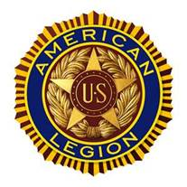
Ray E. Miller Post No. 63
P.O. Box 581
Nicholasville, KY 40340-0581

Thank you for your interest in transferring to Ray E. Miller Post No. 63. Meetings are held at the Senior Citizens Center, 111 Hoover Drive, Nicholasville, on the 3rd Tuesday of each month beginning at 6:00 P.M. and ending at approximately 7:00 P.M.
The information below is needed to complete the transfer:
- If you have not paid your dues for 2018, please enclose a check or money order for $30 made payable to The American Legion.
- A copy of your DD-214 (not the original) or Enlisted Record Brief ERB if on active duty. You may black-out parts of your DD-214 or ERB that are personal and not relevant to the transfer, e.g., social security number.
Name: __________________________________ American Legion Member ID: ____________________
*Transferring from Post Number _________ *Town where current post is located __________________
*Department (State): ________________ *Continuous Years Membership in American Legion: ____
Years of military service: (example 1966-1969) ____________
Branch of Service: ( ) Army ( ) Navy ( ) Marines ( ) Coast Guard
Email Address: ________________________________________________________________________
Telephone Number: (859) 276-3935
Signature: ____________________________________________Date: ___________________________
Questions: Call or email Adjutant Don Thornton at 885-4648 or dathor1@email.uky.edu.
*The information is available on your American Legion Membership Card.

