Dr. ReVivajennz Spa | NeoSkin Rejuvenation  Treatment Care Form

Pre-Treatment
- Notify your practitioner of any medications you have used within the last 6 months.

- Notify your practitioner if you have a history of perioral herpes.

Immediately Before Treatment
- Shave or trim any hair in the area to be treated. This will help achieve the best possible results.

- Remove any make-up and/or lotions and make sure that the skin is dry in the area to be treated.

Post-Treatment
- You may return to your normal daily activities immediately after your treatments.

- Avoid extended sun exposure or tanning for at least 1-week post treatment.

- Any redness that occurs, if any, should disappear within a few hours after the treatment and if you would like, apply an ice pack.

- Use of a broad spectrum UVA/UVB SPF 30 is very important after receiving any laser treatment. Remember to reapply throughout the day.

- To achieve the best results, complete the full treatment schedule at the intervals recommended by your laser practitioner.

Dr. ReVivajennz Med Spa
418 S. Wagner Rd. Ann Arbor, MI 48103
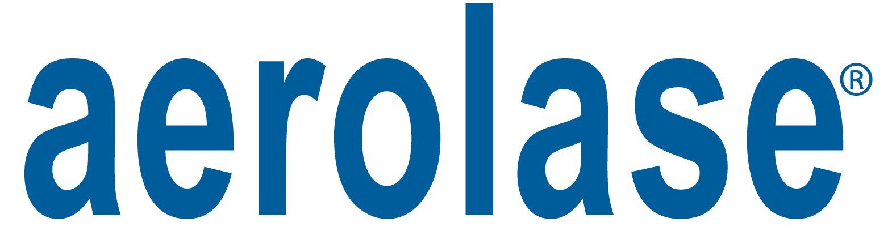
www.revivajennz.com

