Red On Event, Liverpool

For Delegate Distribution Only | Ref: ROELIV  Date: 02 May 2024

RED ON EVENT ADMIN INSTRUCTION ONLY 1 JUN 24.

GENERAL

1. A Red On Event, comprising of fitness, seminars and celebration around health and performance on Sat 1 Jun 24.

AIM

2. To put on an immersive event for fitness professionals and fitness enthusiasts. So whether you are a coach or an athlete preparing for a competition or course, we have packed in arduous fitness activities, elite industry education, coaching mastery, and an epic celebration of health and performance into one unforgettable experience.

LOCATION

3. Crosby Lakeside Adventure Centre L22 1RR

DRESS

4. Delegates.

a. Morning Beach Workout – You will be required to wear suitable clothing and footwear to train on the beach. You must bring a water bottle to stay hydrated. It is recommend you wear long sleeves and pants. You will get wet. Showers are provided after. Black wristbands only (not event lanyards) to be worn throughout. These will be provided on check-in.

b. All day Seminars – Wear comfortable clothing. All seminars are indoors. Notebook, pen, refreshments, and food are all provided throughout the day. Bands and lanyards must be worn throughout the day. These will be provided on check-in.

c. Evening Celebration – Smart casual clothing if you wish to join us in the bar for the evening. Black wristbands only (event lanyards are not required) to be worn throughout the evening. These will be provided on check-in.

5. Directing Staff, Exhibitors, Guest Speakers, Support Staff.

a. Morning Beach Workout – Black T-shirt, Black Shorts, and suitable footwear to train on the beach. You must bring a water bottle to stay hydrated. You will get wet. Showers are provided after. Black wristbands only (not event lanyards) to be worn throughout. These will be provided on check-in.

b. All day Seminars – Wear comfortable, casual clothing. All seminars are indoors. Bands and lanyards must be worn throughout the day. These will be provided on check-in.

c. Evening Celebration – Smart casual clothing if you wish to join us in the bar for the evening. Bands only to be worn throughout. Black wristbands only (event lanyards are not required) to be worn throughout the evening. These will be provided on check-in.

CO-ORDINATING INSTRUCTIONS

6. Timings

- Reception: Check In / Event Lanyard and Wrist Band issue– 0700 - 0745
- Rear Car Park - Fitness Session Start Line - 0755
- Beach – Ready For Anything Session – 0800 - 0845
- Lakeside changing rooms - Refuel, Shower, Coffee – 0845 - 0945
- Welcome Brief – 0955
- Seminars – 1000 – 1715
- Shower and Change – 1715 – 1800
- Celebrate and Network - 1800 -

7. Pre Event Administration

- Registration – Tickets must be purchased online on via eventbrite prior to event.

- Medical care. Prior to the event, all athletes must confirm they have medical clearance by a medical professional to partake, have no known underlying health issues, have read, and understood the admin instruction, kit list and understand the rigours of the beach fitness event.

- Insurance. All personnel are to ensure that health care and personal belongings insurance is held.
8. Event Day Administration

a. Parking. A map of the area can be found in Annex C. Parking on site is pay and display. Ensure you parking within the bay markings and display your ticket inside your windscreen or use the app to pay for you parking. Over 4 and up to 24 hours parking is £3.80.

b. Delegate Arrival. Delegates must be checked in by 0745. The Check in table will be at the reception of the venue. Delegates will be met by members of Support Staff. We will be stepping off for the beach fitness event no later than (NLT) 0800.

d. Refreshments. Refreshments, including, tea, coffee, and snacks are provided all day. Lunch is also provided during the ‘Lunch and Network’ section between 1200-1315.

- Dispersal. The seminars will finish at 1715. Those who wish to join us for the evening ‘Celebrate and Network’ section, will be welcome from 1800. Dispersal from the ‘Celebrate and Network’ section will be around 0000, during last orders.

- Discipline. All delegates, exhibitors, guest speakers and support staff are reminded that they are directly representing themselves, their respected organisation and the Red On Group. Any person found to be in breach of this will be removed from the event and asked to leave the area immediately.

- Alcohol. It is strongly recommended alcohol is not consumed prior and during the beach fitness session in order to reduce instances of injury, illness, and indiscipline. The effects of alcohol are well known, in addition to possible indiscipline they include, dehydration, nausea, vomiting, poor coordination and impaired thinking. When combined with an arduous physical event, effects can be exacerbated making an individual more susceptible to heat or cold injury, for this reason it is incumbent on all pers to restrict all consumption of alcohol. During the seminars and evening, consuming alcohol is at the discretion of the person.

- Risk assessment. A full comprehensive risk assessment will be conducted prior to the event.

POLICY

9. Refunds and Transfer Policy

- Refunds. Refunds are not accepted but transfer of tickets are.
- Transfer Policy. Attendees are allowed to transfer their registration.

ANNEXES:

A. Event Breakdown (Morning)
B. Event Breakdown (Afternoon)
C. Map
D. Guest Speakers

SUMMARY

10. Red On is THE immersive event for fitness professionals and fitness enthusiasts. So whether you are a coach or an athlete preparing for a competition or course, we have packed in arduous fitness activities, elite industry education, coaching mastery, and an epic celebration of health and performance into one unforgettable experience. Join us at the Red On Event where industry leading experts deliver a range of educational seminars on performance in a unique and exciting format you won't find anywhere else in 2024. Effective administration and organisation prior to the event will ensure a safe and enjoyable event. Any questions relating to this event should be directed to the undersigned in the first instance.

M Chadwick

M Chadwick
CEO Red On Group
Mike@redon.group

Annex A to
ROELIV
Event Breakdown (Morning)

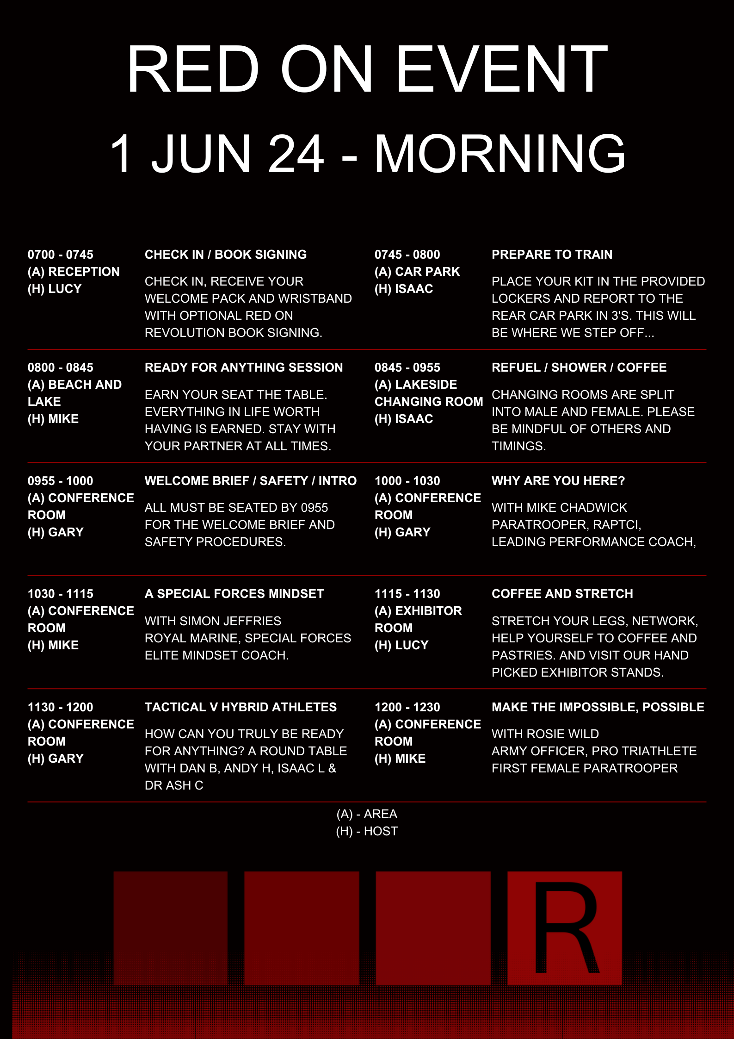
Annex B to
ROELIV
Event Breakdown (Afternoon)

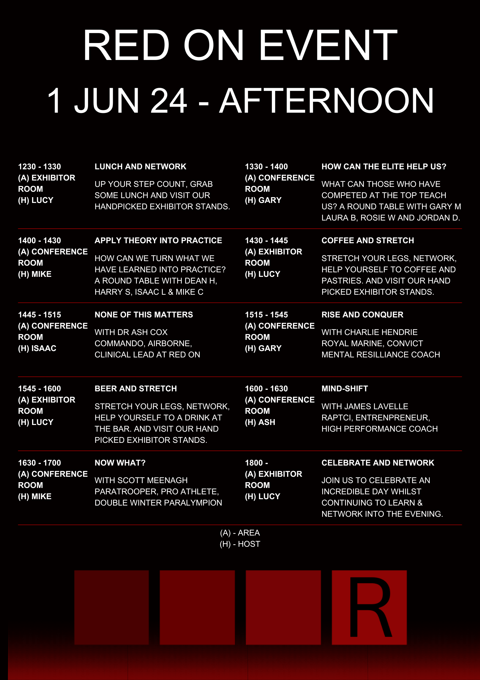
Annex C to
ROELIV
MAP
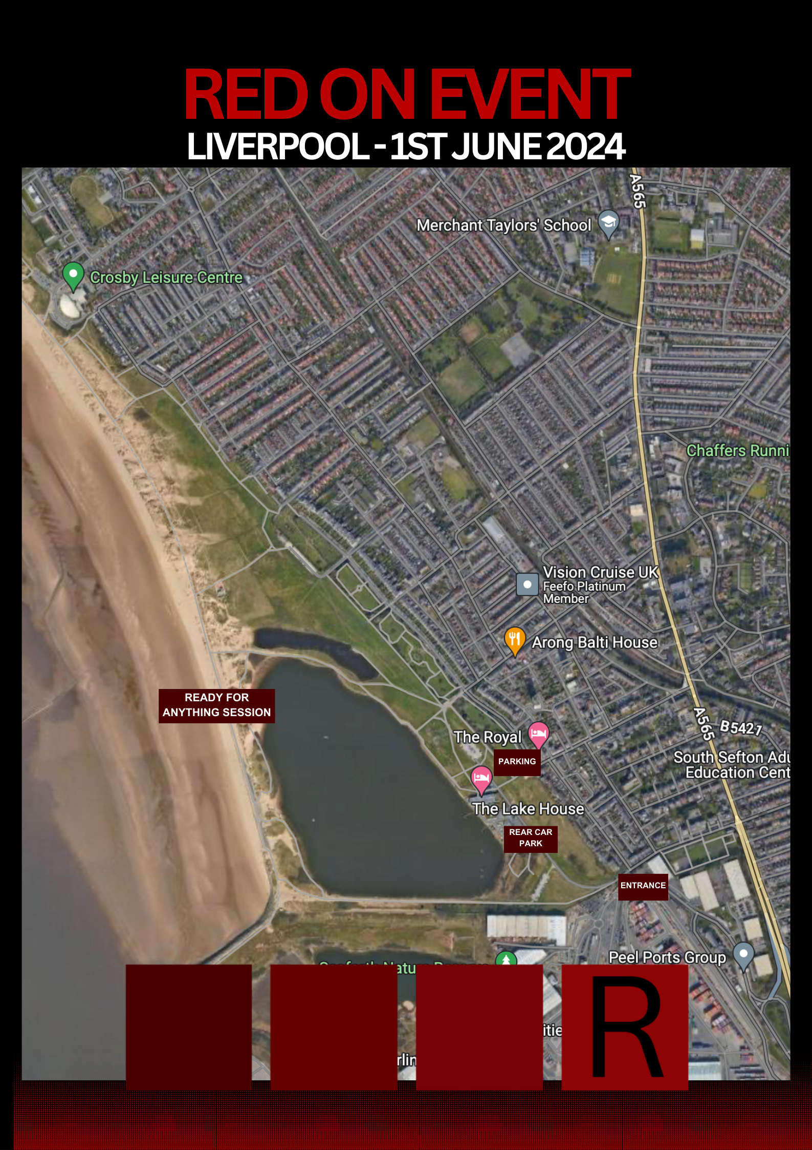
Annex D to
ROELIV
GUEST SPEAKERS
