Revised May 24

Sgoil-àraich Lacasdail

Handbook for parents and carers

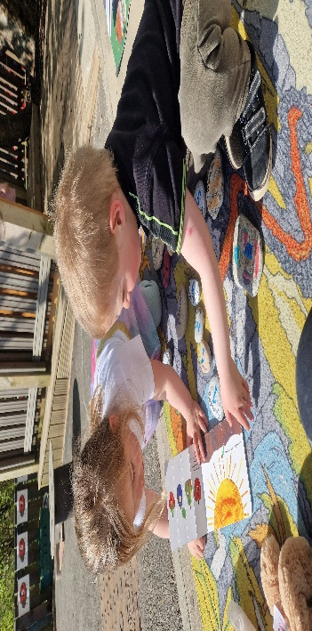

Welcome to Sgoil Araich Lacasdail.
I hope that your child’s time at the setting is very happy and look forward to getting to know you and your child. We understand that starting nursery is a whole new experience. We make every effort to make Sgoil Araich Lacasdail a warm and welcoming environment. This handbook will give you an idea of what goes on at Sgoil Araich Lacasdail as well as providing information which you may need during the year.

The staff and I are always available and willing to answer any questions or help with any problems you may have. As parents, you play a big part in the life of our setting and we encourage your involvement and invite you to engage with us as often as possible. I hope your child will enjoy their time with us as they grow, learn and progress every day

Gillian Macaulay Nursery Manager.

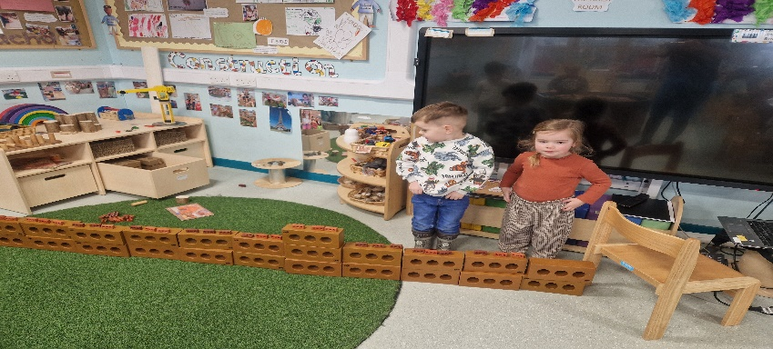

AR LÈIRSINN/OUR VISION
As valued individuals, we belong to a respectful, safe and caring community where together we grow, are happy and learn fun new skills with my friends through play, trips and active learning.

AR AMASAN/OUR AIMS

For parents and families to be engaged in the life of the Sgoil Araich.
To return to adventures in our local woodlands and beaches. Explore our local landmarks and people who help us in our community.

AR LUACHAN/OUR VALUES

For children to feel safe, valued and included in all aspects of life in the Sgoil Araich.
For practitioners to develop a strong home link with children’s families, with good communication at the heart of this.
To promote and celebrate the Gaelic language and culture throughout the setting by learning through play.

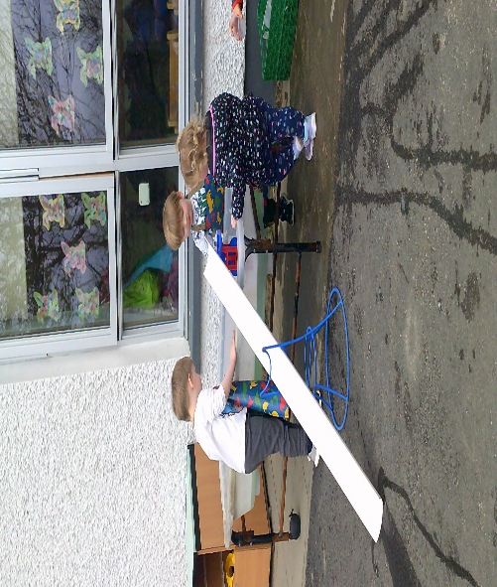

Ar Uairean/ELCC Opening Hours

The Sgoil Àraich operates the following timetable:

Diluain/Monday 8.30am – 5.30pm
Dimairt/Tuesday 8.30am – 5.30pm
Diciadain/Wednesday 8.30am – 5.30pm
Diardaoin/Thursday 8.30am – 5.30pm
Dihaoine/Friday 8.30am – 5.30pm

Luchd-Obrach/ELCC Staff

Head Teacher – Mairi Macleod Nursery Manager – Gillian Macaulay
Gaelic Learners Playroom
PlayLeader – Ancris Morrison Nursery Keyworker – Katie Marzella
Nursery Keyworker – Fiona Macdonald Nursery Keyworker – Donna Cay

Gaelic Playroom
PlayLeader – Elaine Stewart
Nursery Keyworker – Jessica Maclennan Nursery Keyworker – Anne Murray Nursery Keyworker – Donna Macpahil Modern Apprentice – Shannon Maclean

All practitioners are registered with the Scottish Social Services Council and have enhanced disclosure checks.

Contact Details - The telephone number for the Sgoil Àraich is 01851702171
Admission and Enrolment

The nursery aims to ensure that the admission of children is fair and equitable and responsive to the needs of children, their parents and carers. Intakes of children are done throughout the year when space becomes available.

The nursery is open to children aged 2 – 5 years and is registered with the Care Inspectorate to provide a care service to a maximum of children. Children aged 2 years can be enrolled at the group if they meet the requirement for statutory provision or if there is sufficient space. If demand for places outweighs supply priority will be given to children eligible for an early learning and childcare funded place. Children aged 2 years who are not eligible for a statutory place will only be able to attend as long as a space is available.

Contracts, Consent forms & Care Plans
A registration form, consent form and contract will be issued to parents on application for a place at the nursery. Parents will then also be issued with a Care Plan which should be completed alongside a member of staff from the nursery. It is essential that all forms are completed by parent/guardian prior to the child attending the setting.

Enrolment and Eligibility for Early Learning and Childcare
Early Learning and Childcare enrolment takes place in January/February on a date notified to parents by local press advertisement. Parents should be encouraged to enrol at this time for a place in the nursery during the coming year. Children who enrol in the nursery will be invited to spend an induction session in the nursery to experience a little of the nursery atmosphere and to meet the nursery staff.

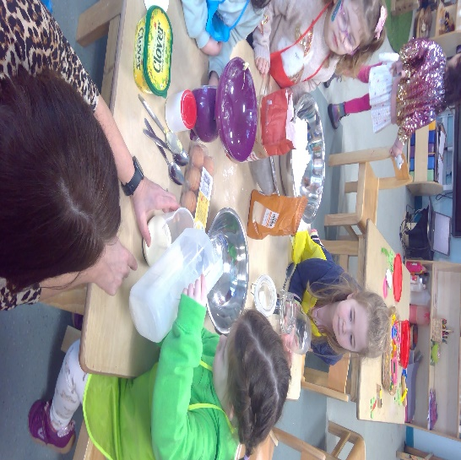
Criteria: |  | Eligible From:
Where a child's 3rd birthday  falls on or between these dates: | 1st March - 31st  August | August (Autumn Term) of  that year
 | 1st September - 31st  December | January (Spring Term)  following their birthday
 | 1st January - last day  February | April (Summer Term)  following their birthday
Or where a 2 year old child's parent(s)/carer(s) are receiving out of work benefits or certain tax credits (see Appendix 1for full list) |  | The term following the child's 2nd birthday (for those already on benefits/tax credits) or the term following the date when the parent(s) become eligible for out of  work benefits/tax credits
Or where a 2 year old child is Looked After, is in a Kinship Care placement, or lives with an appointed guardian (or has been since their 2nd birthday) |  | When arrangements are agreed and recorded as part of the Child's Plan. Please contact Early Years Office for more  information 01851  822655

An advanced booking system operates to enable staff to make well planned provision for all children using the service.
All 4 year olds and eligible 2 and 3 year olds are entitled to 1140 hours per year. High quality is at the heart of our ELC provision, as is providing the flexibility parents need to work, train or study.

Bookings and Cancellations
Priority will be given to children who are eligible for early learning and childcare funding. On enrolment parents will be asked to sign a parent contract and to indicate what days and hours are required. It is important that you read this contract carefully prior to signing as it outlines the conditions attached to your early learning and childcare place.

As detailed above, parents will be expected to pay for the days their child is booked in to the nursery whether they attend or not. This includes absence through sickness and holidays. The nursery

does however have the discretion to reduce fees in the event of a child’s long term sickness. The nursery manager will liaise with parents with regard to this.
Please note: Parents must give a 4 weeks’ notice in writing when leaving the nursery or changing their contract. You may continue to be billed for your child’s place if you fail to do so.
Late fees
If you collect your child over your contracted hours the nursery will charge £15.00 over and above the normal fee.
Holidays
For children on Term-time contracts their holidays will follow CNES schools holidays calendar. No fee will be charged on these days.
For children on all-year contracts, holiday entitlement runs from 1st August – 31st July. For full-time and part-time places, parents are entitled to two weeks holiday leave which can be taken as and when required during the year, provided one month’s notice is given, childcare fees will not be charged.

All year settings are closed for the Christmas/New Year holiday and for all Comhairle public holidays. No fee will be charged for these days.
Childcare Fees
Parents who use any wrap-a-round care will be invoiced monthly in arrears. The preferred method of payment is by Direct Debit, or for CNES employees by payroll – relevant forms are available from the Education and Children’s Services Department, Early Years Office. If you have any queries regarding methods of payment you are asked to contact the Early Years Office (01851 822655). Failure to pay can result in the service no longer being available to your child.

Child tax credits
You may be able to claim help with childcare costs through the Childcare Tax Credits - 0845 300 3900.

Tax free childcare
- You can get up to £500 every 3 months (£2,000 a year) for each of your children to help with the costs of childcare.
- If you get Tax-Free Childcare, the government will pay £2 for every £8 you pay your childcare provider. This is paid via an online childcare account that you set up for your child.
- You can get Tax-Free Childcare at the same time as 30 hours free childcare if you’re eligible for both.

If you’ve already registered, you can sign in to your childcare account.

What you can use Tax-Free Childcare for
You can use it to pay for approved childcare, for example:
- childminders, nurseries and nannies
- after school clubs and play schemes
- home care agencies

Your childcare provider must be signed up to the scheme before you can pay them and benefit from Tax-Free Childcare.
Check with your provider to see if they’re signed up.

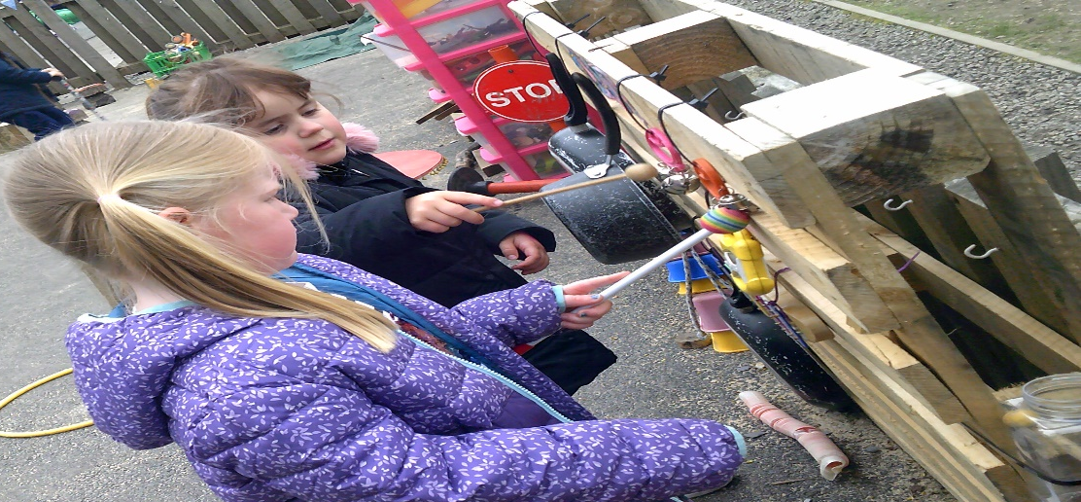
General Information

Snack & Lunch
Staff raise awareness of healthy eating by purchasing healthy options for daily snack and promoting the healthy eating policy during lunchtimes. The children are encouraged to help in the preparation and serving of their snack. There will be no charge for snack for the duration of the child’s time in Early Learning and Childcare settings.
Clothing
Please ensure that your child attends the nursery in clothes and shoes suitable for playing indoors and out (hat, mittens, wellies and spare clothes). We operate a free flow environment where children have access to the outdoors throughout each session. While every effort will be made to protect clothes nursery staff cannot guarantee that children’s clothes will remain clean. Clothing labels are also advisable.
Nappies
For children in nappies, a supply should be provided; this may be in bulk and left in the nursery or brought in every day in the child's bag. Parents are asked to supply nappies, baby wipes, cream (if used) and nappy sacks. Parents will be advised by staff when nappies etc. need replenishing.
Birthdays
For occasional special celebrations, children may have confectionary (sweets/chocolate/cake). For example, you can bring in a shop bought cake for your child’s birthday. Due to food hygiene and allergens home baking is not permitted. If any parent does not wish their child to be given cake or sweets, it is important that they inform nursery staff as soon as their child joins the group.
Photographs
We use photographs to record evidence of participation in activities and progress of child's development. In line with Local Authority policy parents will be requested to give permission in writing allowing their child to be photographed.
Nursery Setting
The nursery has one Gaelic playroom and one English playroom. Both playrooms have direct access into the garden. We share a pollytunnel with the school, where we grow fruit and vegetables.

Security
We are very conscious of security in the nursery. During our sessions our doors are locked. Visitors must ring the bell before being admitted by a member of staff. Before entering the establishment a visitor who is unknown to the member of staff must first show proof of identity and then sign in to the visitor’s book.

Notice Board
We maintain an information notice board for parents. Please check the notice board regularly and read the nursery policies which are also on display for your interest and information.
Signing in System
Parents are asked to sign their child in on arrival at nursery and sign out on departure. Adults, not the children, are required to sign the sheet. Parents must notify nursery staff if/when another adult is to collect their child. To ensure the nursery meets the required adult child ratios, please ensure your child does not arrive at the nursery until the time they are booked in.
Outings
We frequently visit places of interest and attend events in the wider community. At such times we may need more adult supervision. Parents are sometimes invited along to enjoy the learning experience.
Use of Volunteers
The nursery occasionally needs parent volunteers to help within the nursery as well as for outings/trips. Where volunteers are used regularly and are left on their own for short periods of time with the children it is necessary for those volunteers to have a Disclosure check. If you are interested in becoming a volunteer for the nursery, please speak to the play leader. Extra help is always appreciated.
Additional Educational Support Needs
Some children can have short or longer term additional needs and support in the early years could make life easier for the child in school. We welcome any children who might be considered to need any extra support and are more than willing to work alongside any other agencies involved. Such agencies could include, e.g. Speech and Language Therapy, Occupational Therapy or Educational Psychology.
Partnership with Parents
Parents are welcome to come in and discuss their child's progress. Please speak to the Playleader to discuss a mutually convenient time. Parents are the primary educators of their children and have an important role to play in their children's development. Parental contribution is invaluable and greatly appreciated and encouraged at nursery. We welcome support from parents at all times.
Assessment

Nursery staff will assess your child's learning by
- Watching your child play and interact with other
- Listening to your child
- Talking with your child
They will build a record of your child's progress which will include
- Examples of your child's work
- Photographs
- Observations of your child’s learning – developmental overviews

Profiles
Child profiles provide a record of your child’s development during their time at nursery. Children are encouraged to contribute to the content of the profile and children are fully involved in deciding the next steps in their learning. The profiles are on Seesaw. Parents can access their childs profile from home and only they can see it. You will be encouraged to engage with us on this platform by uploading photos, videos or comments and participate in hoe learning we share through this platform.

Developmental Overviews
Developmental overviews highlight where your child is currently at in terms of their development of fine/gross motor, social/interactive skills etc. This record of your child’s learning follows your child from the Nursery to P1. The developmental overviews will be shared with you at a pre-arranged meeting with nursery staff and then forwarded to the receiving school.

Stay and Play sessions

The Sgoil Àraich holds termly Stay and Play Sessions. During these sessions parents/carers are invited to join in activities with their children, view their children’s work and have the opportunity to discuss their children’s progress with all the Sgoil Àraich staff.

You can help your child to learn by playing together at home and;
- Encouraging them to be independent, for example, in getting dressed and washing their hands before meals, and to share and join in with other children, encouraging them to develop healthy habits in diet, exercise and hygiene.
- Reading to them every day, talking about books with them and reading familiar words to them, for example, the labels on their favourite foods.
- Talking with them and answering questions and playing remembering games and guessing games like "I Spy."
- Helping them to match and sort things, for example, putting together forks and knives or cups and saucers, and pairing up socks, sorting out big tins and little tins, putting packets in order of size.
- Encouraging them to count and use numbers in everyday situations and in nursery rhymes.
- Encouraging them to listen to music, songs, stories and rhymes.
- Encouraging them to express their ideas and feelings, for example, using crayons, pens, pencils, paint, music and play.
- Giving them the chance to use their fingers and hands, for example, building with bricks, cutting out with scissors, helping with baking and fastening zips and buttons.

There are many Gaelic books which your child will become familiar with in the nursery which have been made into audio books. Some of these, along with many other resources that you can use to support you child, can be found on the Gaelic4Parents, GoGaelic, Orain na cloinne bige and Learn Gaelic websites.

Abairtean cuideachail/Useful Gàidhlig phrases

Madainn mhath Good Morning Feasgar math Good Afternoon
Tapadh leat/leibh Thank you Is mise……. I am…….
Ciamar a tha thu? How are you?
Tha gu math, tapadh leibh Fine, thank you. Am fàod mi ….? May I….?
De tha thu dol a dhèanamh? What are going to do? De tha thu a ‘dèanamh? What are you doing?
Mòr, beag Big, small Fuar, blath cold, warm
Tha mi …. I am …. Bheil thu deiseil? Are you ready?

Aireamhan gu deich/Numbers 1-10

aon, dha, tri, ceithir, coig, sia, seachd, ochd, naoi, deich
Dathan/Colours

Dubh, geal, dearg, buidhe, gorm/liath, uaine, donn/ru

Curriculum Planning

Learning through play is the main principle within the nursery.

Gaelic early learning and childcare is a very important stage of Gaelic medium education. All children entering Sgoil Àraich Lacasdail will experience the usual activities that children do in a nursery setting through the principles of immersion. Children learn Gàidhlig by being immersed in the language within the playroom and while outdoors. Our nursery staff aim to use all available opportunities to develop the children’s understanding and acquisition of Gaelic through our local context, songs, games, stories and through play. Helpful detailed guidance on total immersion is contained within the Education Scotland Advice on Gaelic Education.
Young children learn very naturally through play and they enjoy learning. In their play they may find out about materials, use and develop language, act out situations, ask questions, look for information in books, make friends, see how their actions affect other people, try out ideas, learn rules or read stories.

Staff plan the learning experiences for the children based on observations and tracking information gathered in the nursery. Parents have the opportunity to contribute to the plans in the parent input section on the planning sheet that is displayed on the notice board outside the nursery room. Parents and children are consulted regularly.

Nursery staff ensure that they make the best use of space to provide play opportunities within the eight curriculum areas indoors and outdoors. Staff ensure that there is a good balance between children’s choice and planned group activities. Nursery staff also encourage all children to become independent and responsible through following daily routines such as assisting at snack. All children also have daily opportunities for active, physical play both indoors and outdoors making use of a variety of equipment e.g. balance bikes, balls etc.

Curriculum for Excellence
The ‘How Good is our Early Learning and Childcare?’ documentation provides the benchmark of quality in the early years’ sector.
The nursery provides a flexible and stimulating environment to engage children in their learning through well planned and challenging play. We believe that children learn best when they have scope for active involvement in a wide range of learning experiences. ’Curriculum for Excellence’ provides statements of the aims of education in Scotland. By providing structure, support and direction to children’s learning, the curriculum should enable all
hildren to become:
c Successful learners
Confident individuals
Responsible citizens
Effective contributors

‘Curriculum for Excellence’ has 8 curricular areas which are all delivered in Gaelic. The following summarises some aspects of learning which will take place within each area.

Language/Literacy
- Listen with enjoyment and respond to stories, songs, rhymes and poems
- Listen and talk to children and adults
- Explore books/texts and understand some of the language, layout
- Develop an awareness of letter names and sounds
- Have fun with language and making stories

Mathematics/Numeracy
- Explore numbers; develop understanding of counting, number processes, order, money, time and measure
- Collect objects, ask questions to gather information, organise and display, share findings with others
- Investigate shapes and objects

• Develop an understanding of the weather
• Make choices and take responsibility in play experiences
Health and Wellbeing
- Develop confidence, resilience, self-awareness and self-worth
- Form positive relationships, take turns and share resources, follow rules
- Take part in physical play and activities, develop body control, use equipment safely
- Develop awareness of healthy eating and healthy lifestyles, fitness, hygiene, safety
Expressive Arts
- Choose and explore ways to create images and objects using a variety of media
- Explore line, shape, form, colour, tone, pattern and texture
- Make music by singing, clapping, playing musical instruments and music technology
- Explore role play and drama
Technologies
- Play with and explore technologies; communication methods, audio/visual, electronic games
- Show care for the environment through recycling methods
- Explore a wide range of resources, materials, software and tools
- Explore ways of presenting ideas
Social Studies
- Explore the importance of special occasions and important people in our lives
- Explore places of interest in local and wider environment and the role of people in it
Sciences
- Develop an understanding of sustainable materials, plants, animals, climate and earth, outer space
- Explore healthy eating and healthy bodies
- Develop an understanding of electricity, sound and ways of communicating
- Develop an awareness and an understanding of the senses
Religious and Moral Education
- Explore Christian beliefs
- Become familiar with religious beliefs all over the world
- Raise an awareness of festivals and celebrations
- Develop beliefs and values

Realising the Ambition
Realising the Ambition is new guidance issued in February 2020 which reflects the original principles and philosophy of Building the Ambition. It aims to support nursery staff in delivering what babies and young children need most and how we can most effectively deliver this in order to give children the best start in life. The nursery will be using this to help further develop key information about the characteristics of child development and what we need to provide for babies and young children as they learn and grow. Staff will be looking again at pedagogy and practice and extend the connections to across the whole of the early level of Curriculum for Excellence (CFE). Staff will retain and expand the focus on the learning environment in terms of interactions, experiences and spaces to raise our expectations of what high quality may look like in different settings.

Policy and Procedures
Policies and Guideline information provides clear advice to staff, students and parents about the procedures and practice at the nursery. Well written policies ensure that all staff and service users are provided with up to date, relevant information about their respective roles and responsibilities. The Manager, in consultation with staff, review and update policies regularly and these are displayed outside the nursery room. Further information is available on line at https://www.cne-siar.gov.uk/schools-and- learning/early-years-services/ the school web site and on the nursery notice board. Paper copies are also available on request. Our complaints policy is detailed below.

Complaints Policy
We believe:
- that children and parents are entitled to expect courtesy and prompt attention to their needs and wishes.
- that most complaints are made constructively and can be sorted out at an early stage.
- that in the best interests of the nursery and parents, concerns should be taken seriously and dealt with fairly and in a way that respects confidentiality.
The Comhairle’s Complaints procedure governs the nursery. This policy is available on line at http://www.cne- siar.gov.uk/complaints.asp, paper copies are also available on request. Complaints will be dealt with speedily, within an agreed time limit. We will keep a register of oral and written concerns. The register will be available to HM Inspectorate of Education, the Local Authority and the Care Inspectorate.

If the issue has not been resolved parents may wish to contact the Care Inspectorate
Contact details as follows. Care Inspectorate
9 James Street
Stornoway Isle of Lewis HS1 2QN
Tel. No: 01851 706157

Useful telephone numbers

Sgoil-àraich Lacasdail 01851702171
Mairi Macleod, Head Teacher 01851702171 Gillian Macaulay, Nursery Manager 01851702171

