PRESS RELEASE
March 22, 2022
Re: From Bad to Disastrous - Hornby and Denman Islands Island ferry service.
We need larger, newer ferries!
The summer line-ups to get to ferry dependent Hornby and Denman Islands are legendary, and about to get worse.
In November, the 21 car Kahloke, the main ferry to Hornby, was downgraded for the amount of vehicle and passenger weight it can carry. Why? Because it is 49 years old and Transport Canada requirements resulted in downgrading the weight it can carry. A new, disastrous development especially as we head into another busy summer season. All predictions are it will be busier than last year.
Even prior to the reduction of capacity for the Kahloke, the ferries to Denman and to Hornby, by BC Ferries own calculations, have the worst performance ratings in the ENTIRE fleet in terms of summer overloads and ferry waits.
Also, census information shows a 19% increase in population on Denman and over 20% on Hornby between 2016 and 2021. More pressure on an already overloaded system.
Denman Island Trustee, David Critchley, notes “Ferry service to our islands has not kept pace with population growth and the huge increases in tourism. The results are extremely long waiting times and dangerous traffic line-ups on our narrow island roads.”
Before the Hornby ferry was reduced in capacity because of deterioration, the summer waits last year were already 5 or 6 sailings long. Trips from Vancouver Island to Hornby were taking up to 6 hours! Ditto on the return journey. With reduced capacity on the Hornby ferry, the situation will be much worse this summer. A Public Relations fiasco when, because of the weight restrictions, the ferry sails with empty deck space, leaving travellers behind sitting in cars in the hot sun.
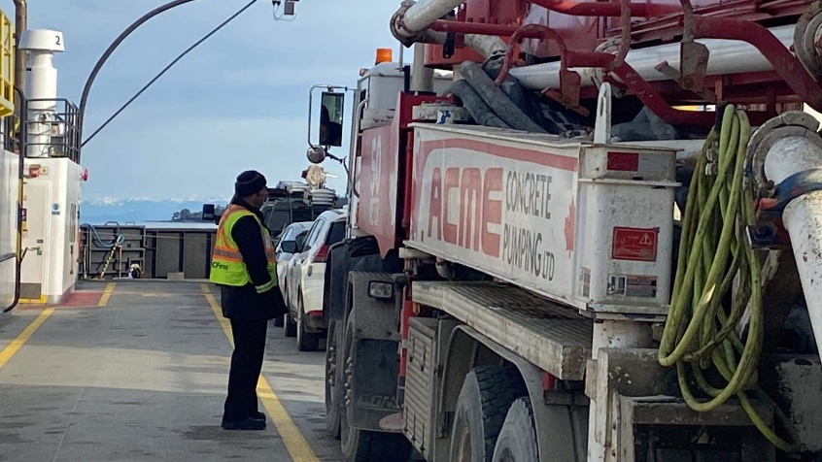
Island Trustee Grant Scott clarifies “Our concerns are not a reflection on the hard-working ferry workers who are members of our communities, and have even more at stake as they live with the nightmare of explaining reduced service levels on every shift they work.”
Pic.: Route 22 ferry crew member explaining why a partially filled ferry departs for Hornby leaving vehicles behind at the Gravelly Bay terminal. Feb/22
BC Ferries management reported to the Hornby/Denman Ferry Advisory Committee, in February, that they will increase capacity on the Hornby and Denman ferries in 2026, in response to the 2021 downgraded carrying capacity of the Hornby Ferry.

Waiting is simply unacceptable.

The Hornby Economic Enhancement rep., Karen Ross, explains “The lack of adequate ferry service impacts every aspect of Island life. This latest capacity reduction will cause further disruptions to access for education, health, food, emergency services, family visits, as well as for people who want to come here for their holidays.”
Tourism is a major economic driver. 40% of Hornby’s land mass is in Parks, the Provincial Government is heavily invested in nature on the Island. In 2021, B.C. Parks spent $11 million to acquire 2 properties to add onto Tribune Bay Provincial Park.
3000 students a year come to the Tribune Bay Outdoor Education Centre, a combined venture of School Districts 69 and 71, and accessible to students of other Districts.
Up to five sailing waits for our guests in the summer, at all 4 terminals serving the Islands is not acceptable and not in keeping with the Super Natural BC image that our Province portrays.
The Province has a vested interest beyond Parks, three currently-underway projects on Hornby are being supported financially by the Provincial Government – the affordable housing project, the new arts centre, and the high-speed fibre optic cable infrastructure. Disastrous, gutted ferry service pushes the cost of all these projects up.
Because of long ferries waiting times, major suppliers of food and construction materials to these islands are raising their delivery rates, raising the cost of living for every resident and visitor. One supplier of construction material has just raised the delivery charge, from Courtenay to Hornby Island, from $125 to $450.
Hornby and Denman Islands NEED ACTION NOW:
- Immediately get Route 22, the Hornby ferry, a newer vessel with serviceable capacity
- Immediately match increasing the ferry capacity on Route 22, with more capacity on Route 21 that provides access to Denman and Hornby from Buckley Bay on Vancouver Island.
Scott summarizes “we need bigger, newer ferries to service Hornby and Denman Islands now. Waiting until 2026 is unacceptable.”

Contacts:
Karen Ross, Hornby Island Community Economic Enhancement Corporation,
E.: karen@hiceec.org P.:250-334-7508
Grant Scott, Island Trust, Hornby Trustee,
E.: gscott@islandstrust.bc.ca P.: 250-218-2323
David Critchley, Island Trust, Denman Trustee,
E.: dcritchley@islandstrust.bc.ca P.: 250-218-3214

