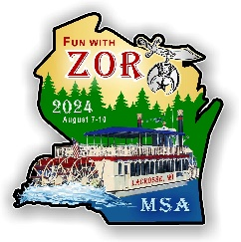
ZOR SHRINERS MSA 2024

January 26, 2024

ATTENTION: POTENTIAL VENDOR
From: Penny Brueggen, Marketplace Chair 2024

I would like to invite you to be a vendor in the Marketplace for Zor Shriners Midwest Shriner Association in August 2024. This event only comes to Wisconsin every 17 years so we are excited to be hosting the event in La Crosse this year.

The Marketplace is open to approximate 800 Association people but is also open to the public. It will be held in the Radisson Hotel Ballroom, in La Crosse. Vendor set-up will take place on Wednesday, August 7 from 12:00-4:00 pm with the vendors selling their wares on Thursday and Friday, August 8 and 9 from 8:00 am to 4:00 pm. Take down will take place on Friday at the close of business at 4:00 pm.

The Radisson Hotel is the headquarters hotel with people coming and going daily. We will be promoting the event throughout all the other hotels hosting Association guests for the three days along with promoting around the La Crosse area. Vendors are encouraged to spread the word as well with patrons they are familiar with.

Please find attached the invite and packet of information for being a potential vendor. We hope you are able to join in the fun and look forward to working with you. Feel free to contact me with any questions and/or concerns.

Penny Brueggen, Chair
Marketplace – 2024
10553 State Hwy 21
Sparta WI 54656
608.487.1205
pennysue_6@hotmail.com

MIDWEST SHRINE ASSOCIATION 2024 MARKETPLACE
August 7-10, 2024
Radisson Hotel Ballroom
200 Harborview Plaza, La Crosse WI 54601

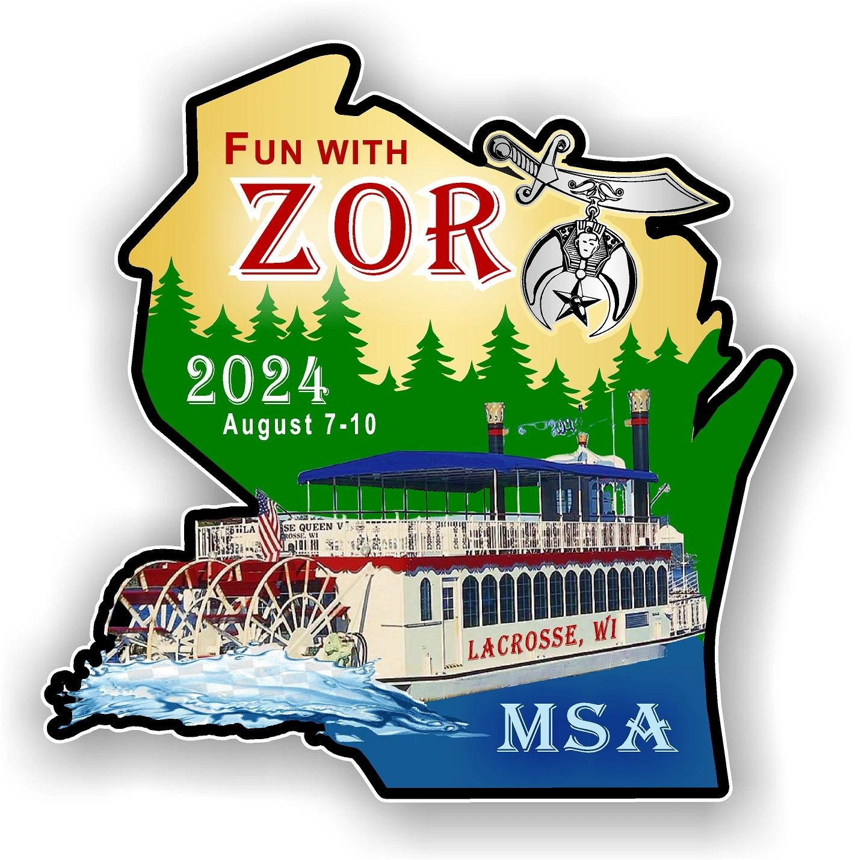

Marketplace Chairperson: Penny Brueggen
10553 State Hwy 21, Sparta WI 54656
608.487.1205
pennysue_6@hotmail.com

Welcome Potential Marketplace Vendors:

Please consider this as an invitation to be a vendor at the 2024 Midwest Shrine Association Marketplace. Vendors are requested to take pride in the display of your merchandise.

LOCATION: The MSA Marketplace will be held at the Radisson Hotel Ballroom in La Crosse, 200 Harborview Plaza, La Crosse WI.

VENDOR SET-UP: Vendor set-up will take place on Wednesday, August 7, from 12:00-4:00 pm in the Radisson Hotel Ballroom on the first floor. All vendors will enter through the front door of the Radisson. Set-up must be completed no later than 4:00 pm.

VENDOR SALES: The Marketplace will open on Thursday, August 8 and Friday, August 9, from 8:00 am and remain open until 4:00 pm both days. Teardown will take place Friday, August 9 after closing at 4:00 pm. The event will be open to the public.

GENERAL INFORMATION
BOOTH & TABLE: Each booth will be a space 8x10, include an Exhibitor Identification Sign and a 6’ clothed table and two chairs. If a vendor needs additional space, it must be prearranged.

ELECTRICAL: Electrical outlets are available but must be requested in advance and will be on a first come first-serve basis. If you require electricity you are expected to supply what you need for extension cord(s) and power strip(s). They will not be provided by MSA.

SPACE ETIQUETTE: All vendors must keep all tables, chairs, merchandise and “check-out” area in their designated space. Vendors shall take pride in the display of their merchandise and sell unique and quality items. Vendors must clean up and appropriately discard ALL trash in their area to trash receptacles including flattened boxes, packing materials, electrical ties, and beverage and food containers. Vendors must communicate with the Marketplace Director or representative only and not with hotel staff.

VENDOR BEHAVIOR: Vendors shall show respect to patrons and other vendors at all times throughout the event. Vendors should engage patrons and have a positive attitude.

PROHIBITED ITEMS: Vendors will not display or sell guns, drugs, CBD items. Any and all other inappropriate items are prohibited. Thank you for your cooperation.

VENDOR PAYMENTS: Vendors must submit payment with the enclosed Vendor Application form. Payments will be made via check. Checks should be made payable to Zor Shriners MSA.

CANCELLATION AND REFUND POLICY: Fees must be included with the Vendor Application and are non-refundable after notification of acceptance, unless the space can be reassigned, in which case, there will be a 50% cancellation fee withheld from your refund. There are NO REFUNDS for cancellation within the ten days prior to the event.

BOOTH SUBLETTING OR SHARING: Subletting or sharing a booth space is NOT allowed without prior written permission from the MSA Marketplace management.

DISCLAIMERS:
*MSA Marketplace cannot guarantee the number of patrons or show attendees
*MSA Marketplace cannot guarantee that the vendors will profit from the events
*MSA Marketplace are not responsible for any lost or stolen items
*MSA Marketplace has no responsibility for any products or services which are sold or promoted, including intellectual property rights.
*MSA Marketplace are not responsible for the cancellation for the event due to circumstances beyond the promoter’s control, including but not limited to natural disaster, severe weather, COVID-19, etc.
*MSA Marketplace reserves the right to photograph and video record people and merchandise at each event, to be used for documentation and promotional purposes. By participating at this event, vendors agree to allow such photography and video recordings, without compensation.

MIDWEST SHRINE ASSOCIATION 2024 MARKETPLACE
VENDOR APPLICATION FORM
August 7-10, 2024
Radisson Hotel Ballroom
200 Harborview Plaza, La Crosse WI 54601

BOOTH FEE: $100.00 per space
This fee includes a space measuring 8x10, include a 6’ table with covering, two chairs and an Exhibitor Identification Sign.

Make checks payable to Zor Shriners MSA 2024. Mail this application form, signed agreement and payment to:

Penny Brueggen, MSA 2024 Marketplace Chair
10553 State Hwy 21
Sparta WI 54656
608.487.1205
pennysue_6@hotmail.com

VENDOR NAME: |  |  | CONTACT NAME:
ADDRESS: |  | CITY: |  | STATE: | ZIP:
PHONE: | EMAIL:
Wisconsin Dept. of Revenue Seller’s Number (Sales & Use Tax):

NAME DESIRED ON BOOTH SIGNAGE: _____________________________________________

CANCELLATION POLICY:
Written cancellation MUST BE RECEIVED by the Marketplace Chair NO LATER THAN May 1, 2024 for a 50% refund. There will be NO REFUND PAYABLE after May 1, 2024. NO EXCEPTIONS.

MIDWEST SHRINE ASSOCIATION 2024 MARKETPLACE
VENDOR AGREEMENT FORM

This Agreement, made this ____ day of ___________, 2024, by and between Zor Shrines and Midwest Shrine Association, herein called “Shrine”, and ___________________________, herein called “Vendor”;

Whereas, Zor Shriners will be holding a Midwest Shrine Session in La Crosse, Wisconsin, on August 7 through August 10, 2024, and will be hosting a Marketplace for various vendors.

Terms and Conditions

RENT:
Vendor shall pay the total fees as outlined in the MSA 2024 Marketplace registration form, in advance of use of the space and accessories to cover the period from Wednesday, August 7 through Saturday, August 10, 2024. Shrine shall provide space and noted amenities appropriate to the registration request and fees paid. Vendor shall use the rented space only for display and sale of vendors’ wares and for no other purposes.
INSURANCE:
Vendors shall provide proper Worker’s Compensation and Employee’s Liability Insurance for any and all vendors’ employees and show proof of same. Vendor shall provide its own Public Liability Insurance and show proof of said coverage.

SALES & USE TAX:
Vendor shall provide MSA Marketplace with a valid Seller’s Permit from the Wisconsin Department of Revenue. Vendor shall collect and pay all required sales and use taxes.

MARKETPLACE ITEMS SHALL BE APPROPRIATE
Vendor agrees the merchandise and services sold in the MSA Marketplace shall be appropriate to an event sponsored by Zor Shrine and the MSA. Vendor agrees that MSA Marketplace may refuse to allow any item or items to be sold or displayed if, in the sole judgment of MSA Marketplace, the item or items are inconsistent with the tenor of the event.

INDEMNIFICATION AND WAIVER:
Vendor shall defend, indemnify and hold Zor Shrine and Radisson Hotel, La Crosse, its employees and representatives harmless from and against any and all claims for theft or loss of merchandise (whether owned by vendor or assigns) and from and against all liability, claims, demands, expenses, fees, fines, penalties, legal proceedings, actions and causes of action arising from Vendors’ conducting its business at the marketplace at the Radisson Hotel, La Crosse, including, but not limited to, vendors’ use, occupancy, management or control of the premises, right to sell and use any intellectual property included in vendors’ merchandise, and vendors’ operations and activities in the Radisson Hotel, La Crosse.

GOVERNING LAW:
This Agreement shall be governed by and enforced in accordance with the laws of the State of Wisconsin, United States of America.

RELATIONSHIP OF PARTIES:
The Parties to this Agreement are independent contractors. Neither party is an agent, representative, or partner of the other party. Neither party shall have any right, power or authority to enter into any agreement for or on behalf of, or incur any obligation or liability of, or to otherwise bind the other party. This Agreement shall not be interpreted or construed to create an association, agency, joint venture or partnership between the parties or to impose any liability attributable to such relationship upon any party.
Notices All notices under this Agreement shall be sent to the names and addresses designated below.

The Parties have executed this Agreement on the day and year first written above.
Shrine, Zor Shrine and Midwest Shrine Association

By ________________________________________________________________ Signed _____________, 2024
Penny Brueggen, Marketplace Chair, Zor Shriners & Midwest Shrine Association

By ________________________________________________________________ Signed_____________, 2024
Vendor Signature

VENDOR NAME PRINTED: ______________________________________________

ADDRESS: _________________________________ CITY: _____________ STATE: ___ ZIP: _______________

EMAIL: _______________________________________________________________________

