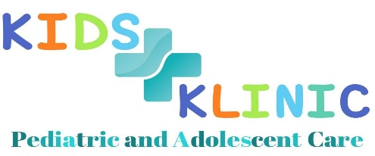 KIDS KLINIC, LLC

Patient Immunization Refusal Form

We at Kids Klinic, LLC are pleased you have chosen us to be the medical home for your child’s health care needs. We are committed to seeing that your child and every child grows up as healthy as possible and reaches their given potential.

We view immunizations as a huge benefit in preventing serious, potentially fatal diseases. History has shown the amazing improvement in the mortality rates and rates of long term disabilities since the advent of vaccines. There are some potential side effects of vaccines, but these are almost all brief and minor, especially when compared to the devastation that these vaccine preventable diseases cause.

You have chosen to not vaccinate your child. We respect your right to choose, but strongly disagree with this choice. The consequences of not vaccinating your child include:
- Contracting the disease the vaccine should prevent (the outcomes of these illnesses may include one or more of the following: pneumonia, illness requiring hospitalization, death, brain damage, cerebral palsy, meningitis, seizures, and deafness, and other very serious outcomes).
- Transmitting the disease to others. The most vulnerable of our population are infants and small children. Their immune systems won’t process certain vaccines until they are over 1 year old. If they are exposed to a child with a vaccine preventable disease, they may well contract the disease and have some of the outcomes listed above. The place where there are more infants and small children in close proximity with other children who may be ill is in a pediatric office.

The following websites provide reliable immunization resources for parents.
- www.cipiimmunize.org
- www.cipiimmunize.org/fam/why.html
- www.paap.org/immunize/
- www.cdc.gov/nip.home-hcp.htm
- www.immunizationinfo.org
- www.vaccine.chop.edu
- www.vaccinesafety.edu
- http://www.immunize.chpa.ca/english/index-e.htm
- www.vaccineinformation.org
- www.aap.org

We will continue to provide care for your child as you educate yourself about the dangers of these preventable diseases. If you still do not feel the need to vaccinate your child after this period of informing yourself as to the safety of vaccines and the devastation that the preventable diseases may cause, we will ask you to consider finding another medical home for your child. We also ask that your child/children do not go into the well room if unvaccinated.

Patient Name: _____________________________ Patient’s Date of Birth: _______/_______/________

Signature of Parent or Legal Guardian: ______________________________

Date: _______/_______/_______

