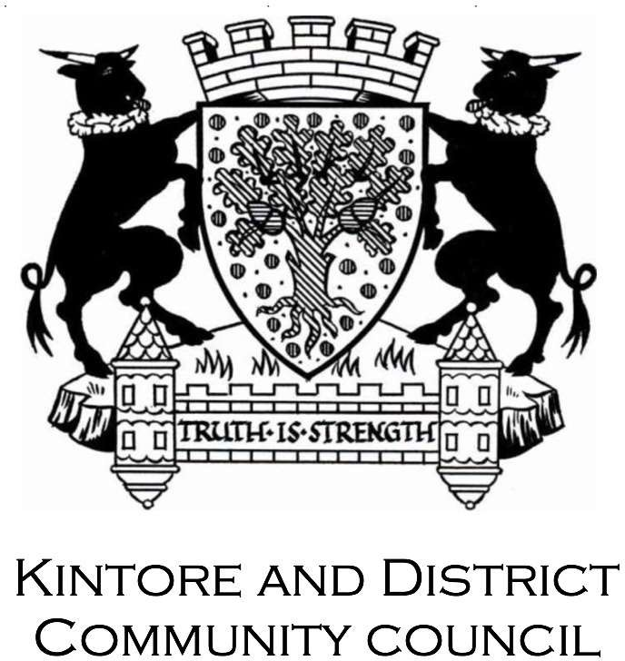
Unapproved Minute of the Kintore and District Community Council
Held 7:00pm on Tuesday 23rd May 2023
Online zoom
- Welcome
The chair welcomed everyone to the meeting.

Attendees and Apologies
Community Councilors Present – Jamie, Ken McEwen, Moira, Alan Milne, Paul Davison, Claire, Donna, Ashleigh, Lesley Monaghan.
Cllrs: Cllr Jim Gifford, Cllr Glen Reid

Apologies: Alan Milne

Declarations of Interest - None

Minutes of the April Meeting
  - Corrections – None
  - 2304 KDCC April Minutes Approval – Jim R / Moira

Matters Arising; Update on Open Actions
None

Police Report & Update
Police Report received, 1 assault and 1 traffic offence.

Planning Matters

  - Town-park Scotia – The chair stated that the plans had been submitted but are not verified on the portal yet.
  - APP/2023/0862 – 14 Oakhill road, Kintore – no comments
  - APP/2023/0504 – Moar Shop, change of use to church – update to say the parking issue had been clarified – 80 spaces available.
  - Leylodge Substation works – No update since last meeting

Community Resilience / AEDs / Energy Crisis

AED – Alan has done the checks. Alan also attended the resilience forum.

Kintore Konnect

First draft in the next two days

Double Checking spreadsheet

Ashleigh pointed out that the content was good

Jim said Kinnons Garage have continued.

Action Kintore
  - The Bothie Update – Youth work is going well. Rachel is away at present.
  - Town House Project – Place based investment progamme, new approach has been accepted after input from Glen. Thanks to all who are involved, in particular Cllr Glen.
  - Bothy Repairs – On going with planning. Delivery of blocks on going, a lot of work to do by action Kintore team. Moira spoke to SSEN about support, liaison person meeting Kenny Thomson to offer labour – contractor starts 4th July.

Community Projects for Kintore

  - Outdoor exercise equipment – Glen says it might be on the reserve list
  - Fireworks – Agreed to book for 4th November, will clarify costs.
  - King’s Coronation – The day was very successful, with donations made to the Bothy.
  - Summer Festival – No update
  - Sundown Cycle – this event is approaching and we should get it on facebook.

Kemnay Academy Parent Council Update

Minutes were sent on by Janine, and passed over by Moira.

We had a discussion on some of the topics – the main one being the “muc up” day which wasn’t received well by parents. Cllr Jim Gifford stated he also raised this with the council during a discussion, and will be following up to put a stop to it.

£10M required for the upgrades to Kemnay Academy will be difficult to find within the Council.

Aberdeenshire Councillors’ Update

Glen Reid –

New bus service – Blackburn to Thainstone – M96, which is the Aberdeen to Inverness service

Town House refurb – Glen is on the board, had looked for application which was down for refusal, scoring was low so he made the case to have this amended.

Fountain Kintore Square – Drew volunteered to clean up, Filpumps then re-comissioned, disinfecting and it seems to work at a slow rate now.

Comfort Partnersip – Crafty Café have signed up to provide public toilets, Square Var also signed up.

B994 Kintore Kemnay road – bad accident, complaints from neighbours to Glen so he is working with roads to reduce speed limit.

New bus stop at Midmill, school buses are poor to kids need more shelter.

Brae Cresent Midmill – complaints about trees being in poor condition, owned by consortium of developers so difficult to get an answer.

Mike Shand has asked about painting the old drinks fountain in the Square.

- Correspondence
  - Moira has been passing everything on, lot’s of funding opportunities and Garioch initiatives.

Treasurer’s Report

Jamie handing over the accounts to Jim Reid, and they will also go for verification before the AGM.

COMMUNITY COUNCIL ACCOUNT

Previous reported balance = £11,961

New balance = £12,500

FLORAL DISPLAY ACCOUNT

No movement.

Balance = £4104.91

AOCB

Paul Davison – Paths, Paul suggests that community councils take ownership of path networks in local areas. Something that can be brought up at the next forum. Paul wants to set up a Kintore Paths Group.

Paul – Asked why the council don’t register enforcement cases, there is 40 but should be more – Glen will investigate

Paul – road past the station has no name, also there needs to be a name plaque for the tree that was planted.

Paul – Issue with gates being closed at Kirkwood Commercial park.

Lesley – Pothole north of the coop, has been reported many times since January – Glen aware and agreed it is frustrating, roads are meant to inspect, due for repair in July.

Moira – Discussed her standing as Chair as well as Secretary. They will have to amend the constitution, and will look for permission from Ann Overton.

Date of next monthly meeting – Tuesday 20th June 2023. AGM also on this date
School, Link Room 3.

