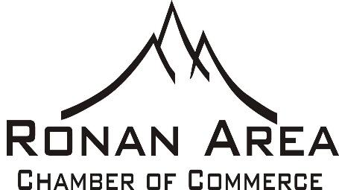
Greetings & Happy New Year!
This message is being sent to all current & potential members of the Ronan Area Chamber of Commerce. It is that time of year again, Membership Renewal! The Chamber has had a year of big changes including a New Manager & revised Membership. The new form includes several membership levels, each providing different benefits for the business, based on what they can afford to contribute.
Your membership dues make a huge difference in the success of the Chamber and its ongoing mission to promote local businesses and help grow the business community of Ronan. Membership dollars are used to run local events, promote the community both in local and state publications, work with tourism groups to promote Ronan, and staff a part-time Manager to promote & develop the Chamber. They also pay for our basic functionality of office supplies, utilities and rent. While we do ask for contributions throughout the year to further enhance events and the community, your membership dollars provide the foundation of the Chamber’s existence.
As most of you know, the Board hired a Manager for the Chamber to help develop and grow the Ronan Business community. Starting in April of 2018, Brian Bergquist became the new Manager, allowing Lana Bartel to focus on bookkeeping for the Chamber. With a Manager, we look forward to making the Chamber more of an active presence in our community.
With this new staffed position, we have increased membership from 88 to over 100 members in only 7 months, and several of our events saw increased participation by vendors, higher attendance by townsfolk and visitors, and generated more revenue. We hope that your business has also seen positive growth during 2018.
Other activities that the Chamber has begun to focus on, or continue to do, as part of the mission to grow Ronan Businesses include:
- Daily Facebook shares of local businesses’ posts to increase visibility & exposure
- Increased followers (audience/viewers) of Facebook from 77 to over 350
- Email events in a “Weekly Happenings” sent each Friday, currently over 260 subscribers
- Provide a Monthly Newsletter with additional information and articles about what is upcoming and brief reviews of events of the past month.
- Staff the Visitor Center during Summer months to promote chamber businesses, pass out literature and brochures, direct folks to local events and tourist attractions in Mission Valley.
- Proposing new Events for the community such as a Spring Day Celebration, a fall beer garden/OctoberFest, a professional chainsaw carving contest on Main Street, and others.
- Monthly business networking event – Ronan RoundUp – which is held on the 2nd Thursday of each month at a local business to promote and provide exposure.
- Work with and donate to local groups such as Beautification to help maintain and improve our town
- Apply for grants and opportunities to develop and promote Ronan businesses.
- Develop new ways to grow the local businesses, attract new businesses and work to promote Main Street as a center of our community.

As we start this new year, we look to the local businesses to help our community grow by providing a good foundation to the Chamber of Commerce. Please examine the different levels of membership that are now being offered to provide the best possible service to you, our customers.
Thank you,
Brian Bergquist, Manager

