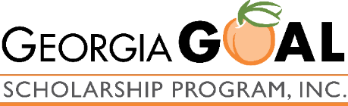
How can I maximize my business
tax benefit and my GOAL
contribution?
HB-149—Breaking it Down

Georgia’s elected officials have just enacted a SALT deduction workaround for pass-through businesses. HB 149 allows your pass-through business to elect to pay state income taxes at the entity level, resulting in significant federal tax savings, of up to $21 thousand on Georgia taxable income of $1 million, as illustrated in this example.

This election also expands the positive impact your business can have through the GOAL program, as your pass-through business can now contribute up to 75% of its annual Georgia income tax liability to GOAL, resulting in a meaningful double-tax benefit of federal tax savings and a Georgia tax credit. See our one-pager entitled Benefit meets Opportunity for further detail.

The significance of this new legislation:
- Since 2018, individual taxpayers have been limited to a $10,000 federal deduction for their state and local taxes (SALT).
- IRS Notice 2020-75, issued 11/9/20, allows for a “SALT Workaround” for pass-through entities paying state income tax, allowing for state and local income taxes paid by a pass-through entity to be taken as a deduction by the pass-through entity in computing its taxable income or loss for the year
- Georgia enacted HB 149, effective in 2022, providing that pass-through entities may make an annual election to pay state tax due on income earned at the entity level at the rate of 5.75%.
- The IRS will allow the entire amount of these state and local income taxes to be taken as a deduction in computing the electing entity’s taxable income.
- Electing pass-through entities will be treated the same as C corporations for purposes of the GOAL Program – meaning that they are able to contribute at a much more impactful level. Rather than limited to $10,000 per pass-through owner, the pass-through entity may contribute up to 75% of its annual tax liability.
- This development could mean that the entire cap on the education tax credit program could be met very early in 2022 – potentially on day one.

Should I race to get in line?
Yes, says HB 149!

