Georgia Pass-Through Businesses have Superpowers!
Pass-through businesses are superheroes of the GOAL Program, providing generous funding for deserving Georgia students. Through an expanded pass-through tax credit opportunity, many more Georgia families will benefit as their children are able to thrive in their chosen private schools.
There is a brand-new benefit for pass-through businesses, allowing a SALT (state & local income tax) limit workaround, coupled with a much more generous GOAL tax credit opportunity, per Georgia HB 149.
Beginning in 2022, Georgia pass-through businesses may elect to pay state income tax at the entity level, thereby enabling the pass-through owners to avoid the $10,000 SALT deduction limitation on their earnings from the business.
The tax impact from this election can result in significant cost savings for the business owners, as illustrated in this hypothetical example.

For businesses making this election, they may now contribute up to three-fourths of their state income tax liability to GOAL, empowering many more families to seek the K-12 education they desire for their children!
HB 149 specifically provides that the electing entity shall be eligible for the Georgia GOAL credit in an amount up to 75% of the entity’s Georgia income tax liability.

The electing pass-through entity will not be required to claim any business purpose for the payment besides satisfying Georgia’s tax liability!

Payments to GOAL may reduce or replace the need to make estimated income tax payments to the state.

Submit your application today for a 2022 income tax credit at this link.

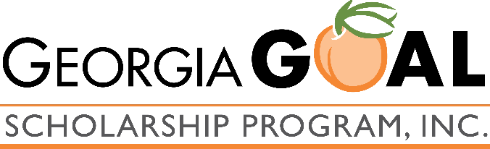
We recommend that you consult with your tax professional about this tax planning opportunity, as GOAL does not provide tax advice.

