EAST CEDAR GROVE MISSIONARY BAPTIST ASSOCIATION OF NC, INC.
Est. 1895
2174 BRASSFIELD ROAD, CREEDMOOR, NC, 27522
www.eastcedargrove-mba.org

2018 CALENDAR OF EVENTS

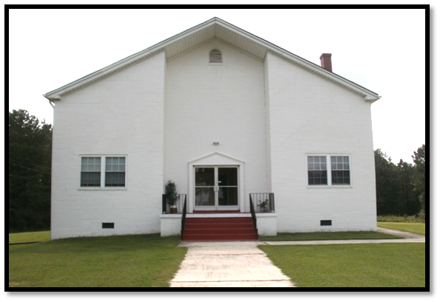

MODERATOR, REVEREND JAMES ISAAC, III
Executive Board Chair, Reverend Dr. Langston, Logan, Sr.

ECGMBA ELECTED OFFICERS 2017-2021

Moderator Rev. James Isaac, III, Pastor New Hope Granville Baptist Church
First Vice Moderator Rev. George Crews, III, Pastor Lattisville Grove Baptist Church
Second Vice Moderator Rev. Alvin Downing, Sr., Pastor, Pettiford Grove Baptist Church
Recording Secretary Deacon Johnny Pettiford, First Ledge Rock Baptist Church
Corresponding Secretary Rev. Elizabeth McCoy, Assoc. Pastor, Lawson Chapel Baptist Church
Treasurer Sister Linda Thomas Brasher, Lawson Chapel Baptist Church
Financial Secretary Sister Sharon Allison Vincent, Lee’s Chapel Baptist Church
Executive Board Chair Rev. Dr. Langston Logan, Sr., Pastor, Lawson Chapel Baptist Church

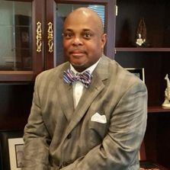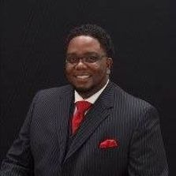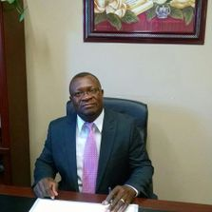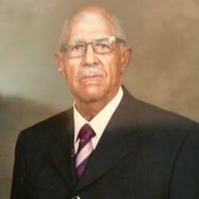

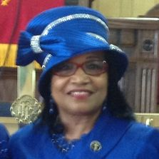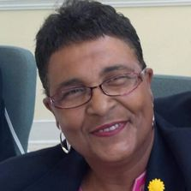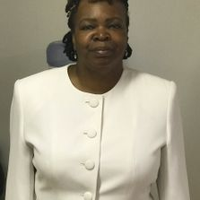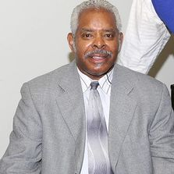

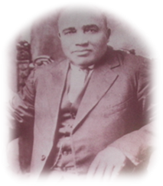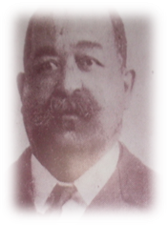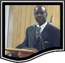
1895 Elected Officers: Moderator, Rev. A. R. Satterfield, Vice Moderator, Re. J. M. Taylor, Corresponding Secretary, Rev. H. G. Tilley, Statistician, Rev. J. R. Cozart, Treasurer, Deacon R. Day
Immediate Past President, Rev. J. Eric Morgan, III, 2013-2017

January 2018
Sunday | Monday | Tuesday | Wednesday | Thursday | Friday | Saturday
 | 1 | 2 | 3 | 4 | 5  Woman’s Auxiliary Choir, Rehearsal 7:00 pm, STCC | 6 Woman’ s Auxiliary Quarterly Meeting , 9:00 am, STCC
7 | 8 | 9 | 10 | 11 | 12 | 13
14 | 15 | 16 | 17 | 18 | 19 | 20
21 | 22 | 23 | 24 | 25 | 26 | 27  ECGMBA  Mid-Year Session, STCC
28 | 29 | 30 | 31
Note: Smith Thomas Convention Center (STCC) | Note: Congress of Christian Education (CCE) | Note: Ministers, Deacon, and Deaconess Union (MDDU)
February 2018
Sunday | Monday | Tuesday | Wednesday | Thursday | Friday | Saturday
 |  |  |  | 1 | 2 | 3
4 | 5 | 6 | 7 | 8 | 9 | 10
11 | 12 | 13 | 14 | 15 | 16 | 17 Youth Department, Black History Program Woman’s Auxiliary  STCC
18 | 19 | 20 | 21 | 22 | 23 | 24
25 | 26 | 27 | 28
March 2018
Sunday | Monday | Tuesday | Wednesday | Thursday | Friday | Saturday
 |  |  |  | 1 | 2 | 3 Ushers Union Business & Training, Guest Pastor, 10:00 am STCC
4 | 5 | 6 | 7 | 8 | 9 | 10 Woman’s Auxiliary Executive Board Meeting, STCC, 9:00 am
11 | 12  ECGMBA Executive Board Meeting, 6:00 pm | 13 | 14 | 15 | 16 | 17 Young Adult Department Program Woman’s Auxiliary STCC
18 | 19 | 20 | 21 | 22 | 23 | 24
25 | 26 | 27 | 28 | 29 | 30 | 31 MDDU Meeting, STCC, 8:30 am
April 2018
Sunday | Monday | Tuesday | Wednesday | Thursday | Friday | Saturday
1 | 2 | 3 | 4 | 5 | 6 | 7
8 | 9 | 10 | 11 | 12 | 13  Woman’s Auxiliary Choir, Rehearsal 7:00 pm, STCC | 14 Woman’s Auxiliary Quarterly Meeting 9:00 am  STCC
15 | 16 | 17 | 18 | 19 | 20 | 21
22 | 23 | 24  Lawson Chapel Spring Revival | 25  Lawson Chapel Spring Revival | 26  Lawson Chapel Spring Revival | 27 | 28
29 | 30
May 2018
Sunday | Monday | Tuesday | Wednesday | Thursday | Friday | Saturday
 |  | 1 | 2 | 3 | 4 | 5
6 | 7 | 8 | 9 | 10 | 11 | 12
13 | 14 | 15 | 16 | 17 | 18 | 19 Congress Christian Ed.  Mid-Year Session/Oratorical  10:00 am, STCC
20 | 21 | 22 | 23 | 24 | 25 | 26  Woman’s Auxiliary  Annual Prayer Breakfast 9:00 am  (STCC)
27 | 28 | 29 | 30 | 31
June 2018
Sunday | Monday | Tuesday | Wednesday | Thursday | Friday | Saturday
 |  |  |  |  | 1 | 2 Ushers Union Business & Training, Guest Pastor, 10:00 am STCC
3 | 4 | 5 | 6 | 7 | 8 | 9
10 | 11  ECGMBA Executive Board Meeting, 6:00 pm | 12 | 13 | 14 | 15 | 16
17 | 18 | 19 | 20 | 21 | 22 | 23 Woman’s Auxiliary Executive Board Meeting,  STCC, 9:00 am  CCE Youth Retreat, 9:30 am
24 | 25 | 26 | 27 | 28 | 29 | 30  Ministers, Deacons, and Deaconess Union Meeting, STCC, 8:30 am
July 2018
Sunday | Monday | Tuesday | Wednesday | Thursday | Friday | Saturday
1 | 2 | 3 | 4 | 5 | 6 | 7
8 | 9 | 10 | 11 | 12 | 13 | 14
15 | 16 | 17 ECGMBA  Annual  Session  Lattisville Grove  Baptist Church | 18 ECGMBA  Annual  Session  Lattisville Grove  Baptist Church | 19 ECGMBA  Annual  Session  Lattisville Grove  Baptist Church | 20 Woman’s Auxiliary Choir, Rehearsal 7:00 pm, STCC | 21 Woman’s Auxiliary Quarterly Meeting 9:00 am  STCC
22  Woman’s Baptist Home & Foreign Missionary Convention, Winston Salem, NC, | 23  Woman’s Baptist Home & Foreign Missionary Convention, Winston Salem, NC, | 24  Woman’s Baptist Home & Foreign Missionary Convention, Winston Salem, NC, | 25  Woman’s Baptist Home & Foreign Missionary Convention, Winston Salem, NC, | 26  Woman’s Baptist Home & Foreign Missionary Convention, Winston Salem, NC, | 27 | 28
29 | 30 | 31
August 2018
Sunday | Monday | Tuesday | Wednesday | Thursday | Friday | Saturday
 |  |  | 1 | 2 | 3 | 4
5 | 6  Lott Carey Convention, Atlanta, Georgia | 7  Lott Carey Convention, Atlanta, Georgia | 8  Lott Carey Convention, Atlanta, Georgia | 9  Lott Carey Convention, Atlanta, Georgia | 10 | 11
12 | 13 | 14 | 15 | 16 | 17 | 18
19 | 20 | 21 | 22 | 23 | 24 | 25
26 | 27 | 28 | 29 | 30 | 31
September 2018

Sunday | Monday | Tuesday | Wednesday | Thursday | Friday | Saturday
 |  |  |  |  |  | 1
2 | 3 | 4 | 5 | 6 | 7 | 8 100 Ushers in White Anniversary Program & Guest Pastor, 3:00 pm STCC
9 | 10  ECGMBA Executive Board Meeting, 6:00 pm | 11 | 12 | 13 | 14 | 15
16 | 17  Lawson Chapel Fall Revival | 18  Lawson Chapel Fall Revival | 19  Lawson Chapel Fall Revival | 20  Lawson Chapel Fall Revival | 21 | 22
23 | 24 | 25 | 26 | 27 | 28 | 29 Woman’s Auxiliary Executive Board Meeting, STCC, 9:00 am  MDDU Meeting STCC 8:30 am
30
October 2018

Sunday | Monday | Tuesday | Wednesday | Thursday | Friday | Saturday
 | 1 | 2 | 3 | 4 | 5 | 6
7 | 8 | 9 | 10 | 11 | 12 | 13
14 | 15 | 16 | 17 | 18 | 19 | 20
21 | 22 | 23 | 24 | 25 | 26  Woman’s Auxiliary Choir, Rehearsal 7:00 pm, STCC | 27  Woman’s Auxiliary Quarterly Meeting 9:00 am  STCC
28  Lawson Chapel 146th Church Revival | 29 | 30 | 31
November 2018
Sunday | Monday | Tuesday | Wednesday | Thursday | Friday | Saturday
 |  |  |  | 1 | 2 | 3
4 | 5 | 6 | 7 | 8 | 9 | 10 Congress of Christian Education Annual Session, 10:00 am STCC
11 | 12 | 13 | 14 | 15 | 16 | 17
18 | 19 | 20 | 21 | 22 | 23 | 24
25 | 26 | 27 | 28 | 29 | 30
December 2018

Sunday | Monday | Tuesday | Wednesday | Thursday | Friday | Saturday
 |  |  |  |  |  | 1 Ushers Union Fellowship Meal & Ministry & Strategic Planning Meeting, 10;00 am, STCC
2 | 3 | 4 | 5 | 6 | 7 | 8 Woman’s Auxiliary Executive Board Meeting, STCC, 9:00 am
9 | 10  ECGMBA Executive Board Meeting, 6:00 pm | 11 | 12 | 13 | 14 | 15
16 | 17 | 18 | 19 | 20 | 21 | 22
23 | 24 | 25 | 26 | 27 | 28 | 29 Ministers, Deacons, and Deaconess Union Meeting, STCC, 8:30 am
30 | 31

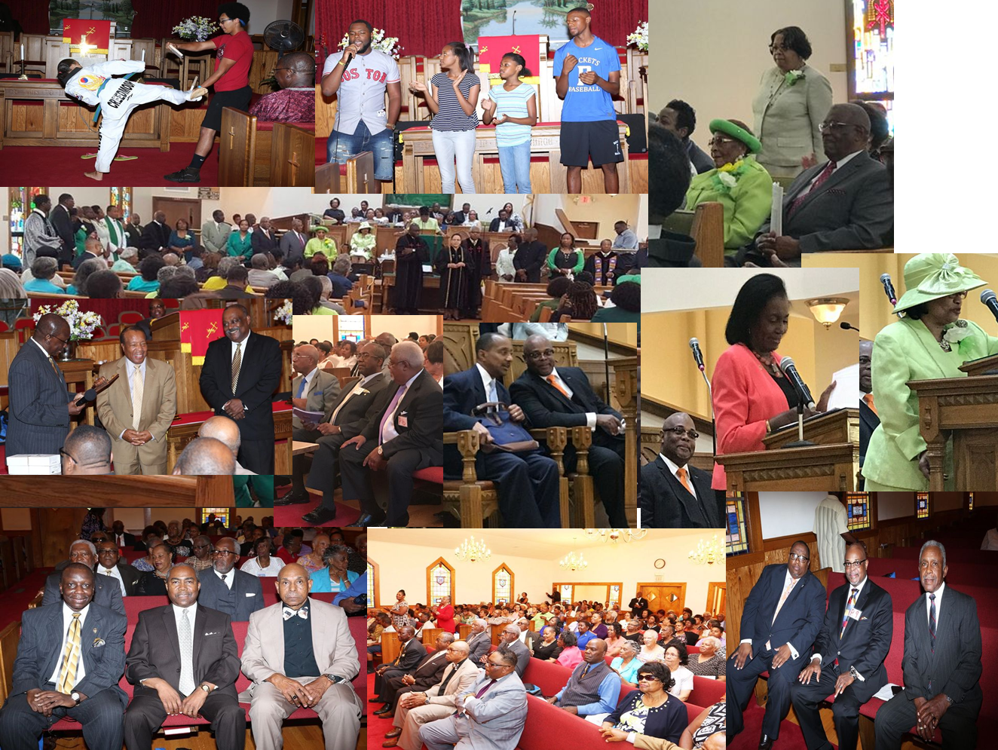
ECGMBA Annual Session & Founders Day Celebration 2017

EAST CEDAR GROVE MISSIONARY BAPTIST ASSOCIATION OF NC, INC.

Member Churches Pastors Est. Date & Site

Cameron Grove Missionary Baptist Church Rev. Jessie L. Alston 1901, Durham, NC
Cedar Grove Missionary Baptist Church Vacant 1865, Roxboro, NC
First Calvary Baptist Church Rev. Dr. Frederick A. Davis 1884, Durham, NC
First Community Missionary Baptist Church Rev. Dr. William Richardson 1986, Hillsborough, NC
First Ledge Rock Missionary Baptist Church Vacant 1975, Durham, NC
Greater Cleggs Chapel Missionary Baptist Church Rev. Louis Cash 1892, Timberlake, NC
Greenfield Missionary Baptist Church Rev. A. J. Bell 1887, Creedmoor, NC
Henderson Grove Missionary Baptist Church Rev. Johnnie Bethea 1915, Morrisville, NC
Jones Chapel Baptist Missionary Baptist Church Rev. Ronald K. Booker 1881, Roxboro, NC
Lattisville Grove Missionary Baptist Church Rev. George Crews, III 1879, Hurdle Mills, NC
Lawson Chapel Missionary Baptist Church Rev. Dr. Langston Logan, Sr. 1871, Roxboro, NC
Ledge Rock Missionary Baptist Church Rev. Marcellus Tyrone Moore 1863, Raleigh, NC
Lee’s Chapel Missionary Baptist Church Re. T. E. Taylor 1893, Cedar Grove, NC
Mt. Calvary Missionary Baptist Church Rev. Dr. James Smith 1892, Bahama, NC
Mt. Level Missionary Baptist Church Rev. Dr. William C. Turner, Jr. 1864 Durham, NC
Mt. Vernon Missionary Baptist Church Rev. Dr. J. Eric Morgan, III 1872, Creedmoor, NC
Mt. Zoar Missionary Baptist Church Rev. Norman Davis 1865, Durham, NC
New Calvary Missionary Baptist Church Rev. Dr. E. Nathaniel Wall 1902, Durham, NC
New Hope Granville Missionary Baptist Church Rev. James Isaac, III 1888, Oxford, NC
New Hope Person Missionary Baptist Church Rev. Wilber L. Richardson 1878, Timberlake, NC
New Light Missionary Baptist Church Rev. Dr. Cicero Williams 1907, Wake Forest, NC
New Red Mountain Missionary Baptist Church Rev. Dr. Larry G. Wilson 1874, Rougemont, NC
New St. James Missionary Baptist Church Rev. Lloyd Oliver, Sr. 1870 Timberlake, NC
Oak Grove Missionary Baptist Church Dr. Charles Bullock 1865, Oxford, NC
Olive Grove Missionary Baptist Church Rev. Johnny White 1865, Oxford, NC
Orange Grove Missionary Baptist Church Rev. Dr. Herbert L. Dickerson 1880, Durham, NC
Pettiford Grove Missionary Baptist Church Rev. Alvin B. Downing, Sr. 1887, Kittrell, NC
Pine Grove Missionary Baptist Church Vacant 1870, Creedmoor, NC
Rock Spring Missionary Baptist Church Rev. Hayward Dock, Jr. 1875, Creedmoor, NC
Shady Hill Missionary Baptist Church Rev. Dr. James Richmond, Sr. 1867, Roxboro, NC
Siloam Missionary Baptist Church Rev. Willie Wayne Johnson 1880, Rougemont, NC
St. John’s Missionary Baptist Church Rev. Robert Daniels 1910, Durham, NC
Synama Grove Missionary Baptist Church Rev. Rev. Eddie A. Fuller 1861, Oxford, NC
Tally Ho Missionary Baptist Church Rev. Moses Fletcher 1863, Stem, NC
Union Baptist Church Rev. Dr. Prince Rainey Rivers 1897, Durham, NC
Union Chapel Missionary Baptist Church Rev. Dr. Harold Trice, Sr. 1864, Butner, NC
Union Grove Missionary Baptist Church Rev. Rufus Johnson, Sr. 1888, Hurdle Mills, NC
United Christian Missionary Baptist Church Rev. Q. L. Becton 2002, Creedmoor, NC
West Durham Missionary Baptist Church Rev. Dr. LaMont Johnson 1892, Durham, NC

Calendar Prepared by, Rev. Joyce Daye Clayton

