Student Guide Book Contents

Item page number

Foreword and welcome 2
Smart behaviour 4
Smart looking 13
Smart health and safety 15
Smart eating 16
Smart diversity and inclusion 18
Smart ICT practices 20
Notes 23
Quiz time 24

Foreword and welcome
Welcome to your Edu-Centre journey with me, Mrs G, and the rest of the Wingu team. We’re excited and motivated about discovering what lies on our education journey together!
Our team is made up of you, other learners in class and the on-line learners and teachers, your parents and caregivers. Our team must work together to make sure we continue to grow and be the best we can be.
We have created this Guide Book to ensure that we work together to reach our goals and exceed our potential.
The Edu-centre motto is Eagar Minds, Kind Hearts, Active hands. This means:
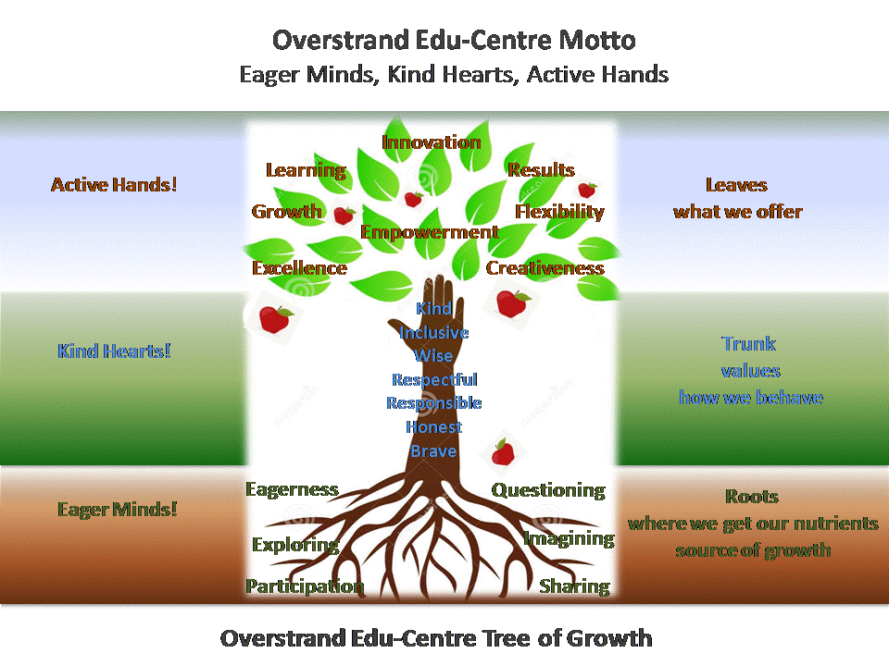

Like with any journey, we need to use our Guide Book often to help us keep on track, it shows us the way, and occasionally we need to stop and double check that we are heading in the right direction so we don’t get lost! And you know what, if we take a wrong turn, we ask for help and get right back on track using our Guide Book!
This is YOUR Guide Book and it will help you keep on track. It consists of the Edu-centre’s guides to:
- Smart behaviour
- Smart diversity and inclusion
- Smart health and safety
- Smart ICT practices
- Smart eating
- Smart looking
- Notes
At the Edu-Centre let’s always try to be the best version of ourselves by understanding and sticking to our Guide Book. Let’s measure and reward ourselves when we do well, throughout this journey that we are taking together!
I’m pledging below to do exactly that, join me and let’s get the rest of the team pledging too!
Mrs G pledge: ________________________________________

My pledge: ________________________________________

My parents’ pledges: ________________________________________

Date: ________________________________________

Smart Behaviour

This document is here to remind our team of what great behaviour looks like, and if you’re struggling, it tells you what your team can do to support you, and help you to get back on track.
At Overstrand Edu-centre let’s always try to be the best version of ourselves. We are a team, made up of learners, on-line teachers, parents and our Edu-Centre Head. We must all work together to make sure we continue to grow and be the best we can be.

Here is what we expect in terms of behaviour from our team of students, parents, teachers and our Edu-Centre head.

Student Behaviour
Remember values in particular help to guide our behaviour, and sometimes we all need a little reminder!
We are kind.
How we show we are kind:

We are inclusive.
How we show we are inclusive:

We are wise.
How we show we are wise:

We are respectful.
How we show we are respectful:

We are responsible.
How we show we are responsible:

We are honest.
How we show we are honest:

We are brave.
How we show we are brave:

Student Commitment
We continue to support everyone’s growth during our time at the Edu-Centre, so we are:
Sharing
How we show we are sharing:

Questioning
How we show we are questioning:

Participating

How we show we are participating:

Eager
How we show we are eager:

Exploring
How we show we are exploring:

Imagining
How we show we are imagining:

Our Passport of Positive Behaviour
At the Edu-centre you will receive a ‘Passport of Positive Behaviour’. Each time, when either one of the learners or the head of the Edu-centre witness you reaching for the stars and living one or more of our values, you will be nominated and awarded a badge which will go into your passport. Children who receive badges will be acknowledged at the end of each month in our circular.

Parent Behaviour
- Parent’s main role is to help create a positive learning experience for their child.
- Parents are to promote the authority and image of the Edu-centre and Wingu Academy, (on-line teachers/coaches and tutors/mentors) - these learning agents’ sole purpose is to help students learn and progress. Be respectful of the team that helps your children.
- Any concerns that parents have are to be directed to the Edu-Centre Head at admin@overstrandeducentre.com. Parents are NOT to direct any concerns to on-line teachers or mentors directly.
- Please be respectful of the Edu-centre Head’s private time so please email instead of phoning after hours.
- Disruption of the virtual classroom or the learning experience of other students, Edu-Centre staff or other parents will lead to immediate dismissal of the student and parent from the academy and Edu-centre.
- Parents are to encourage healthy usage of their child’s computer. Regularly check the sites that your child is visiting.
- Should your child experience any form of negative behaviour at the Edu-centre please notify the Edu-centre head immediately, in order for the matter to be dealt with.

Parent Commitment
During my child’s time at the Edu-Centre, I undertake to:
- Create and promote a positive learning environment at all times.
- Create positive encouragement for students and the Learning Support team.
- Regularly attend parent evenings/meetings.
- Complete quarterly satisfaction surveys.
- Ensure your child maintains a regular presence at the Edu-Centre, and hours of attendance are strictly adhered to.
- Address any issues of concern by immediately making an appointment to talk directly to the Edu-Centre Head.

On-line Teachers’ Behaviour
- Students and the positive learning environment are the first priority.
- Teachers must at all times act respectfully towards students, parents and the Edu-centre Head.
- Teachers must be prepared, professional and a role model for all students, parents and the Edu-centre Head.

On-Line Teachers’ Commitment
During learning sessions, they will undertake to:
- Nurture children’s independent and group learning skills.
- Create and maintain a friendly learning environment.
- Respond to questions within 48 hours.
- Respect the confidentiality of any personal information.
- Conduct assessment without fear or favour.
- Provide feedback to the Edu-centre head on the student’s progress and participation in order to implement timely interventions for improvement of learning support and continuous assessment.

Edu-centre Head Behaviour
As your Edu-centre Head, my first and most important role is to lead by example. Any of the expectations that I may have of you, needs to be fulfilled by me first.
- This includes not shouting but rather talking to you.
- This includes listening to you when you need my attention.
- This includes respecting you as an individual, who is at school under my care.
- This includes working on our values and commitment towards each one of you to reach your potential as a human being.

Edu-centre Head Commitment
- You have my commitment that our Edu-centre will be a safe and secure environment for you.
- My door will also be open for you to approach me with any problems or concerns that you may have.
- Not only will I ensure that learning takes place, but I will make sure that learning is fun and that each one of you will want to come to school daily.
- I will encourage you to always give of your best because I will believe in each one of you and what you are capable of achieving.
- As your Edu-centre head I will be there to support you, in all that you do while at school.

Here’s what will happen if we don’t behave well:
We all have bad days, or days when we don’t feel quite ourselves, let your Edu-centre Head know if you’re struggling so they can help. At the beginning of each day we will do a check-in to see how we are all feeling. During the course of the day, we may stop to practise some mindfulness if we need to self-regulate. If we get tired of sitting and feel the urge to walk around or talk to our friends, ask your Edu-centre head to do a few brain-breaks with you.
We have a problem when your repeated negative behaviour starts to affect the rest of our team, and in the unlikely event that this should happen, we have the right to address your behaviour and help you get back on track.

There are a few behaviours that we have Zero tolerance for at our Edu-Centre:
Bullying: This is the repeated and intentional hurting of another individual either verbally, emotionally, mentally or physically. Bullying also includes social exclusion and cyber bullying.
Harassment: This is the purposeful act of focusing negative attention on another individual causing this person to feel uncomfortable being around you.
Stealing: The removal of someone else’s property, whether it is clothing, food, stationery or money without their permission will not be tolerated.
Physical assault: This is the physical attacking of another child by either hitting or punching, kicking or using an object to do injury.
Substance usage: This is the use of illegal and legal substances for its effect on one’s body. These substances include alcohol or drugs, both of which are prohibited at the Edu-centre.
Following an investigation or disciplinary hearing, any student/parent/teacher, being found guilty of any these negative behaviours, will be asked to leave the Edu-Centre and all access to the Edu-Centre and Wingu Academy will immediately be denied. Should you not be asked to leave the Edu-centre, you may be asked to attend counselling sessions to have your negative behaviour addressed.
Rather aim to be awarded badges in your Passport of Positive Behaviour. Achieving badges will make you feel better about yourself and how you interact with each other.

Smart Looking

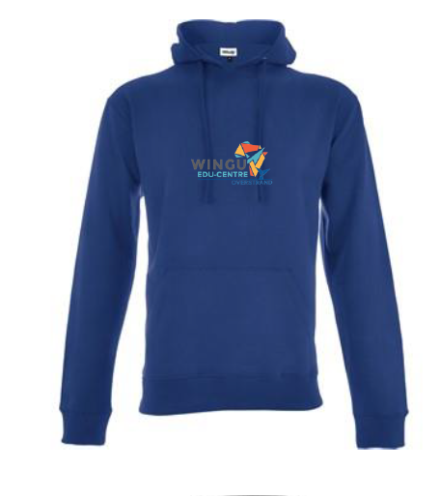
We will outline in this guide our smart but casual and comfortable approach to our Overstrand Edu-centre uniforms. Using natural fibres, we have created a mix and match combination of items, which means you can choose what you prefer and what you feel most comfortable in. You will also find below some fixed rules around what we expect from you while in uniform.

The Overstrand Edu-centre uniform consists of:
- The blue, sand or grey Overstrand tee-shirt
- The blue, sand or grey Overstrand hoodie
- The Overstrand peak caps or the full brimmed Overstrand sun hat

Any combination of the above is to be worn with blue, black, grey, sand orDemin jeans, shorts, skirt or leggings.

Uniform checklist:
- My uniform is a combination of items from the prescribed list above.
- My uniform is clean and tidy.
- All my items of clothing, bags and shoes are marked with my full name.
- My hair is clean and tidy and long hair is tied back and out of my eyes.
- My nails are short and clean with no nail polish.
- I am not wearing makeup.
- I am wearing sandals or sneakers (no flip flops), but I know these can be removed during the school day.
- My socks are plain and of a mono Edu-centre colour.

- The only jewellery I am wearing is either studs or sleepers.
- During the 1st and 4th terms I wear my hat to the Edu-centre.
- During cold weather, if I wear a scarf and/or a beanie, it is plain and of a mono Edu-centre colour.
- During wet or cold weather my windbreaker is plain and of a mono Edu-centre colour.
- My Edu-centre bag is strong and sturdy of a plain and mono school colour.

A few extra bits:
- Full Edu-centre uniform needs to be worn while away from the Edu-centre and out in public.
- Do not wear any of your Edu-centre uniform items on weekends or holidays.
- Remember as long as you’re wearing your uniform you are a representative of Overstrand Edu-centre and we expect you to behave appropriately.
- On your birthday, you’re free to wear appropriate civvies to the Edu-centre.

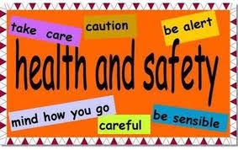
Smart Health and Safety

We will outline in this guide the Edu-centre’s safety rules.
You and your Edu-centre Head will spend most of your day in the classroom. You have a responsibility to make sure you’re always alert. Take care of everyone’s health and safety by reporting any risks to your Edu-centre Head immediately.
Edu-centre safety rules:
- Walk in and around the classroom.
- Keep food and drink away from laptops.
- Inform your facilitator immediately if someone is hurt.
- If you are feeling sick stay at home or report to your facilitator if you are at the Edu-centre.
- Always ask permission to enter and leave the classroom.
- Tuck in your chair.
- Keep outside gates and security gates closed and locked at all times.
- Keep passage ways clear of your bags and other items.
- Be sensible with scissors and other sharp objects.
- Report any damaged furniture or equipment to your facilitator.
- Follow the Edu-centre internet rules.
- Wash your hands regularly.
- Always wear your mask, except when eating and drinking.
- Maintain social distancing.
- Label your personal items but do not have your name displayed externally for strangers to see.
- Make sure you are familiar with the Edu-centre’s emergency procedures.

Smart Eating
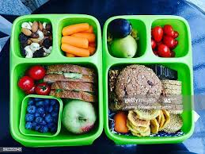
Holistic education means supporting your brain function by eating delicious healthy food. The better you eat, the better your brain can work.
Let us keep this in mind when we eat breakfast, pack our lunch boxes, do markets, fundraising events, any food sales, tuck-shop or otherwise, or when we have a birthday or other celebrations when we bring food to share.

You will find in this section a checklist to keep us on track, and you will also find some fixed rules.

At Overstrand Edu-centre, let us all get behind and support good brain food principles. If we lead the way, others will follow, and what this means is, we will be helping our community by increasing awareness and keeping more of us healthy, smart and energised!

Checklist:

My lunch box may contain:
- Mostly homemade food
- Wholegrain, like whole-wheat bread/pasta/muffins/pita bread etc.
- Fresh fruits and vegetables
- Unprocessed dairy and protein
- Healthy treats from nature, like dried fruits, date balls, popcorn etc.
- Fresh water
- Sugar free pure fruit juice

Rules:
- No pre-packed snack foods such as chips, chocolate etc.
- No sugary confectionery or sweets.
- No fizzy or sugary drinks.
- No chewing-gum at the Edu-centre or on any excursion.
- Check food labels and don’t pack foods with artificial additives and colouring.
- No single use plastic and polystyrene containers.

A few extra bits:

- Need more ideas for healthy lunch boxes - www.holleygrainger.com; www.superhealthykids.com
- Please ask your Edu-centre Head for contact details of suppliers who can bake/cater in line with our policy should you prefer not to supply your own items as and when required for school events/functions.
- Please inform your Edu-centre Head of any food allergies or special dietary requirements you may have.

Smart Diversity and Inclusion

In this section we are reminded just how important it is to treat everyone equally and make sure everyone always feels included and supported at school.

Imagine a world where everything was the same, the plants the same, the animals the same, the food the same, and just imagine if we all looked, thought and acted exactly the same! How boring! Thankfully we have diversity in our world! This means we all display wonderful differences that make us unique and interesting. If we keep an open and inquisitive mind we can learn so much from others who come from different backgrounds and have different experiences.

Overstrand Edu-centre is a fully inclusive establishment; this means we treat everyone as individuals, respecting them for their unique attributes. We do not exclude, harass or bully people because of their differences. This means we welcome learners, teachers, and parents from different races, religions, ages, sexual preferences, political beliefs, physical appearance or have a disability. Remember not all disabilities can be seen.
What are some differences we cannot always see?

How can we help if we are aware of somebody being treated unfairly?

What to do if you are being treated unfairly?

If you bully or harass or treat anyone any less favourably because of their differences, Overstrand Edu-Centre will take it very seriously, such behaviour is not tolerated, and if, after an investigation, we find it to be true, you and your parents should be aware it could result in immediate expulsion. Furthermore, any behaviour outside of the Edu-Centre which brings the reputation of the Edu-Centre into disrepute could also result in a disciplinary hearing and/or expulsion.

At the Overstrand Edu-centre we are tolerant and understanding of the differences within each one of us. We support these differences, and we encourage one another to always give of one’s best and to reach for the STARS regardless of our differences. Differences make us strong and help us to grow into strong and confident individuals.

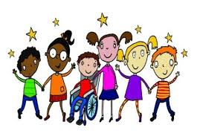

Smart ICT

You have joined a dynamic, on-line Education Centre and as such there are some equipment essential which you will need to enable you to participate in your learning journey with us. This section specifies what equipment you will need, and outlines our rules for engaging on-line while at the Edu-centre.

Equipment essentials:
- Laptop
- Security lock
- Headphones with a speaker (ideally noise reduction)
- Backup dongle for internet

You must have these items before joining the Edu-centre. Without them you cannot participate in your lessons. Your parents will also need access to e-mail and Whatsapp.

Security:
- You will be issued with a Wingu username and password on enrolment.
- Change your password after you have logged in for the first time. Your password must be more than 6 characters, and must include at least one CAPITAL letter and one number.
- Always keep these details secure and do not share them with anyone or allow anyone else to use them.
- You are responsible for your laptop while at the Edu-centre.

- The Edu-centre will not be held responsible for any loss, damage or theft of your property.
- Please ensure your laptop, security cable and headphones are clearly marked with your full name.
- Learners using a windows-based device must ensure that they have a working anti-virus installed. Spot checks on devices will be performed from time to time.

Appropriate use of the internet and your laptop:
- Make sure your laptop is always fully charged before coming to the Edu-centre.
- Always secure your laptop to your desk when entering the classroom.
- All gaming services like Steam and Epic games must be turned off while at the Edu-centre. Automatic updates of games must be disabled at all times.
- The Edu-centre’s network will not allow any social media browsing.
- The only chat application allowed while at the Edu-centre is that provided by the Wingu platform.
- All security and system updates need to kept up to date. Please do this with your parents/caregivers regularly at home.
- YouTube videos are only allowed if approved by a teacher and if it is required for a lesson.
- No illegal software, music or video files such as utorrent or any P2P software is permitted on the Edu-centre network.
- Data transfer is not permitted using the Edu-centre network; this means no external USB sticks may be bought to the Edu-centre.

Rules for engaging during your on-line lessons:
- Always address your teacher Miss or Mr and then their first name, for e.g. Mr Werner, Ms Louisa.
- Always greet your teacher at the beginning of the class and thank them at the end of class.
- Always have your camera on at the beginning and end of your lesson.
- Always use your real name as your screen name.
- If you wish to interrupt the teacher you can put your hand up or use the ‘raise your hand icon’.
- Use the chat box appropriately at all times. It may only be used when instructed to do so by your teacher to answer a question or raise a query.
- Mute your microphone when you’re not talking.

My Notes
________________________________________________________________________________________________________________________________________________________________________________________________________________________________________________________________________________________________________________________________________________________________________________________________________________________________________________________________________________________________________________________________________________________________________________________________________________________________________________________________________________________________________________________________________________________________________________________________________________________________________________________________________________________________________________________________________________________________________________________________________

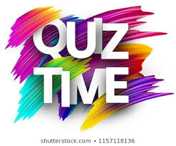
Test Your Knowledge!
__________________________
__________________________
__________________________
__________________________
__________________________
____________________________________________________________________________________________________________________________________________________________________________________________________________________________________________________________________________________________________________________________________________________________________________________________________________________________________________________________________________________________________________________________________________________________________________________________________________________________________________________________________________________

