OptoMap
“Wide Field Scanning Images”

We have to look into your eyes to see if they are healthy and the best way for us to do that is with our Optomap. It allows the doctor to see exponentially more with AND WITHOUT DILATION!!! Isn’t technology great!
With this cutting edge technology, the doctors can detect and monitor the health of your eyes better than ever before!
“I would never do an eye exam on a friend or family member without performing this test.” ~Dr. David Anderson

There is a nominal fee of $29 to perform this procedure (it is not covered by most insurances).
 | I would like this procedure. |  | No, thank you.
____________________________________ Patient Signature Date

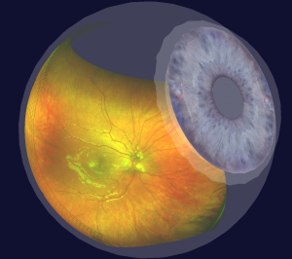

More information: We are proud to introduce the latest in retinal imaging, the Optomap. It is quick and painless, with no residual effects normally experienced with dilation. This instrument will enhance our ability to detect and monitor retinal defects associated with common systemic diseases such as hypertension, diabetes, high cholesterol and thyroid problems as well as diseases and defects of the retina. Through digital imaging of the retina we can observe early changes in the eye relating to glaucoma, cataracts, and macular degeneration. This technology can be used with and without dilation and will be a permanent part of your medical records.

By the time you have symptoms affecting your vision it is typically too late to prevent permanent sight damage.

We care about your vision and want to be sure we actively monitor your eyes. The Optomap is the optimal, least expensive, way to do this.

