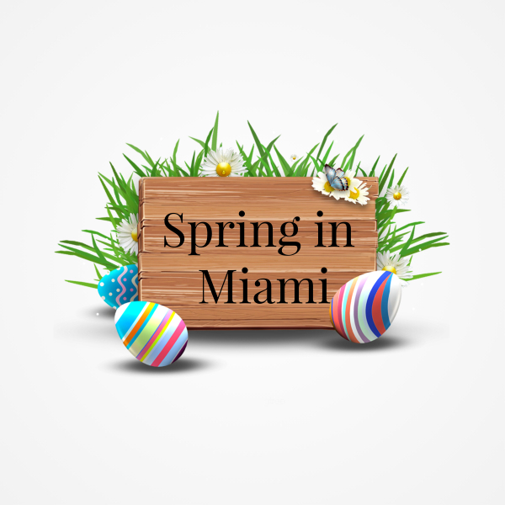
Spring in Miami Registration
Event Info:
March 23,2024
Saturday 10 am to 5 pm.
Event Address:
Miami Elks Lodge
10301 SW 72nd Street
Miami, Florida 33173
Contact us at (305-251-8989)
Events@Wendyschocolates.com

APPLICATION PROCESS;
Please provide 3 pictures of your items either by email or a link to your website. Limited numbers per category will be picked to maintain an amazing show. If you change products prior to the show you will need to be reapproved. Fill out the application and submit application, pictures and form of payment.
PAYMENT AND CANCELLATION POLICY;
Show fees are listed on the application. Please provide payment at the time of applying.
Once approved and notified payment will be processed. Cancelations within 60 days will receive 50%. Cancelations within 30 days of the event will not be refunded.
BOOTH DISPLAY;
All tables must be draped to the floor on all 4 sides. Canopy frames are NOT allowed. If requesting electrical please bring 50 foot cords. All boxes, coolers, totes or carts should not be visible. Vendors should always stay within their designated area. NO sale signs will be permitted within your booth. Remember this is a family friendly event.
SET-UP AND BREAKDOWN;
Upon arriving, please check in for your space assignment. Set up will begin on Friday March 22nd at 2 pm and go until 7 pm. Saturday at 7 am til 9:30 am If you are unable to make it to the event please call and let us know. My phone is on 24 hours a day. You MUST stay set up for the entire show hours. No packing up until the show has been announced as closed on Saturday.
VENDOR RESPONSIBILITIES;
Vendors should keep a professional appearance for themselves and their booths. You are responsible for all clean up at the end of the event. Trash areas will be provided throughout the facility. All booths should be attended. No pets or alcoholic beverages. Please pack a sweater. This building can be warm or cold on any given day.

Vendor Information Required * (Please print clearly)

Name*_____________________________________ Phone*____________________________

Email*

Company Name*

Address*
Referred By:
Vendor Type:
Tell us what you make/sell:
Space Size:
- 6ft x 10ft space.... $125 ea _____qty (Will fit 3 6’ tables in a U pattern)INSIDE
  - (optional) 6' Table rental..... $10 ea _______ qty

- 4ft x 12ft space.... $100 ea ____qty ( Will fit 2 6’ tables linear)INSIDE
  - (optional) 6' Table rental.... $10 ea ____ qty

- 4ft x 6ft space.... $75 ea ____qty ( Will fit 1 6’ table)INSIDE
  - (optional) 6' Table rental.... $10 ea ____ qty

- 10ft X 10ft Space…. $75 ea____ Outside
- Food Vendors…. $125 ea____Outside
- Electrical (limited spaces available) $20 ea

I understand that I will have to pay $____________ (total amount) *
- I have read ,understand and agree to all terms in this agreement.
- Form of payment: Visa, Mastercard, Discover, or American Express
- Checks: Payable to “Wendys Chocolates” 11032 SW 166th Terr Miami,Fl. 33157
- Card number ________________________________

- Expiration date__________________ CVV __________________

- Signature________________________________ Date_______________

WENDY'S CHOCOLATES is proud to present Spring in Miami event. I know that we as vendors are excited to do events, I need all of your help to pull off the most amazing event and with your vendor help we will make this happen. For those of you that know me THANK YOU in advance. For those that do not know me please know that this event means a lot to me so I will do everything I can to make it a success for the vendors and customers. If you have any questions or need more answers please reach out to me 305-251-8989 or thru email at Events@Wendyschocolates.com

