Club Zeus April 1, 2024 Board Meeting via Email to Include Items for Vote

Email sent to Crisann Black, Kat Mullins, Sadie Pendleton, Amara Comeau and Landi Roark

- Treasurer - Account Update:
  - As of April 1, 2024, The Club Zeus Account has $9,199.22
- Board Changes
  - Kat Mullins will be returning to England in May 2024 : (
    - Club Zeus will need a new treasurer
  - Sadie Pendleton has accepted a stipend position with Club Zeus and will resign as secretary
    - Landi Roark has volunteered to fill the secretary position
    - All in favor of Landi filling this position as of April 8 vote below and initial
      - Amara Comeau - yes A.C. 4/1/24
      - Kat Mullins - yes K.M.. 4/2/24
      - Sadie Pendleton - yes S.P. 4/2/24
- Monthly stipends for Crisann Black and Sadie Pendleton for marketing and administrative work. Stipend will be paid by the third Wednesday of of the month starting in April 2024
  - Crisann Black - $300 per month
    - All in favor vote below and initial
      - Amara Comeau - yes A.C. 4/1/24
      - Kat Mullins - yes K.M. 4/2/24
      - Sadie Pendleton - yes S.P. 4/2/24
  - Sadie Pendleton - $150 per month
    - All in favor vote below
      - Amara Comeau - yes
      - Kat Mullins - yes K.M. 4/2/24
      - Sadie Pendleton - yes S.P. 4/2/24
- Purchases for Club Zeus Monthly Events (see attachment)
  - Walkie-Talkie (comes in packs of four) for Security Staff and Crisann cost not to exceed $100 plus tax
  - All in favor vote below and initial
      - Amara Comeau - yes A.C. 4/1/24
      - Kat Mullins - yes K.M. 4/2/24
      - Sadie Pendleton - yes S.P. 4/2/24
  - Two New Speakers for D.J. (two) cost not to exceed $400 plus tax
    - All in favor vote below
      - Amara Comeau - yes A.C. 4/1/24
      - Kat Mullins - yes K.M. 4/2/24
      - Sadie Pendleton - yes S.P. 4/2/24
  - Volunteer Lanyards 25 at a cost not to exceed $30 plus tax
    - All in favor vote below and initial
      - Amara Comeau - yes A.C. 4/1/24
      - Kat Mullins - yes K.M. 4/2/24
      - Sadie Pendleton - yes S.P. 4/2/24

Page 1 of 2
Club Zeus April 1, 2024 Board Meeting via Email to Include Items for Vote

Email sent to Crisann Black, Kat Mullins, Sadie Pendleton, Amara Comeau and Landy Roark

- Monthly Marketing Budget
  - Crisann/Sadie shall have $100 to spend for marketing items such as Egee’s, lollipops etc
    - Items do not need to be voted on by the Board
    - Receipts must be provided
      - All in favor vote below and initial
        - Amara Comeau - yes A.C.
        - Kat Mullins - yes K.M. 4/2/24
        - Sadie Pendleton - yes S.P. 4/2/24

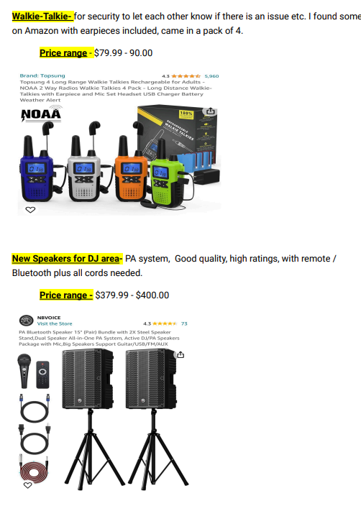

Page 2 of 2

