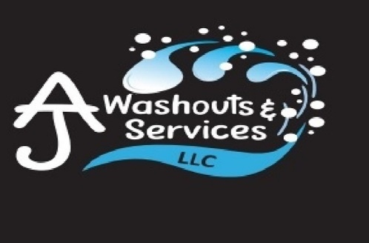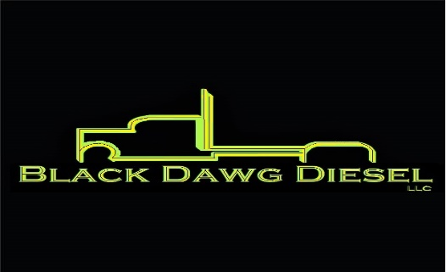

920.912.5242 blackdawgdiesel.com
N4560 State Road 57 ajwashoutsandservices.com Plymouth, WI 53073

Hours of Operation: 8am- 5pm Monday through Friday

AJ Washouts & Services LLC
is open for trailer washouts
Dry Van Trailer
Reefer Van Trailer
Dump Trailers
Cost of washouts START at $42.00 plus tax
Black Dawg Diesel LLC
Shop Rate: $100/hr
Reefer Trailer Rate: $115/hr
(Once reefer unit is touched)
Service Call: $120/hr
Service Call Fee: $150
Service Call Computer Hook Fee: $150
Located:
2 miles south Cty Rd PP on State Road 57, just north of Highway U.
Veteran Owned and Operated
This Photo by Unknown Author is licensed under CC BY-NC
This Photo by Unknown Author is licensed under CC BY-NC

