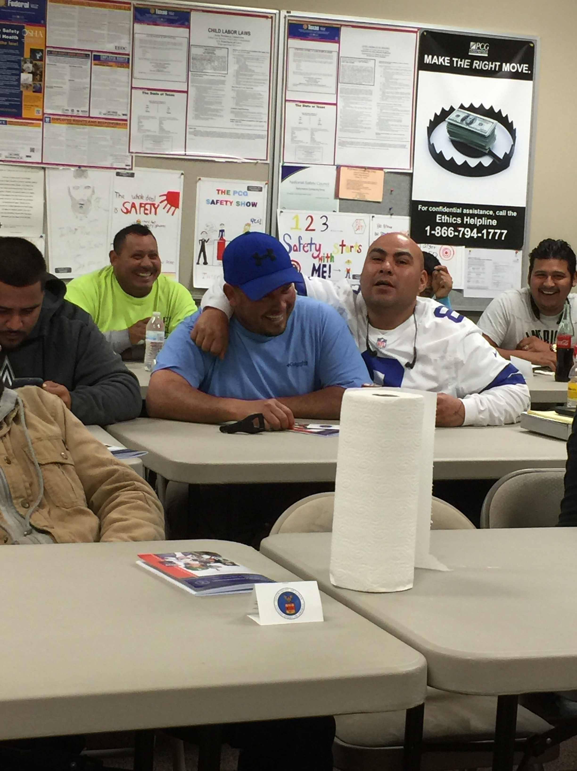  We do Training at Your Site  CBC Safety Solutions is a full-service training company!  Training at your site is one of the many features that we offer our clients. This is an affordable alternative, when you have large groups, to the public class. Whether an Annual Refresher or New Miner Class, we come to you on your schedule. This saves you both time and money!  We offer MSHA Part 46 and Part 48(b) Surface, Part 77 Surface Supervisor Certification, First Aid Classes, and many others.  A MSHA form 5000-23 is issued upon completion of all Part 48 training and is valid for one (1) year. After which an annual refresher must be taken.  We service a large geographical area! Call us today to see how we can accommodate you. |  |  | Who We Are  About Us  We are a family owned and operated business that believes in offering the most up to date class material along with affordable pricing options. Our instructors are Contractors, Mining Industry Specialists or Education Specialists.  Qualified Part 46 and Part 48 Surface Instructors brings real world mining experience as part of the learning environment.  Contact Us  Phone: 903.571.7681  Email: cbctyler@hotmail.com  Web: www.cbcsafetysolutions.com  Online Registration is Available!  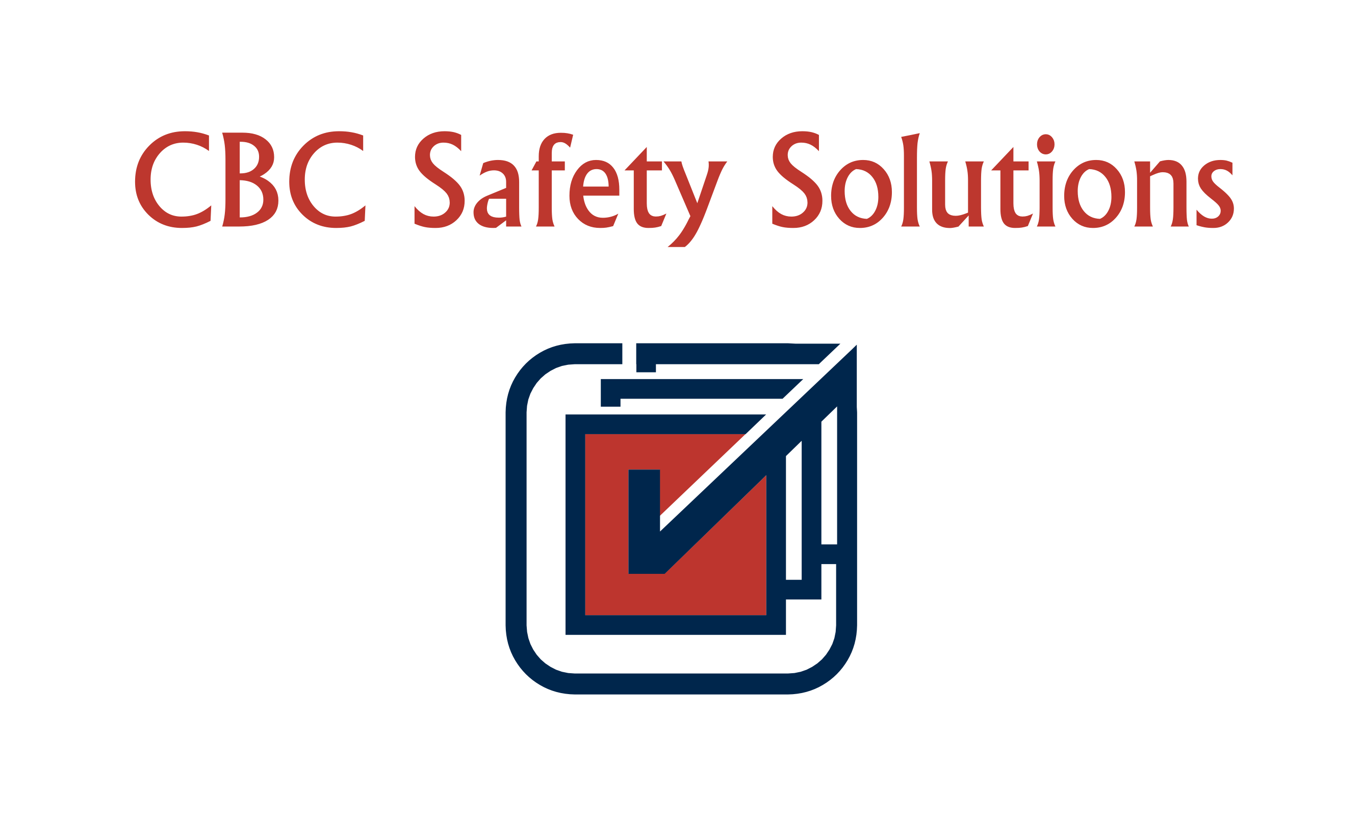 CBC Safety Solutions 3043 S Yellow Bill Dr Saratoga Springs, UT 84045 |  |  | 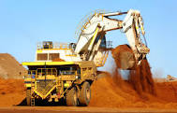  “Great customer service. I was able to schedule a class immediately that fit with our work schedule!” _{John TX}  CBC Safety Solutions  we don’t just check the box!  - We Know Mine Safety!

Online Training Alternative  This is the alternative to the traditional on-site training! The class or classes can be taken from the convenience of your home, office, or hotel room if on the road. This is a “live” webinar where attendance and participation is mandatory. This is not a self-paced class.  Currently we are offering Online Training in both Annual Refreshers and New Miner Surface for the Coal and Metal/Non-Metal industries.  Class requirements:  - Computer with high-speed Internet access  - Working Webcam access on the computer  - Built in speakers and microphone or headset with microphone  - Phone can also be used for teleconference service  - ID and all certifications for prior MSHA training  - Attendance & Participation Required! |  |  | Customer service, experience, and affordable pricing are the company’s driving force in building lasting bonds with their clients!  “The Online class was great! It fit right into my schedule, and I did it while on the road!” _{Richard OK}  If you have a problem with safety contact us today. We can discuss the options available in order to get you on the right track.  Need help with your training plan, let us help you to create one or update yours today!  All Part 46 Classes, our instructors teach to your plan. We also provide an addendum to your plan every year.  All Part 48 Classes are taught to our training plan unless otherwise specified.  Let us know what you think! Join us on Facebook or visit our website and join our blog! |  |  | 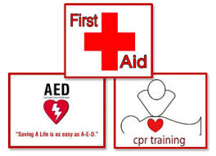  We provide First Aid Training at your site  Our Product and Services  - Online Training for New Miner and Annual Refresher Classes in Part 48(b) and Part 46  - In Person MSHA Part 46 and Part 48(b) Surface New Miner and Annual Refresher Classes  - Emergency MSHA Training Classes  - First Aid/CPR Classes  - Supervisor Surface Certification  - Surface Supervisor to your job

