Round 1: Entertainment

- Peter Fenn was the resident organist on which t.v. programme? (Sale Of The Century.)
- What was the name of Steptoe And Son’s horse? (Hercules.)
- Which sitcom was situated on Craggy Rock? (Father Ted.)
- Who sang “Let Me Be The One” for the United Kingdom in the 1975 Eurovision Song Contest? (The Shadows.)
- Which t.v. series was introduced by the title music “Overkill”, and it’s last ever episode was called “Respect”? (The Bill.)

Round 2: Food And Drink

- Which tea has been flavoured with the addition of Oil of Bergamot? (Earl Grey.)
- According to Winston Churchill, which potent concoction saved more Englishmen’s lives and minds, than all the doctors in the empire? (Gin And Tonic.)
- In the dish “Devil’s On Horseback”, what type of fruit is stuffed and wrapped in bacon? (Prune.)
- Which cocktail would you find in a toolbox? (Screwdriver.)
- In which city was chop suey invented? (San Francisco.)
- What is the name of the oldest brewery in England? (Shepherd Neme.)

Round 3: Music

- In music, who has sometimes been called “The Thin White Duke”? (David Bowie.)
- “The Sun Is Up, The Sky Is Blue, its Beautiful And So Are You” are lyrics from which song? (Dear Prudence.)
- The song “Abide With Me “, has been sung at most F.A.Cup finals since 1927. It was also the last song played by which band? (The band on board the Titanic.)
- Which famous work of music commemorates the battle of Borodino? (1812 Overture.)
- What was the first song to reach number 1 in the U.K. charts that was sung in a foreign language? An extra 2 points if you can name the 2 singers. (Je T’aime Mon Non Plus…Serge Gainsbourg And Jane Birken.)
- Who was the first female to have a U.K. no 1 single, solo, part of a duo, a quartet and a quintet? (Melanie Chisholm…Sporty Spice.)

Round 4: People

- Which 2 Englishmen arrived in Montreal in September 1910, on the ship Cairnrona, and would later go on to be 2 of the most recognizable faces in the world? One point for each name. (Charlie Chaplin & Stan Laurel.)
- Who was 57 years late for her daughter’s 11th birthday? (Ellen Ripley in Aliens.)
- Who said “at last I can wear high heels now” after breaking up with her boyfriend? (Nicole Kidman.)
- What does Alfred Pennyworth do for a living? (He is Batman’s butler.)
- Who was Jennifer Aniston’s most famous Godfather? (Telly Savalas.)
- Monique Delacroix was the mother of which debonair hero? (James Bond.)

Round 5: Science And Technology

- What rain cloud means lock of hair? (Cirrus.)
- With reference to the human body, and measured in grams, what are the 4 heaviest organs? One point for each correct answer. (Skin, Liver, Brains and Lungs.)
- Which part of the body is affected by keratitis? (The eyes.)
- Strontium produces what colour in fireworks? (Red.)
- In 1971, astronaut Alan Shepherd became the only human being in existence to do what? (Play golf on the moon/anywhere other than Earth.)
- What is the only clockwise rotating planet? (Venus.)

Round 6: Sports

- Which two South American Nations have never won the Copa America? One point for each correct answer. (Ecuador And Venezuela.)
- Before the 2001 tournament, who were the ball boys at Wimbledon warned not to stare at? (Anna Kournikova.)
- Sixways Stadium is the home of which English premiership rugby union team? (Worcester Warriors.)
- What figure skating jump involves a launch from the back edge of one skate, a full rotation and landing on the back edge of the other? (The Lutz.)
- Which so called sport, banned in many countries, was practiced in The Lord Of The Rings? (Dwarf Throwing.)
- Which cricket regulation seems to have stemmed from a cricket match in May 1775 between Five Of Hambleton and Five Of Kent, after “Honest Lumpy Stevens” bowled several near perfect balls without taking a wicket? (The introduction of the third stump, originally, there were only two.)

Round 7: Picture Round: James Bond’s Baddies & Their Films
- Oddjob (Goldfinger)
- Max Zorin (A View To A Kill)
- Hugo Drax (Moonraker)
- Irma Bunt (On Her Majesty’s Secret Service & You Only Live Twice Novel)
- Elliot Carver (Tomorrow Never Dies)
- Raoul Silva (Skyfall)
- Elektra King (The World Is Not Enough)
- Jaws (The Spy Who Loved Me & Moonraker)
- Francisco Scaramanga (The Man With The Golden Gun)
- Rosa Klebb (From Russia With Love)
- Le Chiffre (Casino Royale)
- Auric Goldfinger (Goldfinger)
- Baron Samedi (Live And Let Die)
- Alec Trevelyan (Goldeneye)
- Karl Stromberg (The Spy Who Loved Me)
- Xenia Onatopp (Goldeneye)
- Prince Kamal Khan (Octopussy)
- Mr. Wint & Mr. Kidd (Diamonds Are For Ever)
- Ernst Stavro Blofeld (Spectre)
- Emilio Largo (Thunderball)
- Aristotle Kristatos (For Your Eyes Only)
- Domenic Greene (Quantum Of Solace & Mentioned In Spectre)
- Franz Sanchez (Licence To Kill)
- Dr. Julius No (Dr. No)
- Renard (The World Is Not Enough)
- Ernst Stavro Blofeld (You Only Live Twice)
- Nick Nack (The Man With The Golden Gun)
- Dr. Kananga/Mr. Big (Live And Let Die)

Finally…. The Jackpot Question…….
Plus or minus 2% what is the height difference in feet between the highest mountain peak, and the deepest part of the ocean on Earth? 64,843 feet. (66,139.86 – 63,546.14)
Everest is 29,029 feet high; The Mariana Trench is 35,814 deep.)

Tie Breaker (If required)
1. How many lines did Raquel Welch have in the film One Million Years B.C.?
(3 lines.)
2. When sung in its entirety, how many gifts are given in the 12 days of Xmas song? (364)

Round 7 – Picture round – Name the James Bond baddie and their film

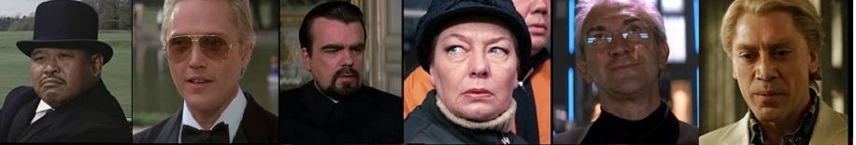
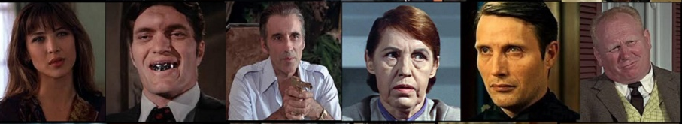
1 2 3 4 5 6

7 8 9 10 11 12

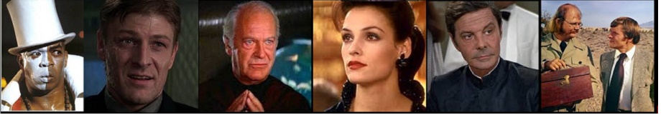
13 14 15 16 17 18
19 20 21 22 23 24

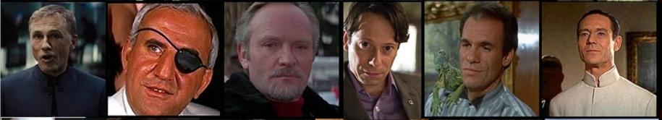
25 26 27 28
