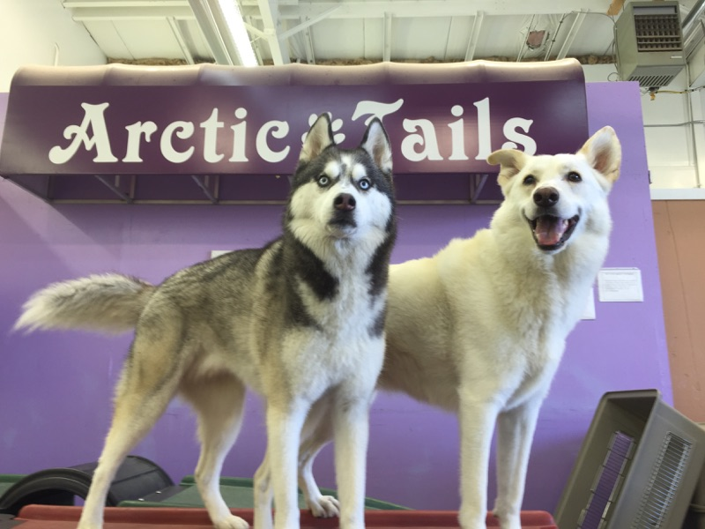

**Boarding**

**Standard Run**

**[3’x5’ Small room or 4’x6’ Big room**

**Single Dog $60**

Each Additional Dog $50

**Luxury Suite**

**[6’x8’ Bedroom w/ PLUSH bedding]**

**Single Dog $70**

Each Additional Dog $60

**Daycare**

**Full Day (Over 6 hours)**

**\*Family dogs share pass**

**Full Day $55**

5 Day Pass $260 ($52/Day)

10 Day Pass $500 ($50/Day)

20 Day Pass $960 ($48/Day)

**Pricing Info**





Luxury+ Suite

[7’x9’ Bedroom w/ LOVESEAT]

**Single Dog $75**

Each Additional Dog $65







**Half Day (Under 6 hours)**

**\*Family dogs share pass**

**Half Day $40 (up to 6hrs)**

5 Half Day Pass $185 ($37/Day)

10 Half Day Pass $350 ($35/Day)

20 Half Day Pass $650 ($33/Day)

**CAGE-FREE**

**[Board in Daycare ALONE, w/ couches made up for bedtime]**

**Single Dog $80**

Each Additional Dog $75







**Advantix II**

Advantix II - $20

We require a **MONTHLY** flea, tick, & lice preventative;

***We* MUST apply it!**

**Grooming**

**Nail Trim - $20**

**Nail Trim w/smooth edges - $25**

**5 Nail Trim Punch-card - $80 (5th free!)**

Gland Expression - $20

**ULTRASOUND Teeth Cleaning - $35**

**5 Teeth Cleaning - $140 (5th free!)**

Bath – Price is about the weight of the dog

Sanitary Trim (groin area) - $40

Blowout/De-shed – Bath + $20hr

**Evaluation**

[Registration, Office meet ‘n’ greet, 2hr Intro Day into daycare, and Report Card]

Eval - $35

Additional dog(s) - $ 30

Eval **EXPIRES** if 2 years has passed since we’ve seen the dog

**Loyalty Club**

Monthly - $65

Includes ADVANTIX, NAIL TRIM & DREMEL, & ULTRASOUND TEETH-BRUSHING! *[$15 savings]*