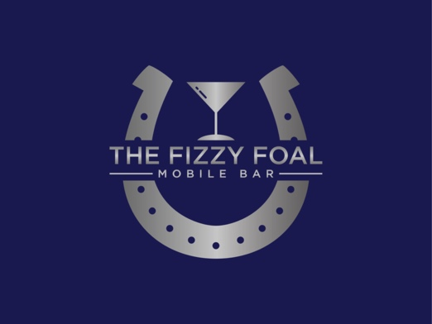
Booking Form
Fizzy Foal Ltd will provide the customer with a booking confirmation on receipt of the fully completed Booking Form and the required Booking Fee/Deposit payment. We will provide a fully bespoke service to the customer which includes: Fully insured (£10M Public Liability), uniformed staff, plastic drinkware, temporary events notice etc. Please note we do not hire out the bar on its own.

Name
Home Address
Contact Phone Number
Venue Address
Email
Nature of event
Date of event
Main contact at event
Main contact phone
Fizzy Foal Ltd. The Grange, Tinkle Street, Grimoldby, Louth, Lincolnshire. LN11 8TF.
Tel: 07773 444 333 Email: jodie@fizzyfoal.com

Any special vehicle access
requirements for the venue?
Does the venue hold a current
premises licence to sell alcohol?
Will there be a 240v power supply
at the venue?
Will there be access to Wifi at
the venue?
Please provide further details about
the location of event
(House/Garden/Field/Stairs etc)
Number of guests (Estimate) | Over 18  Under 18
Bar service time | From  To
Preferred Bar Type | Cash Bar (Cash or Card PAYG)  Free Bar (Pay at end of event)
Any other Info you would like to add

Fizzy Foal Ltd. The Grange, Tinkle Street, Grimoldby, Louth, Lincolnshire. LN11 8TF.
Tel: 07773 444 333 Email: jodie@fizzyfoal.com

Customer declaration

I agree/disagree to Fizzy Foal using pre agreed imagery from my event on their website/social media etc.

I agree to paying a £250 booking fee which is non-refundable should I choose to cancel the booking within 30 days of the event date.

Signed by the Customer:…………………………………………………………….

On Behalf of Fizzy Foal Ltd:…………………………………………………………

Once we have received your booking form and it has been checked over and accepted we will send you an invoice for the Booking Fee along with our bank details.
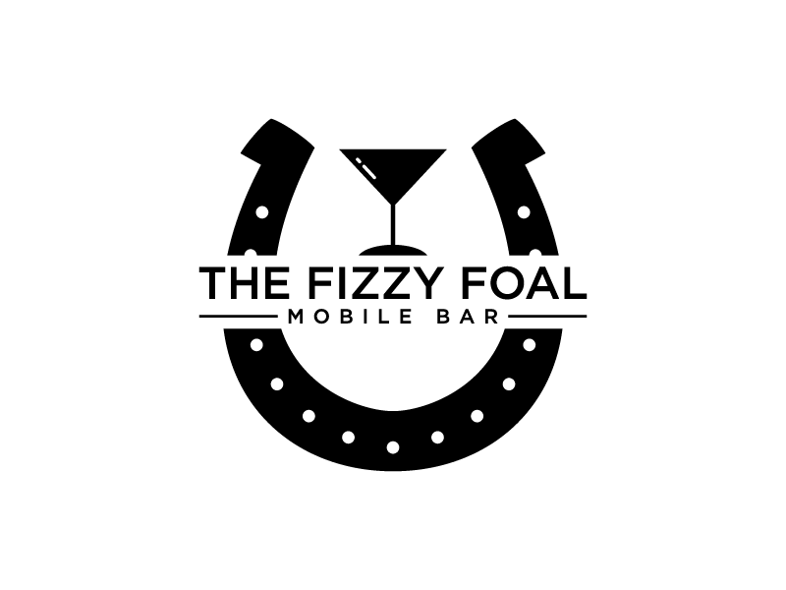
Fizzy Foal Ltd. The Grange, Tinkle Street, Grimoldby, Louth, Lincolnshire. LN11 8TF.
Tel: 07773 444 333 Email: jodie@fizzyfoal.com

