FIRST VISIT REGISTRATION

Thank you – wellbodyKC looks forward to getting you well soon!

email: support@wellbodykc.com www.wellbodykc.com 2111 East KC Road,
Olathe, Ks 66061
phone: 913-430-8905 fax: 913-222-1907

DOUBLE CLICK ABOVE TO ENTER NAME AND BIRTHDAY
ONCE COMPLETED DOUBLE CLICK BELOW TO CONTINUE

Sport: _______________ Level: ___________
Team/ Club: _______________ Practice schedule Hours per week: _____
Competition Season: (Place an “X” after the correct time when you are “in season”)
Year Round ☐ Winter ☐ Summer ☐ Spring ☐ Fall ☐ I don’t compete ☐

Next scheduled event: _______________ I plan to compete/perform at this event: YES ☐ NO ☐

- Past Medical History: (include fractures, dislocations, asthma, diabetes, hospitalizations, etc.)

- Past Surgical History: (include ear tubes, tonsillectomy, appendectomy, orthopedic procedures)
Procedure Date

- Medicines I take every day: (include prescription, over the counter, supplements, vitamins, alternative)
Medicine Dosage (if you know it)

- Medicines I take every once in a while: (include Tylenol, ibuprofen, creams, alternative)
Medicine Frequency (daily, weekly, monthly, rarely)

- Allergies to medicines/ foods/ environmental: __________________None ☐

- I received immunizations and am up to date: Yes ☐ No ☐
I received a COVID immunization Yes ☐ Never had ☐
I last had COVID on this date: Never had Randy
☐

- During every week I eat something in this food group: (Place “X” after each of what you eat/drink)
Meat/Fish ☐ Fruits ☐ Vegetables ☐ Grains ☐ Water ☐ Desserts ☐ Soda/Pop ☐

- I have had this many stress fractures diagnosed: (extremity/back): Never had ☐
- I have had this many concussions: Number: Never had ☐

- School: “X” after correct response: Public/Private ☐ Home ☐ College ☐ I don’t go to school ☐

- I get this kind of treatment at least once a month: (Place an “X” after all that apply)
Massage ☐ PT☐ Chiropractor☐ Dry needling☐ Cryotherapy☐ Other: _________

- Today’s appointment: My question / my problem / my concern/ my goals for today:
CONSENT FOR EXAMINATION, MEDICAL TREATMENT
Bring to Communicate Full Name Relationship to Patient Phone # or email
clinic HIPAA release
☐ ☐

inform my coach ☐ Coach Contact: ____________________ Email or Phone: _______________

inform my doctor ☐ Primary Care Provider: __________________ Email or Phone: _______________

I have read and consent to the above information. I was offered access to the wellbodyKC HIPAA information handout

Signature of Parent/Guardian: ______________________________ Date: ______________
(or Patient/athlete if over 18 years ) Go to menu at top of page and hit “Draw”, select a pen and sign.
When completed go to top of page menu and hit the cursor icon to continue typing.

Printed name of Parent/Guardian: __________________________

Address: ______________________________

City: ____________________________ State: _________ Zip: __________

Phone Number: _____________________ Email: _____________________
[ ________ ] Initial here to permit NON encrypted communication
to the contacts listed for the above patient

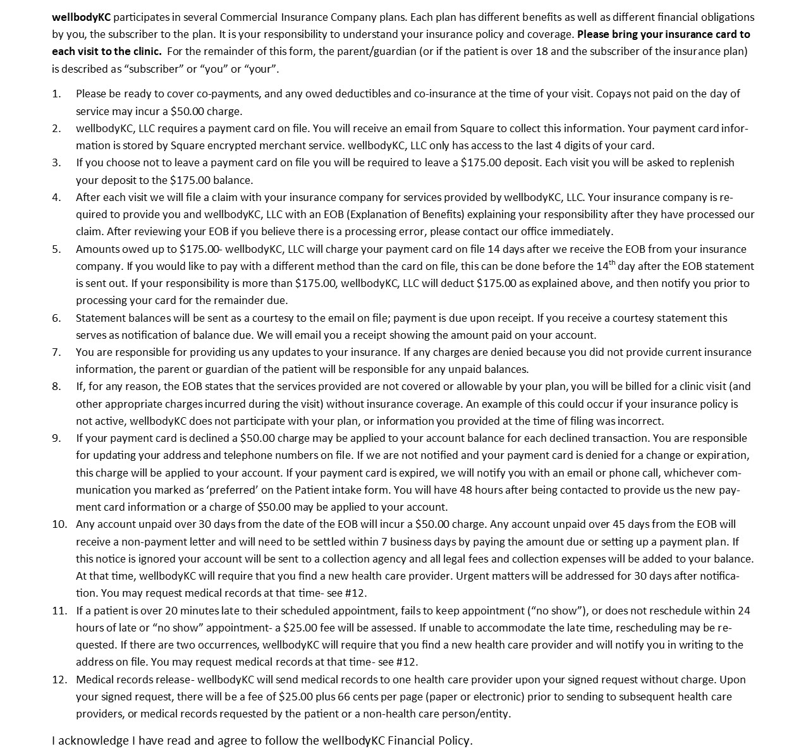
wellbodyKC Financial Policy- All Members 3/2023

Signature of Parent/Guardian__________________________ Date: _____________________
(or patient if over 18 years old and Guarantor) Go to menu at top of page and hit “Draw”, select a pen and sign.
When completed go to top of page menu and hit the cursor icon to continue typing.

IN NETWORK COMMERCIAL INSURANCE PLANS
(BCBS, Anthem, UHC, UMR, Aetna, Cigna), not in network with Medicaid products within these plans
not in network with Exchange Benefit or Marketplace plans

The Guarantor for the Insurance Policy is: _________________ __________ Usually the mother or father
Name of Guarantor Date of Birth if CIGNA insurance
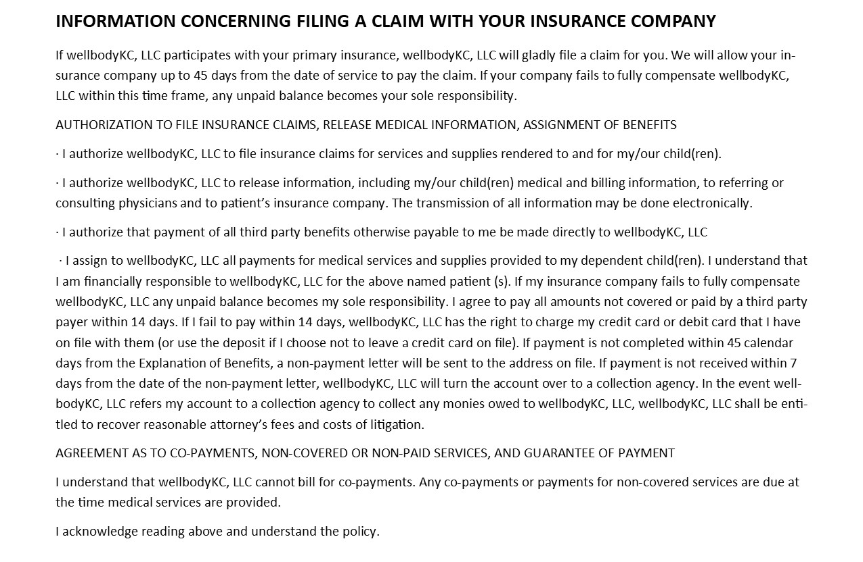

Signature of Parent/Guardian: _____________________________ Date: _____________________
(or Patient/athlete if over 18 years old and Guarantor)
Go to menu at top of page and hit “Draw”, select a pen and sign.
When completed go to top of page menu and hit the cursor icon to continue typing.

Save and email to support@wellbodykc.com or fax to 913-222-1907 or bring to visit.
Thank you!

