Broekhof USA appoints new Sales Manager for North America.

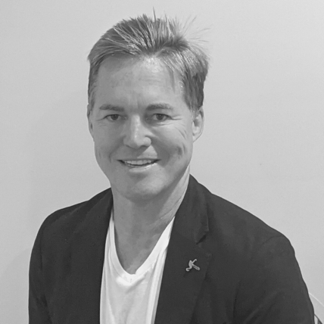
Miami, Fl, August 3, 2021 - Broekhof USA, a global leader in flower packaging, is proud to announce a new addition to the sales team. Joseph Anderson has been appointed Sales Manager for North America.

Joseph will be responsible for developing the sales strategies and operations for Broekhof’s key account channels in North America. He will be in charge of implementing and managing the sales activities, identifying new market opportunities and defining the actions required to bring a new dynamic to the existing team.

Joseph has extensive experience in sales management in the gift business industry. He started his career with Pacific Balloon Corp which supplied many growers, wholesalers and distributors with balloons, picks and containers. Later Pacific Balloon Company branded themselves as Chantilly Lane and introduced animated musical plush toys.

Broekhof USA is excited to join forces with Joe to bring fresh new ideas to this growing industry. Jim Bos, General Manager of Broekhof USA: ‘I am confident that Joe will excel in his new role and will ensure a tighter coordination of our sales operations to better serve our customers and meet our market goals. We have been substantially growing our business and have just had our most profitable quarter ever. We are keen to build on our success and see the sales team as key to this.’

About Broekhof:
Since 1974, Broekhof has been a leading global supplier of packaging and decorative material for the flower and plant sector. Since 2018 Broekhof is part of the Horti Division of the Royal Dutch Paardekooper Group. The Broekhof company has 115 employees in The Netherlands and 250 employees abroad. Next to the Netherlands, Broekhof has branches in Colombia, Kenia, USA and Vietnam and has its own factory located in Vietnam where flower and plant sleeves are produced.
=================
Note for the editor:
For more information, please contact Jim Bos at j.bos@broekhofusa.com or +1 305-570-5181

To contact Joseph Anderson: j.anderson@broekhofusa.com or +1 770 856 1759

