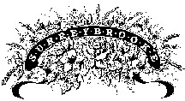

2024 Photography Session Request Form

Request must be made and approved 5 days prior to specified date. By requesting a session, you have read and agreed to abide by the Surreybrooke’s Photography Guidelines and Garden Etiquette. Please complete Photography Session Request Form : Drop off at Garden Center, or email nancywalz@surreybrooke.com . You may text Nancy @ 301-676-8263 to request and we will fill form out ahead of session.
Photographer’s Name: _________________________________________________________
Types of Photos: ______________________________________________________________
Client’s Names: ________________________________________________________________
Total Number In Group: _____________________ Amount DUE: $_______
($35.00/session During normal business hours $60/session After normal business hours)
Date Requested: ____________________________ PAID AMOUNT: $______
Time Requested: ____________________________ DATE PAID: _________
Special Request: __________________________________________________________________________________________________________________________________________________________

