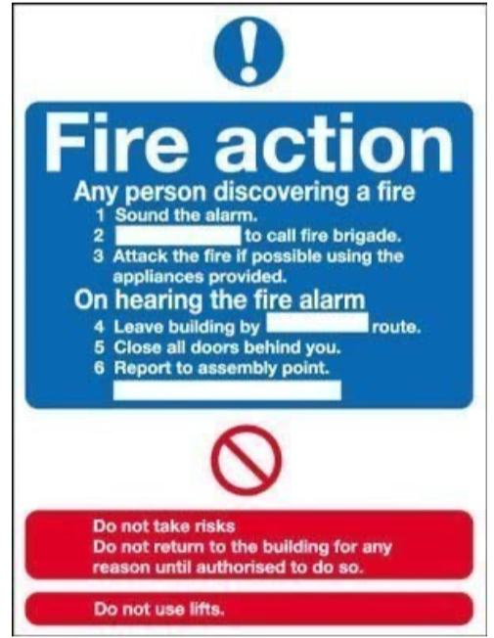
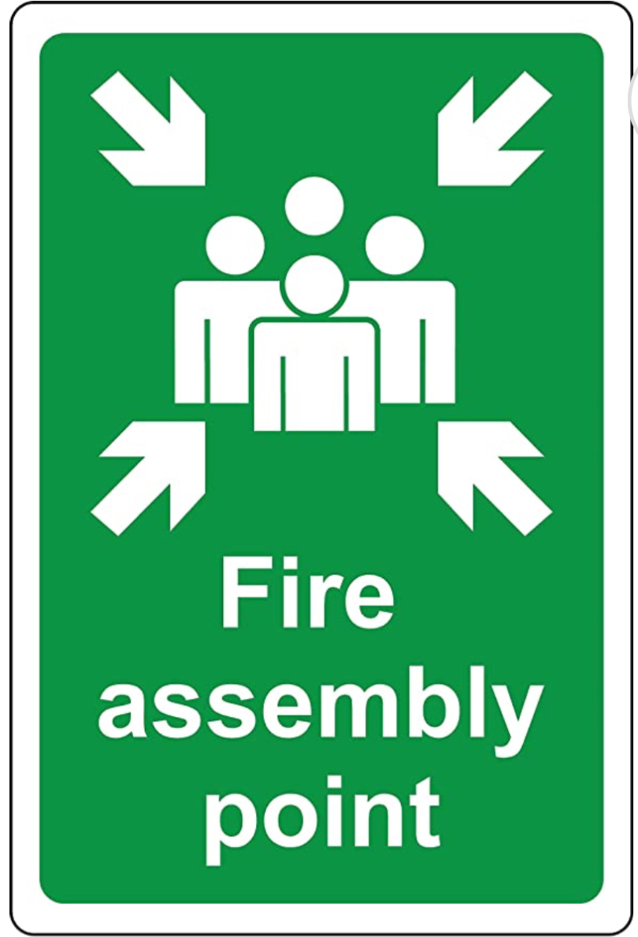
Fire Safety

Introduction:
Welcome to our safety blog, where we provide valuable information and guidance on various topics related to maintaining a safe working environment. In this edition, we focus on fire safety—an essential aspect of workplace safety. Fires can cause significant damage to property and pose a serious threat to the lives of employees. By implementing best practices for fire prevention and establishing effective evacuation plans, organisations can mitigate the risks associated with fires and ensure the safety of their workforce. Let's delve into the key practices and strategies for preventing fires and creating comprehensive evacuation plans.
1. Conduct a Fire Risk Assessment:
To effectively prevent fires, it is crucial to identify potential fire hazards in the workplace. Conduct a thorough fire risk assessment to determine areas of concern. Some common fire hazards include faulty electrical equipment, flammable materials, improper storage, and inadequate fire suppression systems. Regular inspections and risk assessments help in identifying and addressing these hazards promptly.

2. Install and Maintain Fire Safety Equipment:
Fire safety equipment is your first line of defense against fires. Install and maintain fire extinguishers, smoke detectors, fire alarms, and sprinkler systems throughout your premises. Ensure that all equipment is regularly inspected, properly maintained, and functional. Train employees on how to use fire extinguishers and other equipment correctly.

3. Develop and Communicate Clear Emergency Procedures:
Create comprehensive emergency procedures that outline the steps to be taken in case of a fire. Communicate these procedures to all employees through training sessions, informational posters, and regular drills. Make sure employees are aware of evacuation routes, assembly points, and the location of fire alarms and extinguishers. Regularly review and update the emergency procedures to accommodate any changes in the workplace layout or workforce.

4. Establish Evacuation Plans:
Develop well-defined evacuation plans that are tailored to the specific layout and needs of your workplace. Identify primary and secondary escape routes, taking into account accessibility for individuals with disabilities. Assign evacuation roles and responsibilities to designated employees to facilitate a smooth evacuation process. Clearly mark escape routes with illuminated exit signs, and ensure they are kept clear of obstacles at all times.

5. Educate and Train Employees:
Employee education and training are vital components of fire safety. Conduct regular fire safety training sessions to ensure that all employees are familiar with fire hazards, emergency procedures, and proper evacuation techniques. Teach them how to recognise potential fire hazards, report safety concerns, and take appropriate action in case of a fire. Reinforce the importance of prompt evacuation and the necessity of remaining calm during emergencies.
6. Regularly Test and Evaluate:
Regular testing and evaluation are essential to maintain the effectiveness of your fire safety measures. Test fire alarms, smoke detectors, and sprinkler systems periodically to ensure they are in working order. Conduct evacuation drills at least twice a year to assess the efficiency of your evacuation plans and identify areas for improvement. Gather feedback from employees to address any concerns or suggestions they may have.
Conclusion:
Protecting lives and property from the devastating effects of fires requires a proactive approach to fire safety. By implementing these best practices, conducting thorough risk assessments, and establishing clear evacuation plans, organisations can significantly reduce the likelihood of fires and enhance the safety of their employees. Remember, fire safety is a shared responsibility, and ongoing vigilance is key. Stay informed, be prepared, and prioritise fire safety in your workplace.

Remember, fire safety is a shared responsibility, and ongoing vigilance is key. Stay informed, be prepared, and prioritise fire safety in your workplace. get stock from most Manufacturers at the

