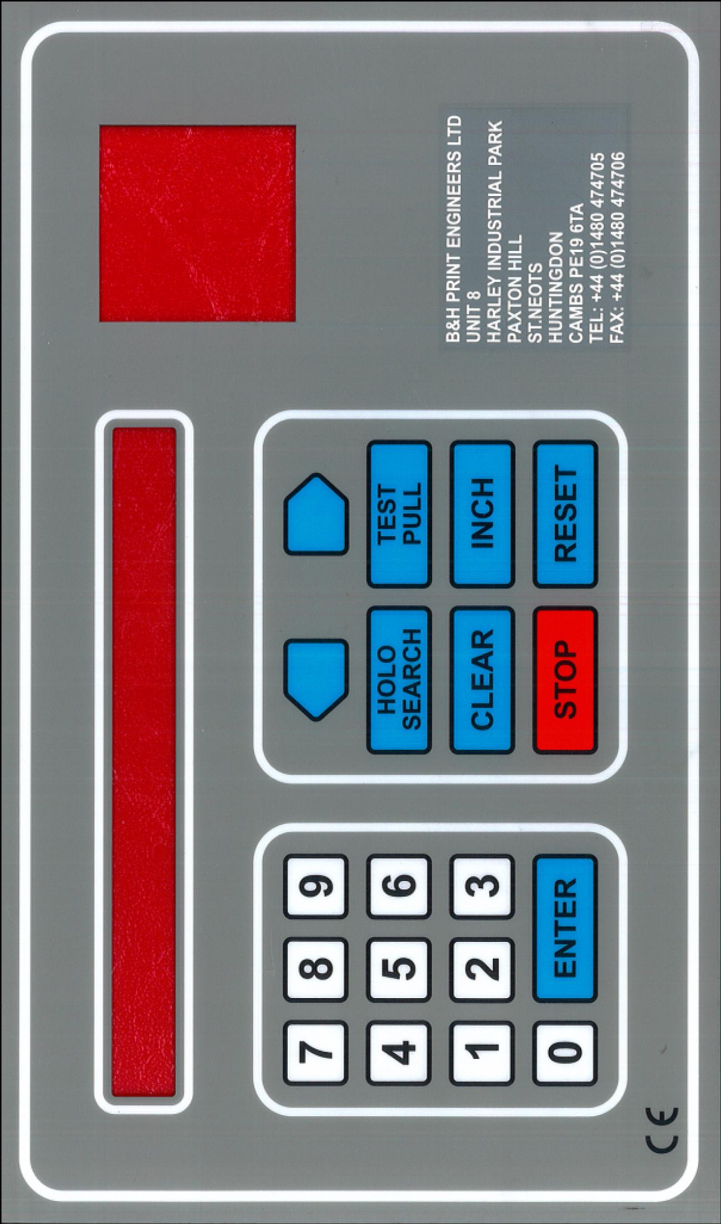

B & H PRINT ENGINEERS LTD

Unit 8, Harley Industrial Estate
Paxton Hill, St. Neots
Cambs, PE19 6TA, U.K.

Tel: + 44 (0)1480 474705 Fax: + 44 (0)1480 474706

ABOUT THIS GUIDE

To get the most from your conversion it is recommended you get to know the keypad and the numerous features that the system has to offer.

FEATURES:

FOIL PULL:

Pull step and clear, keeps foil wastage to a minimum.

SPEED ADJUSTMENT:
This enables you to set the speed at which the foil is pulled through the rollers, keeping pre-heating to a minimum.

FOIL ALARM:

Omits an audible warning when the foil is low.

COUNT:
Features impression counter and meters how much foil is used on the job.

HOLOGRAMS: (If fitted)

NEXT MENU:

Time, Date, System set up

FOIL PULL:

Select Foil Pull, press enter.

The following is now displayed:

FOIL :- PULL STEP CLEAR DELAY EXIT
000.0 00 000.0 0000 ms

Measure die, allow for wastage. Select Pull – press enter
Enter new value via numeric keypad (For measurements below 100, enter 0 first)
As the last digit is entered, the display returns to FOIL :-
If you do not want to change the value, press CLEAR.

If step and repeat is required, measure the largest die (see diagram).
Set pull to largest die.

Step: Calculate how many times die A can be advanced before it reaches die B.
This is the amount of steps: program and enter

Clear: Measure distance as shown in diagram and program amount in Clear.
The machine will now step and repeat.

Delay: allows the operator to delay pull up to 2 seconds 2000ms.

This can help with foil separation especially on large foil areas.

To return to Main Menu, select exit and press enter.

SPEED ADJUSTMENT:

This feature is used for controlling the speed at which the roller pulls foil.

Its main usage is to avoid pre-heating of the foil.

To select this feature, select Speed Adjustment, press enter.

The following message appears:

FOIL :- PULL CLEAR INCH EXIT

00 00 00

Select figure necessary to pull the foil (1 – 10) so that the foil pull works faster than the machine (If figure is set too low the foil will keep on breaking.)

In the step and repeat mode the clearance pull is always greater than the foil pull, so with this program it is possible to enter in two different figures i.e. foil pull 20mm, speed 01, clearance pull 300mm, speed 09. This keeps the foil away from the die for the greatest possible time, thus avoiding pre-heating. As a general rule however, it should be possible to set this figure to a midway setting and no further adjustment should be necessary.

Inch: This should only have to be set once and to your own requirements.

To return to Main Menu, select Exit and enter.

FOIL ALARM

This useful feature monitors when the foil is low and displays a warning as well as an audible warning!

To program:
Select Foil Alarm, press enter.
The following is displayed:

ALARM ENABLE FOIL ROLL SIZE EXIT
00 METRE 000 METRE

Enter foil roll size - 400 Ft = 122 Mtrs
800 Ft = 244 Mtrs
1000 Ft = 305 Mtrs

Select appropriate amount, program and enter

Select Enable: This will sound the alarm at the pre-set figure you appoint i.e. 1 Mtr, 2 Mtrs before the foil roll size you have entered.

If you do not want to use the alarm, set ENABLE to 00.

To return to Main Menu, select Exit and enter.

COUNT:

This program will act as an impression counter, meter the amount of foil used on the job and indicate the amount of steps you have done in a step & repeat mode.

To re-set Counter and Foil Used, select Count, and press enter.

The sub menu will now read:

COUNT IMPRESS FOIL USED ROLL EXIT
000000 0000 METRE 000

To re-set, select enter and press reset key; it is now zeroed.

The same procedure for Foil Used and Roll.

When the alarm is being used, you must reset ROLL when a new roll is put on the machine, this will count up to the roll size you have put in.

To return to Main Menu, select Exit and enter.

TEMPERATURE CONTROLLER

PV : PRESENT VALUE

SV : SET VALUE

: MOVES SV UP

:MOVES SV DOWN

S.Err: displayed in PV indicates thermocouple is broken or disconnected.

Op1 : output turned on to heat plate.

NEXT MENU:

TIME:

To change the time, press enter, enter new time, based on the 24 Hour system.

DATE:

To change the date, press enter, enter new date starting with year, month, day.

SYSTEM SET UP:

This should only be adjusted by a trained engineer from B & H Print Engineers Ltd.

SETTING THE OMRON E3X DA21

- LOOK AT THE INSTRUCTION SHEET E3X-DA-N-SERIES TO FAMILIERISE YOURSELF WITH THE PHOTOELECTRIC SWITCH FIRST.
- PLACE THE HOLOGRAM REGISTRATION MARK IN FRONT OF THE FIBRE OPTIC LIGHT.(THE LEVEL INDICATOR SHOULD HAVE A HIGH READING, SCALE 0000 - 4095)
- OPERATION MODE "L-ON" (ALWAYS)
- MOVE THE MODE SELECTOR TO "SET"
- PRESS THE SET KEY "TEACH" ONCE.(RED INDICATORS SHOULD DISPLAY FOR APPROXIMATELY ONE SECOND ("NOT FLASHING")
- MOVE THE HOLO REGISTRATION MARK AWAY FROM THE LIGHT(THE LEVEL INDICATOR SHOULD HAVE A LOWER READING)
- PRESS THE SET KEY "TEACH" ONCE. (GREEN INDICATORS SHOULD DISPLAY FOR APPROXIMATELY ONE SECOND). IF THE RED INDICATORS FLASH AT THIS STAGE GO TO STEP 2 AND START AGAIN.
- MOVE THE MODE SELECTOR TO RUN.
- NOW THE SENSOR IS SET, IF YOU MOVE THE FOIL LEFT OR RIGHT YOU MAY NEED TO REPEAT THE PROCESS AGAIN.
- TO CHECK, PRESS HOLO SEARCH ON THE CONTROL BOX, WHEN THE REGISTRATION MARK GOES IN FRONT OF THE LIGHT THE ROLLER SHOULD STOP, THE OPERATION INDICATOR SHOULD LIGHT UP ORANGE. (IF YOU HAVE AN OFFSET PUT IN THE PROGRAM THE ROLLER WILL GO THE DISTANCE OF THE OFFSET AND THEN STOP. THIS MAY BE EVEN FURTHER THAN THE SIZE OF THE REGISTRATION MARK, MEANING THE OPERATION INDICATOR WILL GO ON THEN OFF AGAIN. THIS DOES NOT CAUSE ANY PROBLEM TO THE PROGRAM.)

