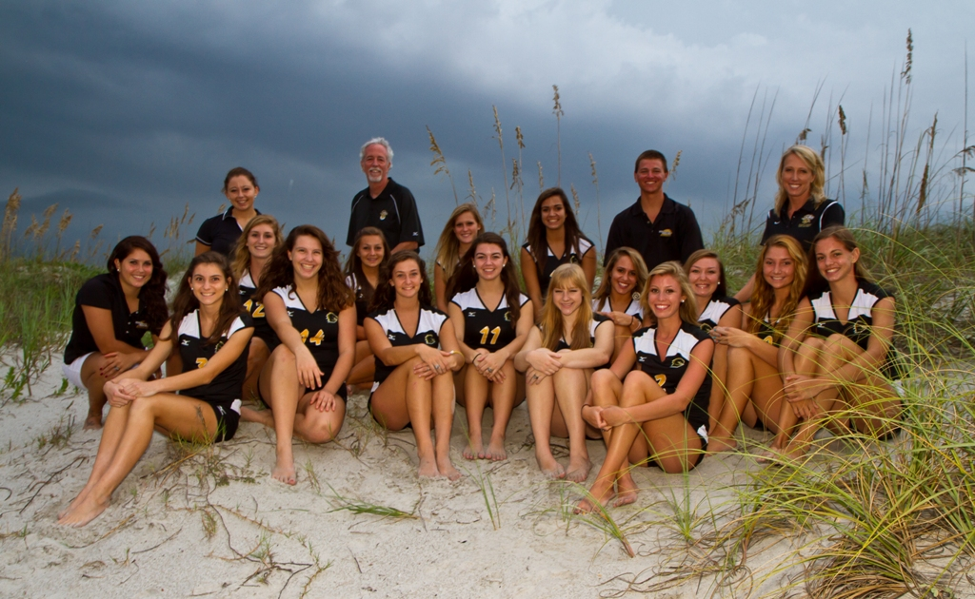

ISLAND VOLLEYBALL CLINICS

June 11-14th 8:00–11:00 (beginner/intermediate grades 4-9)

12:00-3:00 (experienced grades 6-9)

July 13th 6-9 pm and July 14th 9-noon

(intermediate/experienced grades 7-9)
We will help you prepare for a successful high school and club tryout!

Location: Merritt Island High School Gymnasium
Open to boys and girls!!

Clinic Features:
*Quality instruction of the fundamentals of volleyball in a fun and positive environment
* Many opportunities for one-on-one and small group training. Current high school and college players will assist in training.
* Exciting games/drills that will emphasize teamwork and excite players about volleyball and competition
*AWARDS FOR ALL-STAR TEAM *All STAR MATCH * POOL PARTY *TEAM SPIRIT DAY
* CLINIC STORE- PURCHASE VOLLEYBALL APPAREL
Clinic Director:

Lady Mustangs Head Coach ANGIE PATRICK
Coach Patrick has 14 years club coaching experience, 2 years as Embry Riddle University Asst. Coach and 15 years as Merritt Island High School Varsity Coach.

Cost: JUNE 11-14 $105, JULY 13/14 $50 ($45 if attended the June clinic)
(6/11 clinic includes t-shirt and pizza party Thursday after camp)
Make checks payable to “ISLAND VOLLEYBALL”
Players will need to wear shorts or spandex, t-shirt (no tank tops please), and athletic shoes.
Knee pads and other volleyball apparel will be available for purchase on site.

Any questions, please contact Coach Patrick at MIVBcoach@gmail.com
Please pre-register by mailing or delivering the completed form to Merritt Island HS c/o Coach Patrick, 100 E. Mustang Way, MI, FL 32953, by MAY 26th. Please send in early to secure a spot.
Players registered after MAY 30th will not be guaranteed a t-shirt. $5 late registration fee at the door.
***this form can be downloaded off of islandvolleyballclinics.com

ISLAND VOLLEYBALL CLINICS Registration

Name______________________________________________________________

Grade ___________________ T-Shirt Size (Youth) _____, or (ADULT) S M L XL

Address____________________________________________________________

Phone______________________________________________________________

*School attending next Year_____________________________________________

How did you find out about this clinic? ____________________________________

Parent signature______________________________________________________

e-mail: _____________________________________________________________

Circle session(s) below:
JUNE 11-14
1. INTERMEDIATE/BEGINNER a.m. (played league or school team or no exp.)
-OR-
2. ADVANCED p.m. ( 2yrs competitive/travel experience)
-AND/OR-
3. JULY 13-14 Intermediate/Advanced grades 7-9 (contact coach Patrick for younger
consideration)
Medical Release
I _______________ understand that there are risks associated with strenuous physical exertion and with this event. I hereby assume all risks associated with this event and I hereby waive, release, and discharge any and all claims for damages, personal injury of any kind which may hereafter occur to me or to any person as a result of my participation in this event. This waiver and release shall be binding on my heirs and assigns, and shall run in favor of coach Patrick, Merritt Island Volleyball players/coaches, Island Volleyball Clinics, or anyone else connected with this event.
Print Name: ________________________________________________
Player Signature:______ ___________________________________________
Parent Signature:_______________________________________
Date: ____________________________________________________

Please sign below if you give us permission to take photos and post them on the web.

________________________________________

