PRE-K CLASS
SUPPLIES REQUESTED

- WIPES (2)
- BOX OF TISSUES (2)
- BLANKET/SHEET (for rest-time)
- 2 COMPLETE SETS CLOTHING (appropriate for current weather/climate including 2 pairs of socks & 2 underwear)
- HAIRBRUSH & COMB
- LARGE BACKPACK (to easily carry daily supplies & projects)
- ART SMOCK/OLD SHIRT (that covers clothing)
- GLUE STICKS (6)
- 1 MARBLE NOTEBOOK
- BOX OF CRAYONS (24 Pack)
- BOX OF MARKERS (10 Pack)
- BOX OF COLORED PENCILS (12 Pack)
- #2 Pencils (3)
- ONE 2-INCH WHITE BINDER WITH PACK OF 5-TAB DIVIDERS
- PLASTIC POCKET FOLDERS (2)
- CURRENT FAMILY PHOTO (4x6 preferred)

Please be sure to
LABEL ALL your child’s items with COMPLETE FIRST & LAST NAME

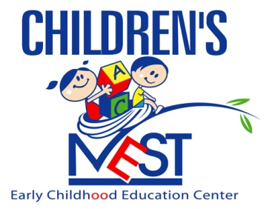

“Nurturing Tomorrow’s Leaders”

Welcome to the new school year and “Let’s Dream it, Believe it, and Achieve it!!!

