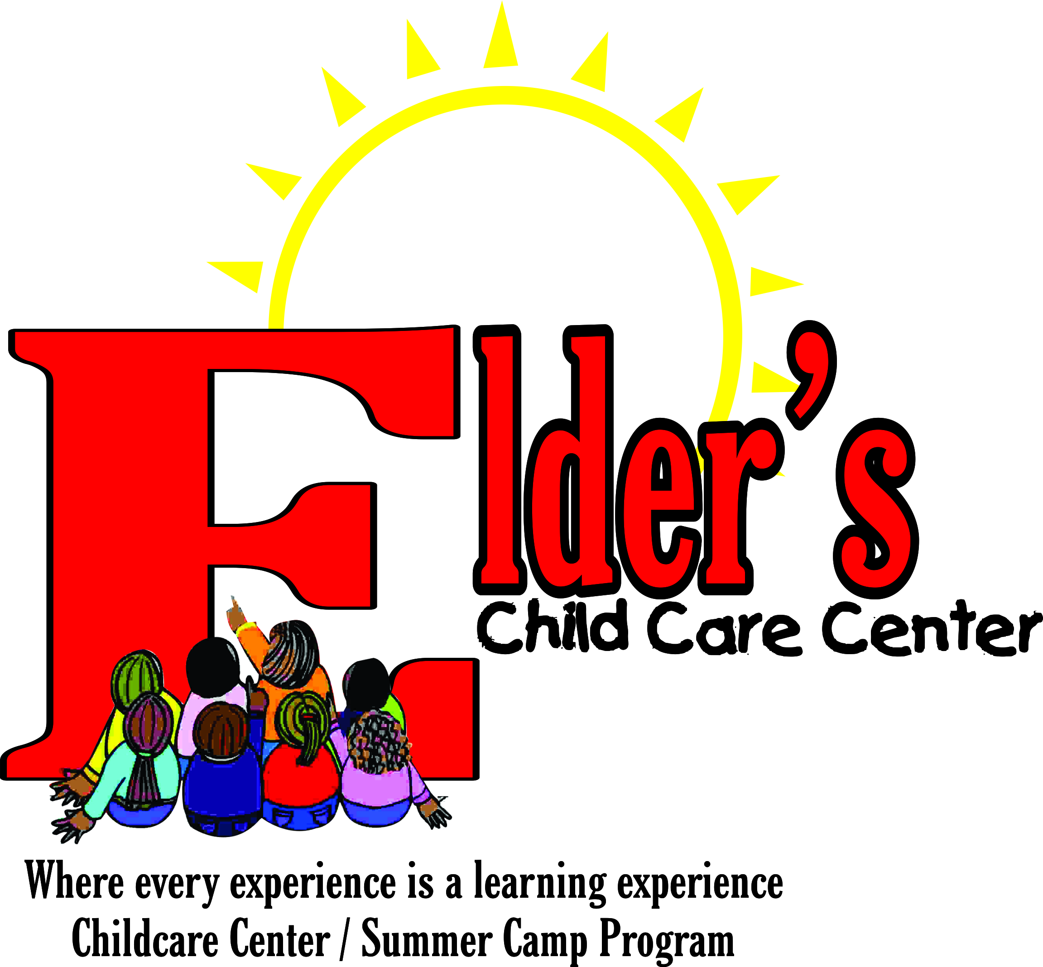

Child Release Authorization

Elder’s Childcare Staff is authorized to release my child______________________ to the following individuals who I have authorized to pickup my child from daycare. I understand that each authorized person must be at least sixteen (16) years old, and that my child will be permitted to leave the facility only with a parent or guardian or the individuals listed below. All authorized individuals must show identification. Elder’s Childcare Staff may release my child to the following people.

Name | Phone Number | Relationship
1.
2.
3.
4.
5.

Activity and Field Trip Liability Release and Authorization

I hereby give permission for my child_____________________________ to participate in all the program activities at Elder’s Childcare. This includes going on field trips and riding in approved vehicles (Vans, Buses, Cars, Sports Utility Trucks). I agree to release Elder’s Childcare, its employees, and agents from all liability arising from any harm or injury incurred by the participation of my child excluding gross negligence.

By signing this form, I also authorize Elder’s Child Care to obtain medical and hospital treatment for my child if an emergency occurs.

_________________________________________________________
Signature of Parent (or Guardian) Date

Print Parent (or Guardian’s) Name: _____________________________________________

Home #____________________ Work#___________________ Cell/Pager#_________________

2nd Emergency Contact Person

Name___________________________________________

Home #_____________________________ Work#______________________________

Cell/Pager#__________________________________

