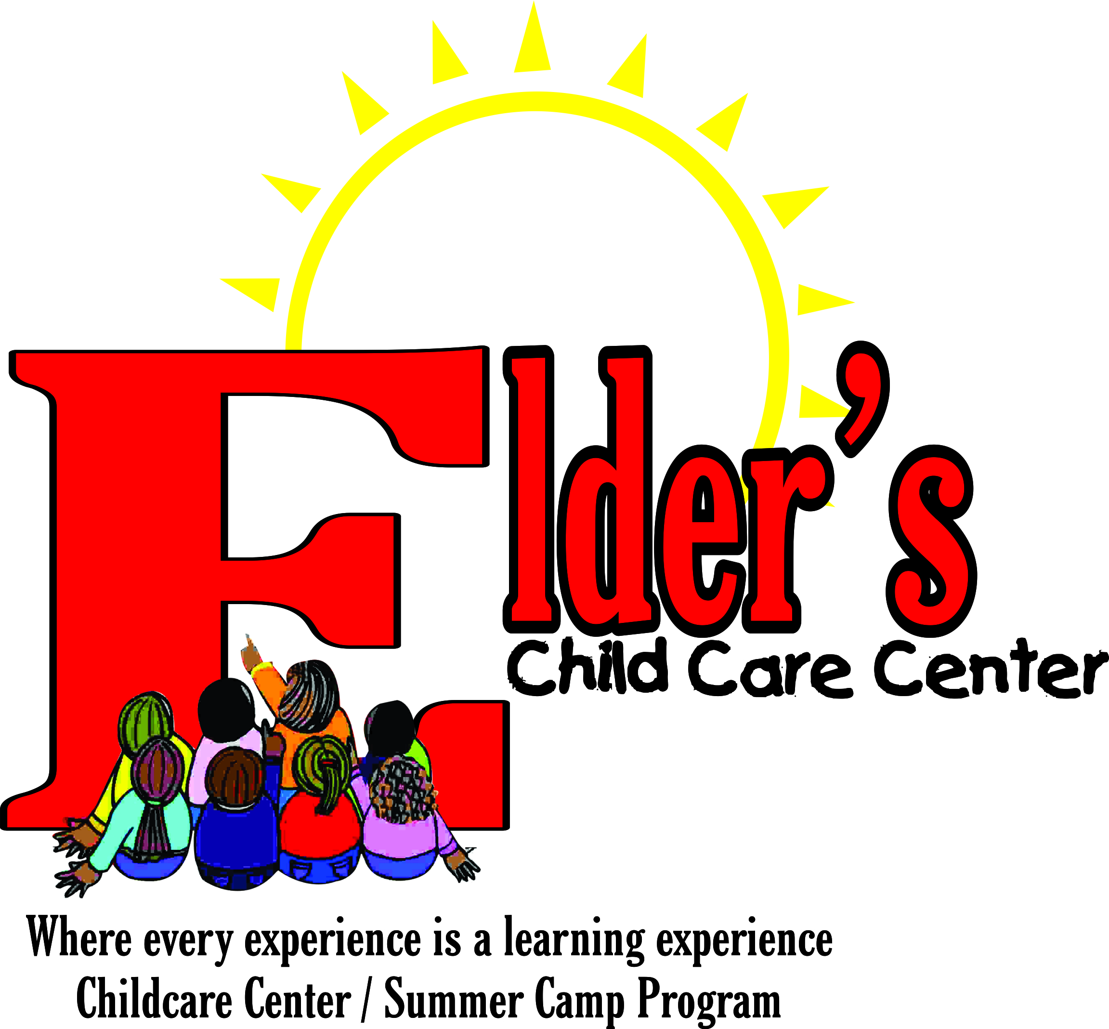

Elders’s Childcare Center

Uniform Policy

Students 2 through 5 years old are required to wear uniforms Monday- Thursday. Parents of students not wearing an appropriate school uniform will be contacted by telephone and required to provide uniform within one hour of school call. If proper uniform is not provided, the student may be sent home or restricted from class.

Dress Code for all Pre- school students:
Boys: Girls:
White collar shirt Scoop- neck white or light blue shirt
Navy slacks Navy blue jumpers/ skirts
Black rubber sole dress shoes Black/ Navy blue rubber sole shoes
Black belt Navy/ White tights /Crazy tights
Navy sweater Navy sweater
Navy shorts Navy stretch pants may be worn under jumper
(During the winter season)

Fridays are dress down day for students. Students are not allowed to wear attire that promotes demonic or violent practices (i.e., guns, witches, wrestling, etc.)
Students should wear clothing that is washable and adaptable to food spills, and/ or water play. Be sure to provide for seasonal changes (hat, coats, jackets, boots, mittens, etc). Parents are also asked to provide two extra sets of clothing; which should include underwear, socks, tops and bottoms. We ask that you label all clothing.

