(#188) Dear Management:

November 21, 2019

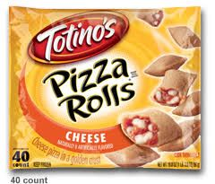

What's in a name?  And how important is it to your business model?  (PART 1 of 2)  
  
Because I often see two arguments come up when trying to grow.  
  
1 - The name is too regional...  
  
This one is lost on me.  I mean if a company has GREAT service, GREAT pricing, GREAT people, GREAT (fill in the blank)... would I say, "Nope, I'm an Oregonian... I can't possibly do business at Smoky Mountain Lending".    
  
??? - I mean doesn't everyone love Dolly?  
  
But I digress.    
  
Think of it this way:  A young Italian man fresh off the boat, scared of the backlash of his ethnic surname... changes it to Thomas.  
  
He and his wife then start making pizzas...  
  
If not for their foresight we'd all be eating Thomas' party pizzas.  
  
What a shame that would have been, and good thing Rose and Jim Totino were proud of their name.  
  
And let's all give thanks to the powers to be, for TOTINO's PIZZA ROLLS!  
  
My youth was full.  
  
Find my book and blog at [www.mrtenkey.com](http://www.mrtenkey.com/)  
#mrtenkeytips #chrismasonanalytics #