(Mr. Tenkey's Tips #242) www.mrtenkey.com

February 11, 2020

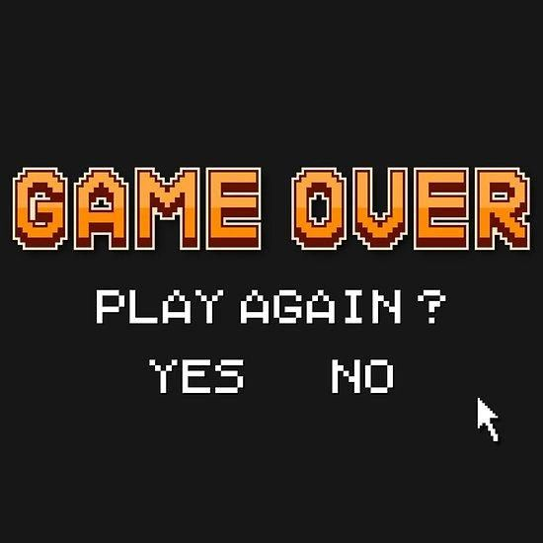

Dear Management:  Do you know many times I've died within the first few minutes of a new video game?  
  
Well... more than i care to admit...  
  
And while some might say I failed,  
  
I say to those naysayers...  I was just getting started!  
  
A sacrificed life, is just a learning lesson.  
  
Because, the next level always awaits.  
  
Play again peeps!