(Mr. Tenkey's Tips #298) www.mrtenkey.com

April 29, 2020

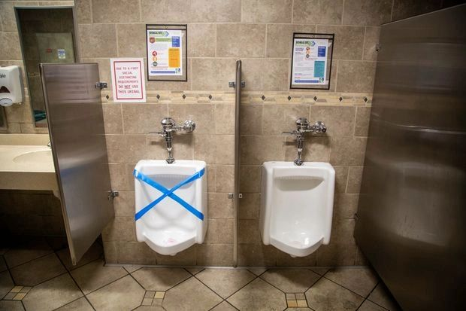

Dear Management: Yes... a funny pic, but also a "possible" new normal... with talk of employees returning to the workplace.  
  
And the POST-stay-at-home-order workplace... is gonna be different.  
  
So do you have a plan?  
  
No??? Well you should...  
  
Because there are a lot of logistics that need to be worked out... and a driving force of that, will be the potential liability involved in bringing employees back into an unsafe work environment.  
  
Yep, NOW I have your attention.  
  
And now that I do... you need to ask all the questions everyone else is asking... like:  
  
Do we need a plexiglass shield at the front desk?  
Do we just leave all doors in the office open during working hours?  
Do we bring everyone back or do some stay working from home?  
Does everyone need to wear a mask?  
Do we close the lunchroom?  
Do we discontinue conference room meetings?  
Are employee workspaces adequately distanced?  
And yes, do we tape off every other urinal?  
  
If you haven't asked these (and other) questions....  
  
Then you my friends... have NO plan.  
  
Start there!