(Mr. Tenkey's Tips #299) www.mrtenkey.com

April 30, 2020

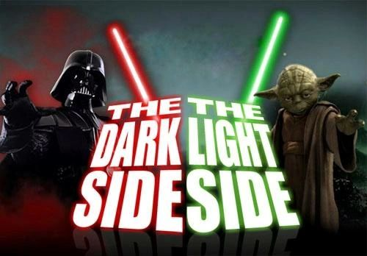

Dear Management: We've all heard the verbal spoutings... about how... "to be a good mentor, you have to have been a good men-tee"... blah... blah... blah...  
  
But so OFTEN, what it ignored in all that... is an explanation of what does it mean to have been a good men-tee???  
  
In my book, it's... CHOOSING the "right" mentor.  
  
Now often... the choice of people in your life, isn't within your power, but what IS...  
  
Is the POWER to evaluate the actions and lessons learned from the "acting" mentors, that come into your life... and realizing a better way forward.  
  
THAT... is the best choice YOU can make for yourself.  
  
THAT... will make YOU a better mentor down the road.  
  
Now go...  
  
May the force be with you.